post development testing

# functionality: the specification

This section involves testing all the different examples on the specification. I have ignored some small examples and have added some extra lines to others to prove their functionality.

The link to these examples is at:  
<https://www.ocr.org.uk/Images/558027-specification-gcse-computer-science-j277.pdf#page=27>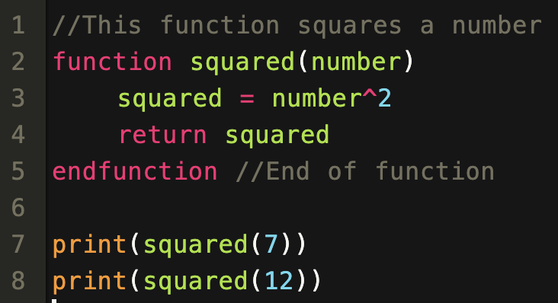

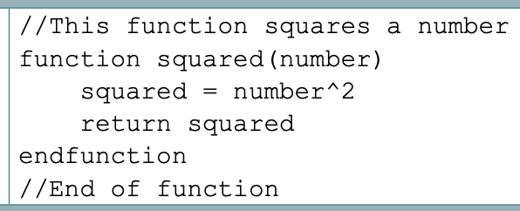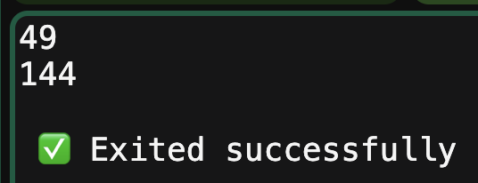🡺 **Commenting example**

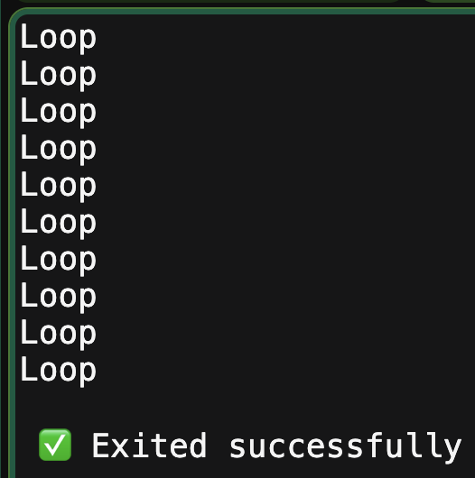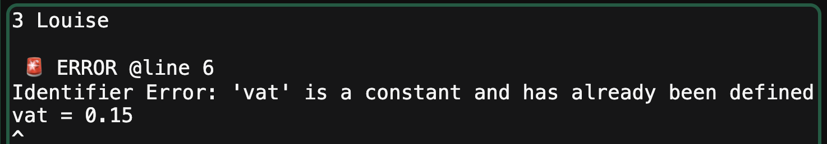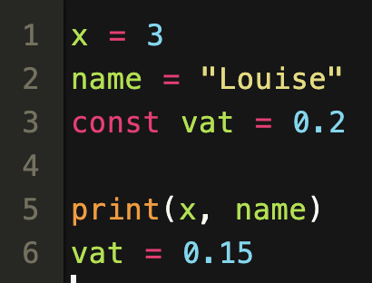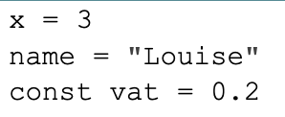  
 **🡺 Variables examples**

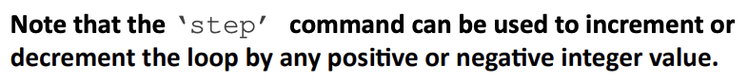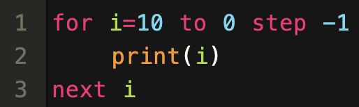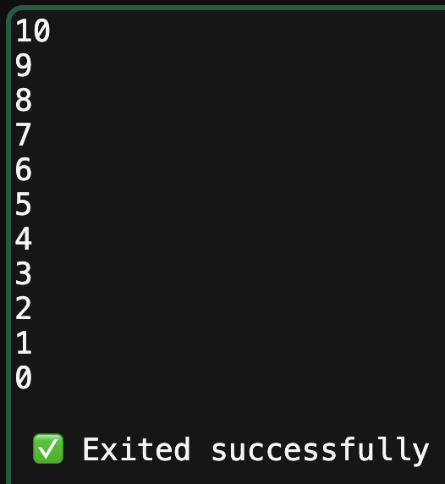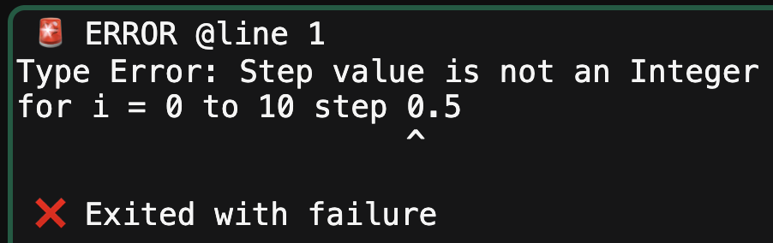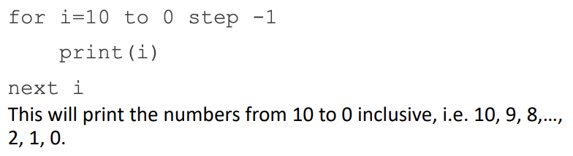**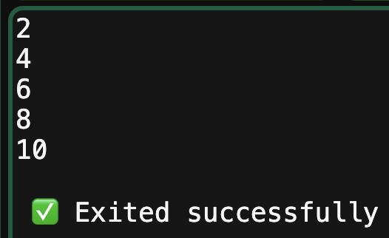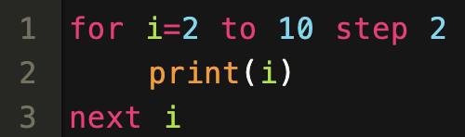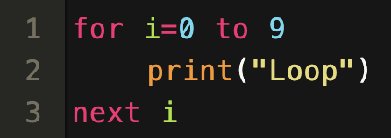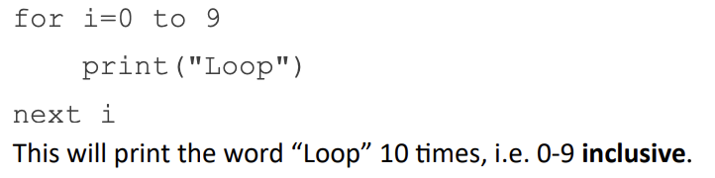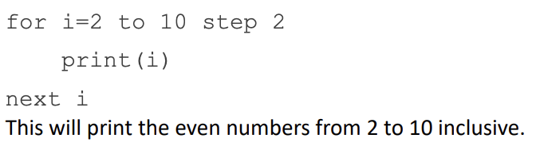  
  
  
🡺 For loop examples**

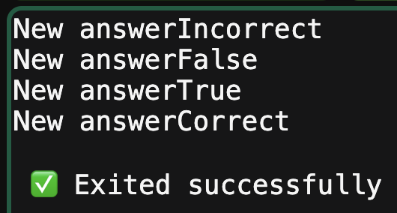

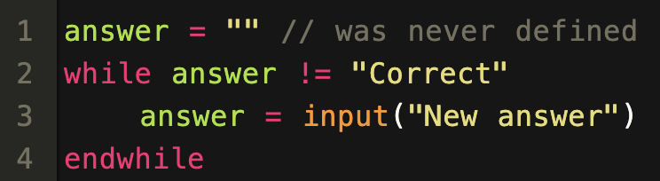**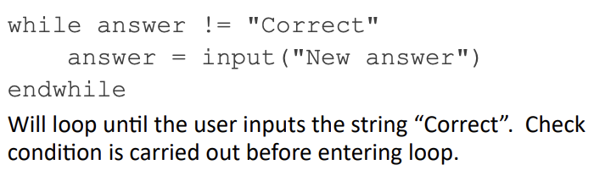🡺 Other loops**

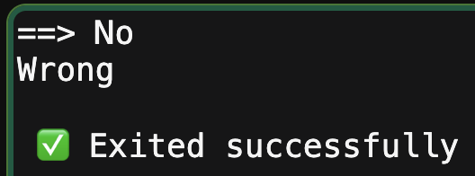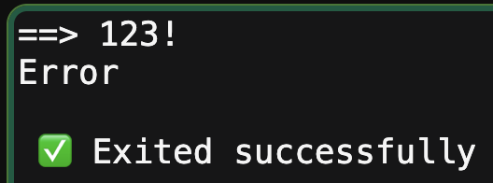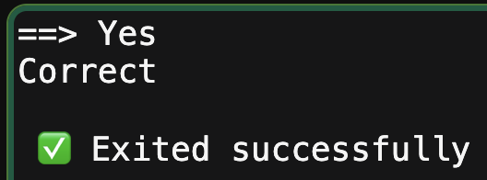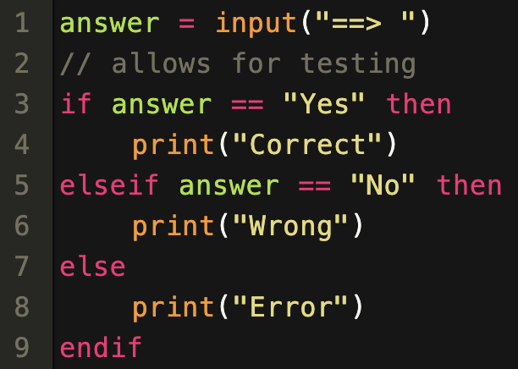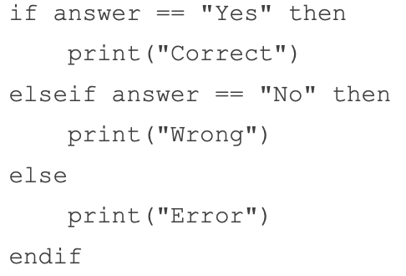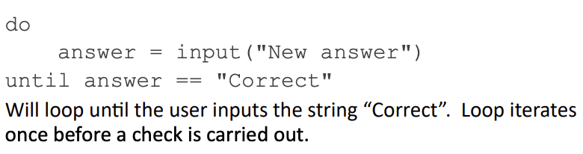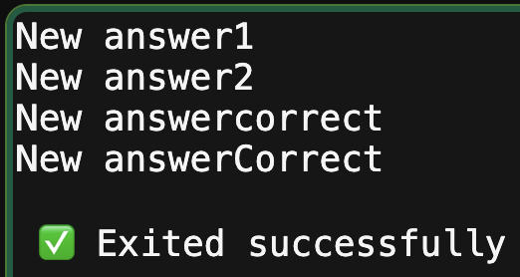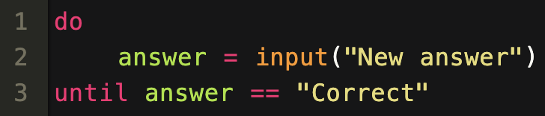**🡺 If statement**

**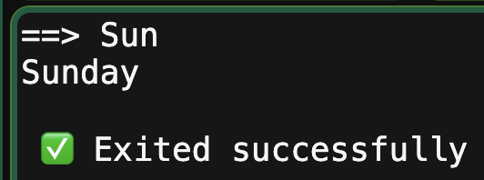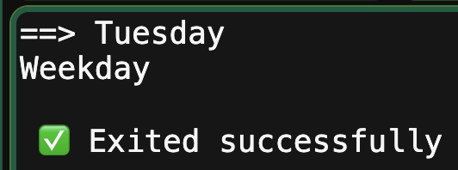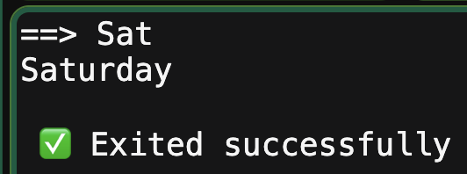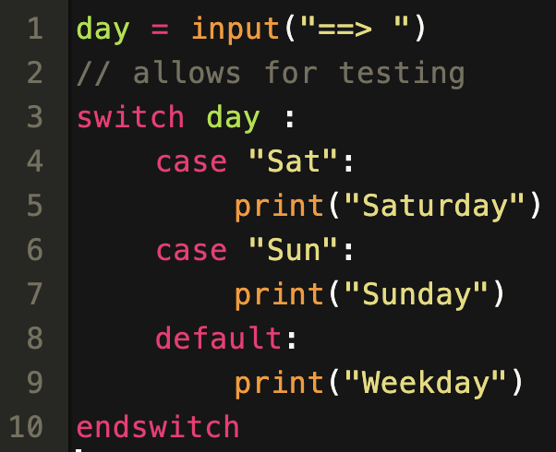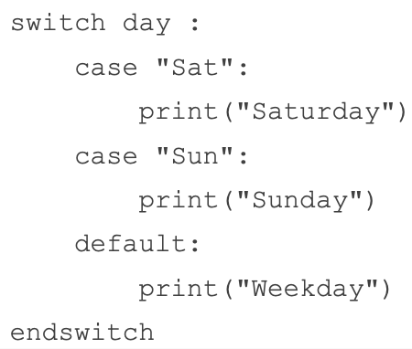  
🡺 Switch statement**

**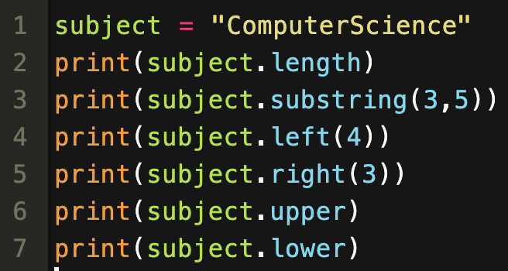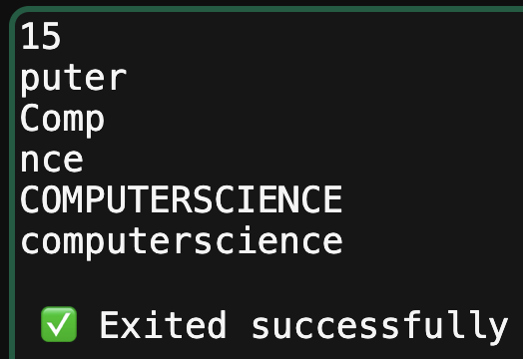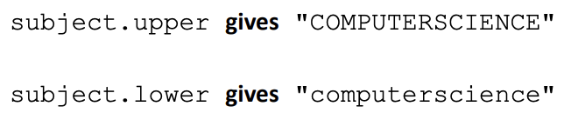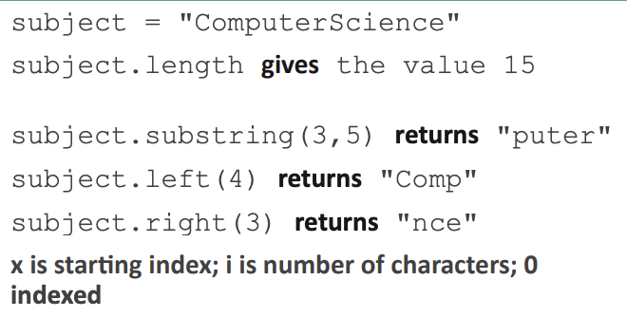  
🡺 String methods**

**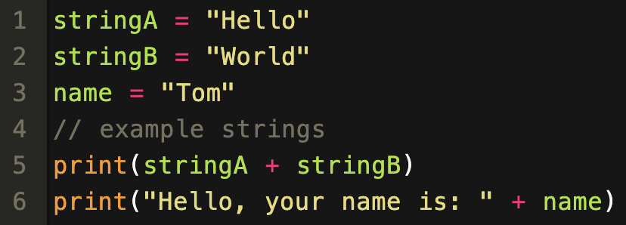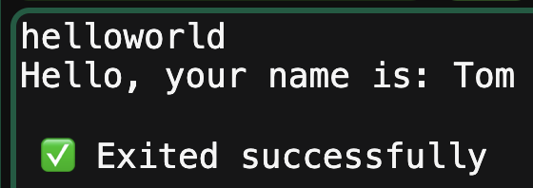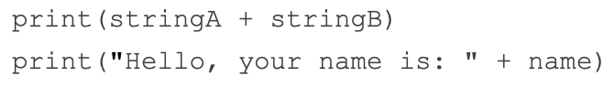  
🡺 Concatenation**

**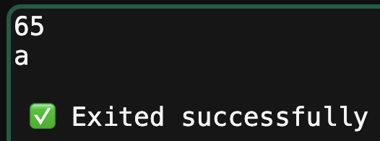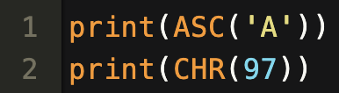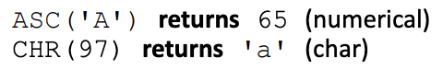  
🡺 Ascii Conversion**

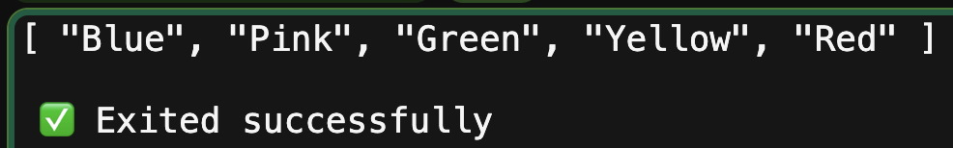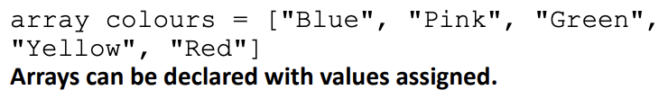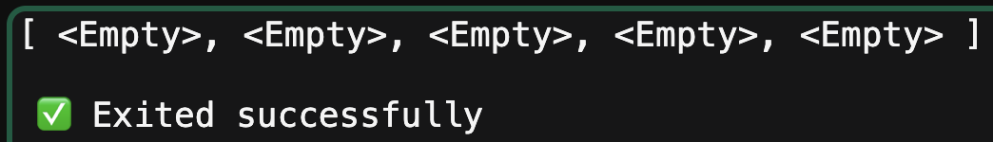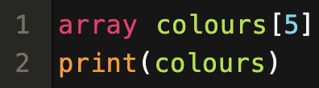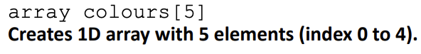**🡺 Arrays**

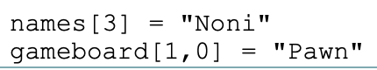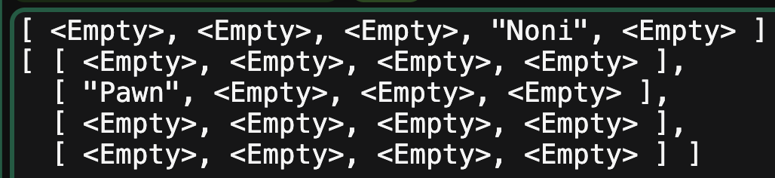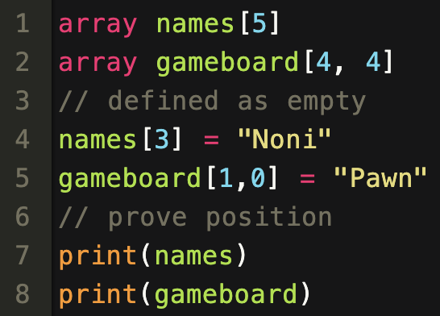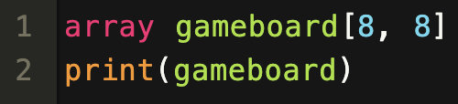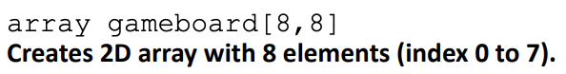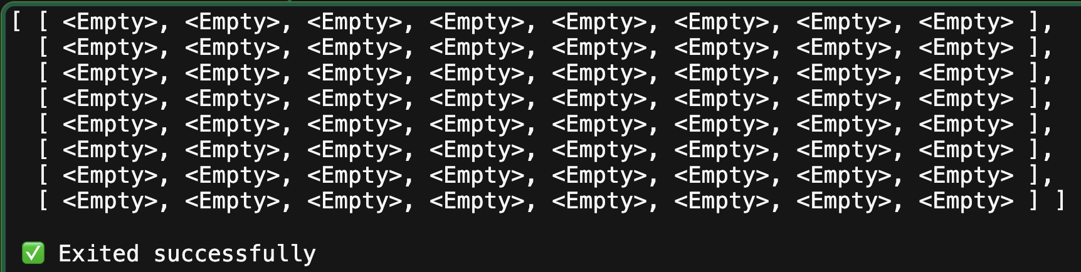

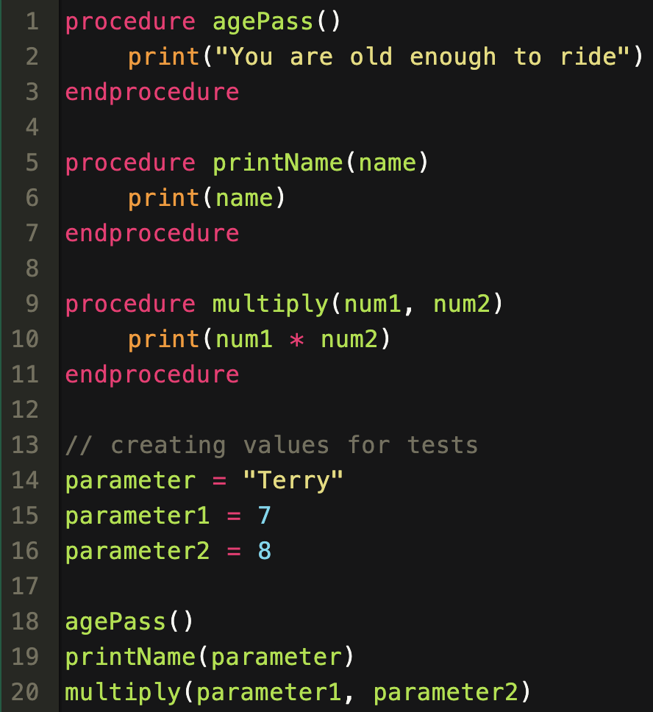

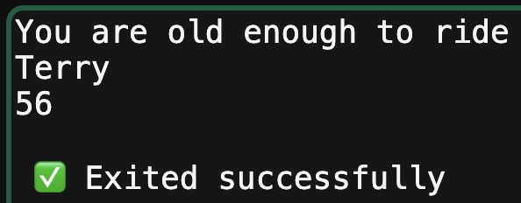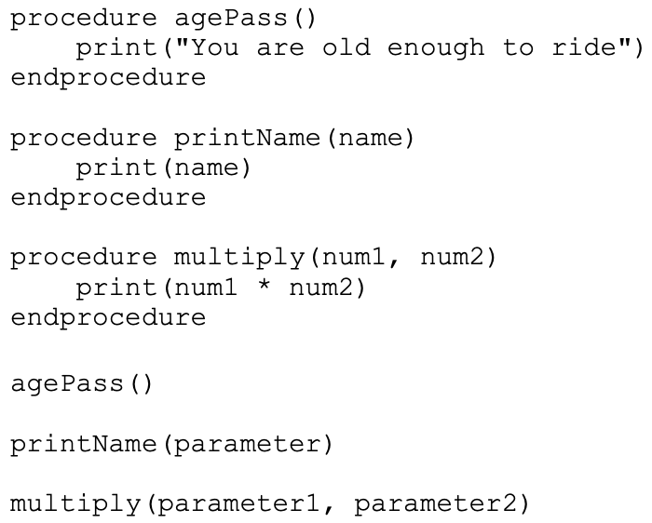**🡺 Procedures**

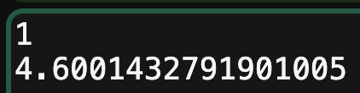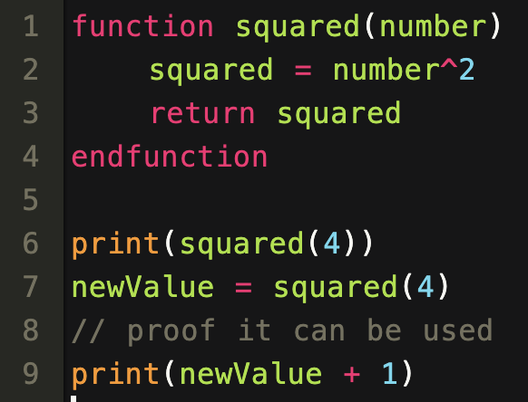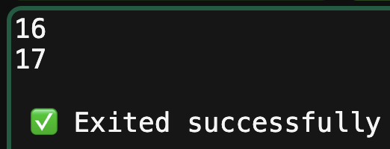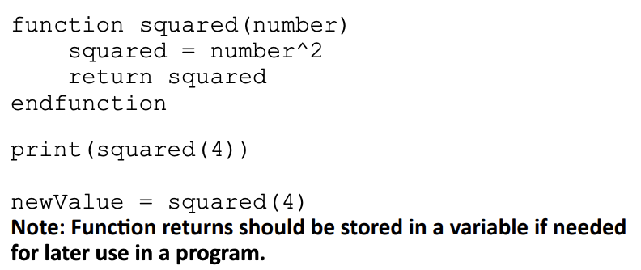**🡺 Functions**

**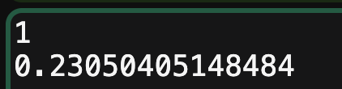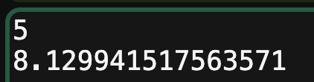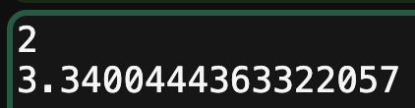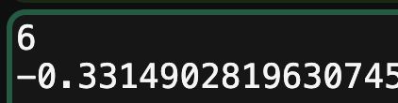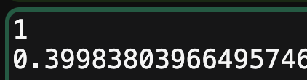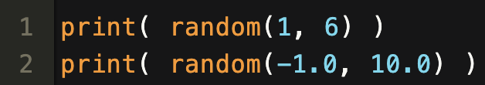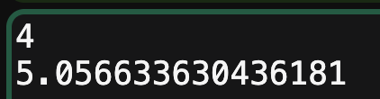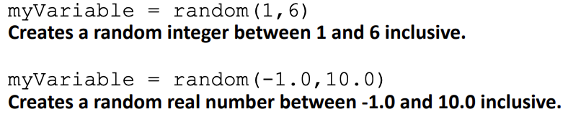  
  
🡺 Random**

Excluding the file handling, this has been all the different examples in the specification. The format is a bit messy in this layout: it will be more nicely formatted for the success criteria testing but I just wanted to fit it all into as small a space as I could.

Overall, this is very positive because all the cases executed completely correctly, showing that I have followed the specification perfectly because of these expected outputs.

This includes every single feature (except for the file system), which means that the scope of the project has been achieved, which I am very pleased about as there were points in the projects where I was unsure if I would manage to implement the entire specification.

### file testing

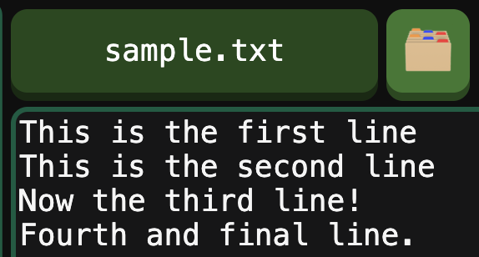The final testing I need to do is for the file managing system: both the ERL code and how it interacts with the interface, however this mainly falls under the interface testing.

Using the built-in file management system, I created a file called “sample.txt” and filled it with some test data for the examples.

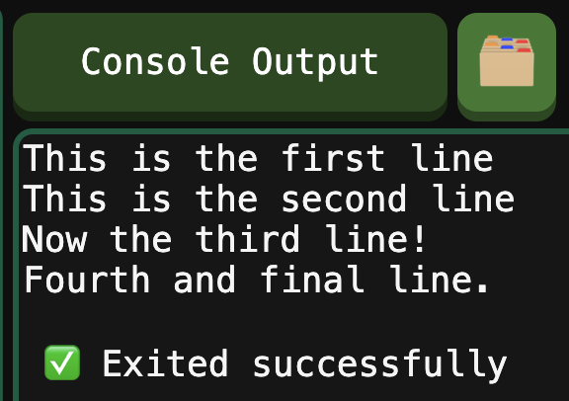I will read and write to this as proof.

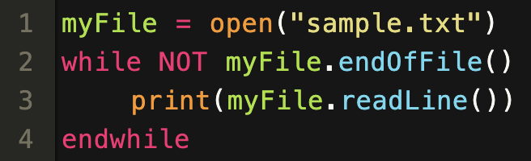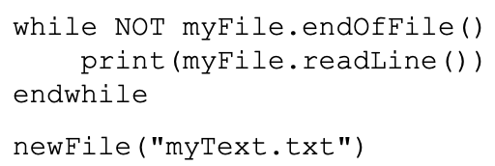

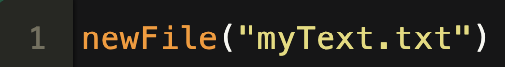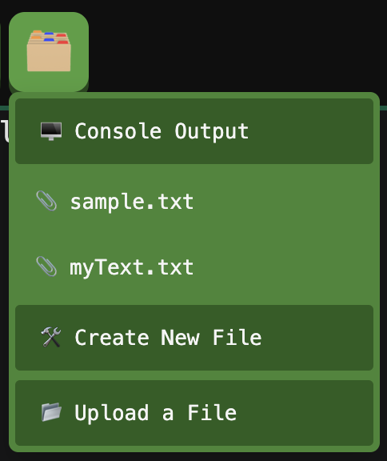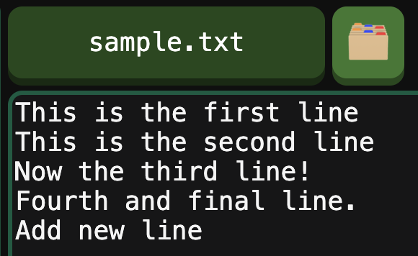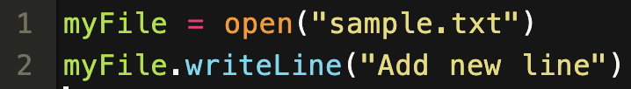  
  
Going back to the file after execution shows that the contents have been updated.

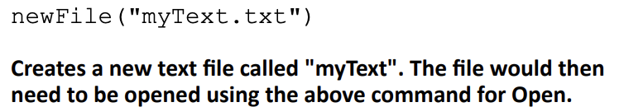  
The creation of the new file correctly added it to the management system and it was empty so is working as anticipated.

This also proves that the file handling for the system is correctly functioning (at least for the specification examples), so I am content that I have implemented the specification exactly how OCR lays it out.

## past paper example

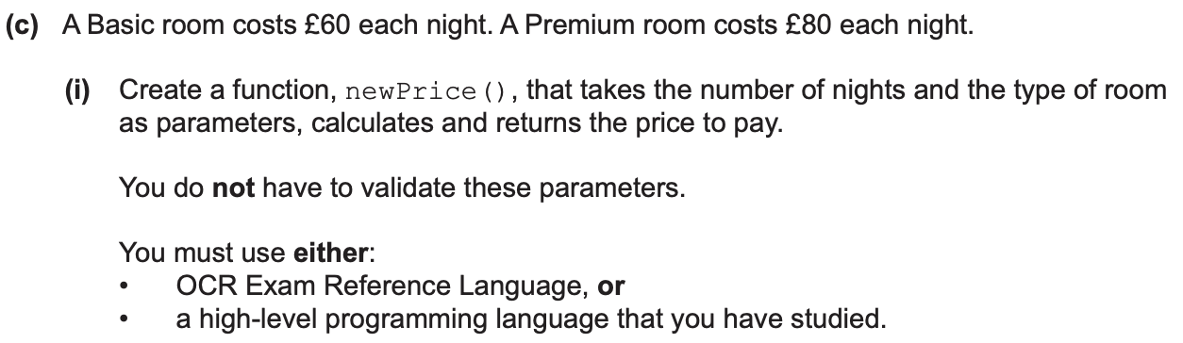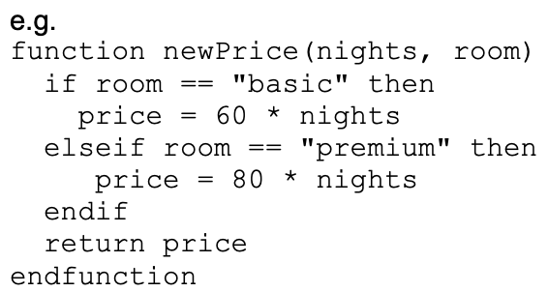

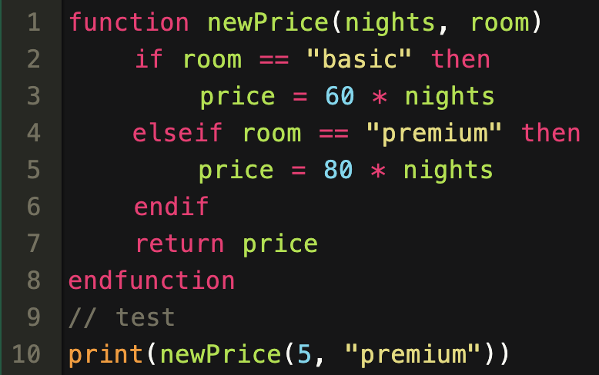As a final test, I took one of the code examples from a past paper mark scheme and pasted it into the Interpreter to see how it would run.

I also added a test case at the bottom to check that the code was working.

It successfully displayed the correct cost for the number of nights, once again showing that my code is correctly working and so matches perfectly with what OCR wants.

Now I am going to test my program against my success criteria to ensure all the detailed features are working.

# functionality: success criteria test cases

There will also be a little bit of testing for robustness in this section because some basic error testing is included, however this will largely be testing the features.

## 1: arithmetic

|  |  |  |  |
| --- | --- | --- | --- |
| No. | Test Case | ERL Input | Output |
| 1.1 | print( 2 + 3 ) 🡺 5 print( 3 * 7 ) 🡺 21 |  |  |
| 1.2 | print( 2 + 3 * 4 ) 🡺 14 print(10 – 2 ^ 3 ) 🡺 8 |  |  |
| 1.3 | print( 9 / 2 ) 🡺 4.5 print( 2.0 + 3.0 ) 🡺 5.0 |  |  |
| 1.4 | print ( (-3 * 4) + 2 ) 🡺 -10 |  |  |
| 1.5 | 5 / 0 🡺 Error 3 * / $ 🡺 Error |  |  |

All of these returned the intended result.

## 2: variables

|  |  |  |  |
| --- | --- | --- | --- |
| No. | Test Case | ERL Input | Output |
| 2.1 | variable = 7 print(variable) 🡺 7 |  |  |
| 2.2 | variable = 2 * 8 print( variable – 5 ) 🡺 11 |  |  |
| 2.3 | const pi = 3.14 pi = 7 🡺 Error |  |  |
| 2.4 | print( var ) 🡺 Error var = 🡺 Error |  |  |

These tests had a 100% success rate.

## 3: Logic

|  |  |  |  |
| --- | --- | --- | --- |
| No. | Test Case | ERL Input | Output |
| 3.2 | print( 3 + 5 > 2 ) 🡺 True print(True != False) 🡺 True |  |  |
| 3.3 | print( NOT 3 > 5 ) 🡺 True print( NOT False ) 🡺 True |  |  |
| 3.4 | print(True AND False) 🡺 False print(NOT False AND True) 🡺 True |  |  |

Also an 100% success rate.

## 4: if statement

|  |  |  |  |
| --- | --- | --- | --- |
| No. | Test Case | ERL Input | Output |
| 4.1 | if 2 + 2 == 4 then  print(“Passed”) endif 🡺 Passed |  |  |
| 4.2 | if False then  print(“Fail”) elseif 5 > 3 then  print(“Passed”) endif 🡺 Passed |  |  |
| 4.3 | if True == False then  print(“Fail”) else  print(“Passed”) endif 🡺 Passed |  |  |
| 4.4 | elseif 4 > 5 then 🡺 Error endif 🡺 Error |  |  |
| 4.5 | if True: 🡺 Error if 2 then 🡺 Error else then 🡺 Error |  |  |

These test cases were also completely successful.

## 5: loops

|  |  |  |  |
| --- | --- | --- | --- |
| No. | Test Case | ERL Input | Output |
| 5.1 | counter = 1 while counter < 3  print(“A”)  counter = counter + 1 endwhile print(counter) 🡺 A, A, 3 |  |  |
| 5.2 | while False  print(“Fail”) endwhile 🡺 No output |  |  |
| 5.3 | var = 1 do  var = var – 1  print(“B”) until var == 0 print(var) 🡺 B, 0 |  |  |
| 5.4 | do  print(“C”) until True 🡺 C |  |  |
| 5.5 | for i = 1 to 3  print(i) next i 🡺 1, 2, 3 |  |  |
| 5.7 | for i = 5 to 1 step -2  print(i) next i 🡺 5, 3, 1 |  |  |
| 5.8 | for var= 0.3 to 2.3 🡺 Error while 3 🡺 Error do True 🡺 Error |  |  |

Still completely as expected.

## 6: strings and casting

|  |  |  |  |
| --- | --- | --- | --- |
| No. | Test Case | ERL Input | Output |
| 6.1 | print(“test”) 🡺 test print(“a” + “b”) 🡺 ab |  |  |
| 6.2 | 2 + “test” 🡺 Error “hello” * 3 🡺 Error |  |  |
| 6.3 | print( int(“7”) + 1 ) 🡺 8 float(“test”) 🡺 Error |  |  |

Still completely correct.

## 7: functions and procedures

|  |  |  |  |
| --- | --- | --- | --- |
| No. | Test Case |  |  |
| 7.1 | procedure square(x)  print( x^2 ) endprocedure |  |  |
| 7.2 | square(7) 🡺 49 |
| 7.3 | a = 7 procedure test()  a = 5 endprocedure test() print(a) 🡺 7 |  |  |
| 7.4 | a = 7 procedure test()  global a = 5 endprocedure test() print(a) 🡺 5 |  |  |
| 7.5 | function double(x)  return 2 * x  print(“Ignored!”) endfunction double(3) 🡺 No output |  |  |
| 7.6 | print( double(3) + 1 ) 🡺 7 |  |  |
| 7.7 | function factorial(n)  if n <= 1 then  return 1  endif  return factorial(n – 1) * n endfunction print( factorial(5) )🡺 120 |  |  |
| 7.8 | factorial(7, 9) 🡺 Error procedure error()  return “Test” endprocedure 🡺 Error |  |  |

All these cases were still successful.

## 8: native functions

|  |  |  |  |
| --- | --- | --- | --- |
| No. | Test Case | ERL Input | Output |
| 8.1 | print(“a”, “b”) 🡺 a b |  |  |
| 8.2 | x = input(“Enter name: ”) print(x) 🡺 Enter name: Joe 🡺 Joe |  |  |
| 8.4 | print( ASC(“A”) ) 🡺 65 print( ASC(“a”) – 7) 🡺 90 |  |  |
| 8.5 | print( CHR(65) ) 🡺 A |  |  |
| 8.6 | roll = random(1, 6) temp = random(10, 35) |  | Different values on each run |
| 8.7 | input(5) 🡺 Error ASC(“test”) 🡺 Error CHR(2.7) 🡺 Error |  |  |

## 9: switch and arrays

|  |  |  |  |
| --- | --- | --- | --- |
| No. | Test Case |  |  |
| 9.2 | switch “test”:  case “te” + “st”:  print(“Passed”) endswitch 🡺 Passed |  |  |
| 9.3 | switch 3:  case 4:  print(“Fail”)  default:  print(“Pass”) endswitch 🡺 Pass |  |  |
| 9.4 | switch “no colon” 🡺 Error case 3 then 🡺 Error default 🡺 Error |  |  |
| 9.5 | array countries[4] array chessboard[8, 8] |  | Chessboard test case was in the ERL specification testing. |
| 9.6 | array cols = [“Red”, “Blue”] array nums = [1, 2, 3, 4, 5] |  |  |
| 9.7 | print( cols[1] ) 🡺 “Blue” print( nums[3]^2 ) 🡺 16 |  |  |
| 9.8 | cols[0] = “Green” |  |  |
| 9.9 | cols[0] = 3 🡺 Error array test = [[1, 2, 3], [4, 5]]  🡺 Error |  |  |

All of these returned the correct result.

## 10: String methods

|  |  |  |  |  |  |
| --- | --- | --- | --- | --- | --- |
| No. | Test Case | | ERL Input | | Output |
| 10.1 | print(“hello”.length) 🡺 5 | |  | |  |
| 10.2 | print( “hello”.substring(1, 2) ) 🡺 el print( “test”.substring(3, 1) ) 🡺 t | |  | |  |
| 10.3 | print( “hello world”.left(4) ) 🡺 hell print( “hello world”.right(3) ) 🡺 rld | |  | |  |
| 10.4 | print( “hello”.upper ) 🡺 HELLO print( “WORLD”.lower ) 🡺 world | |  | |  |
| 10.5 | 3.substring(4, 5) 🡺 Error “test”.substring(2, 7) 🡺 Error “”.right(3) 🡺 Error |  | |  | |

## 11: File handling

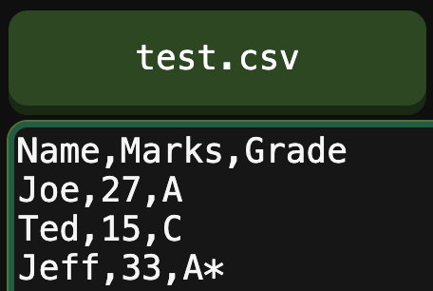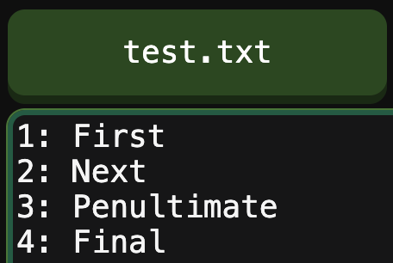For this section of testing, I have written the two test cases on the left, as a basis for the cases to work with.

Note that I will also be creating an additional file, and I will show that this has been done when I execute it.

|  |  |  |  |
| --- | --- | --- | --- |
| No. | Test Case |  |  |
| 11.2 | file.close() file.readLine()  🡺 Error |  |  |
| 11.3 | print( file.readLine() ) 🡺 prints the line |  |  |
| 11.4 | while NOT file.endOfFile()  print( file.readLine() ) endwhile 🡺 will output entire contents |  |  |
| 11.5 | file.writeLine(“testing”) file.writeLine(“A\nB\nC”) |  |  |
| 11.6 | newFIle( “names.txt” ) f = open( “names.txt” ) |  |  |
| 11.7 | file1 = open( “test.csv” ) file2 = open( “test.csv” ) print(file1.readLine()) print(file2.readLine())| 🡺 Outputs first line twice |  |  |

### conclusions

Overall, every single test case produced the expected result, proving that the functionality of the program is perfect, and that the success criteria for the ERL have been met.

I will be evaluating the User Interface criteria after I have tested the program with users to have a more detailed overview of it. Firstly, though, I will be including some more examples for robustness to show the extent of the Error Handling I have implemented.

## robustness: Error messages

Overall, the program contains 195 different, custom error messages for different invalid cases.

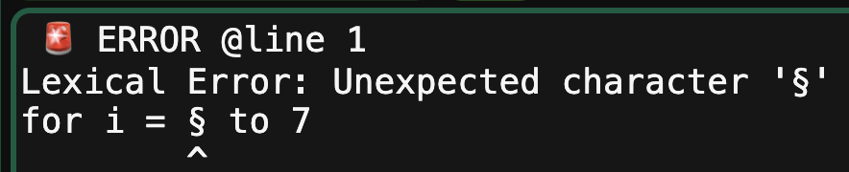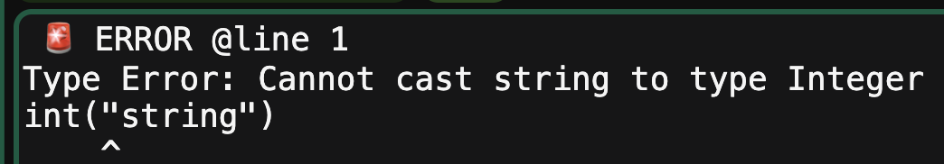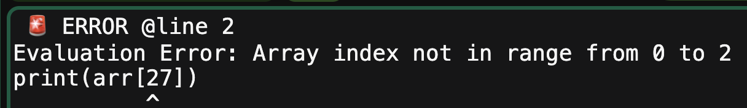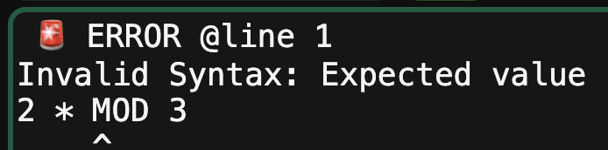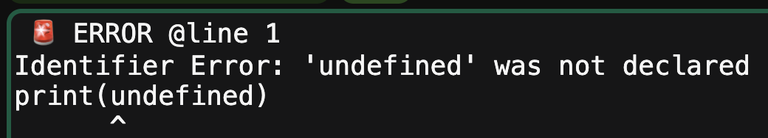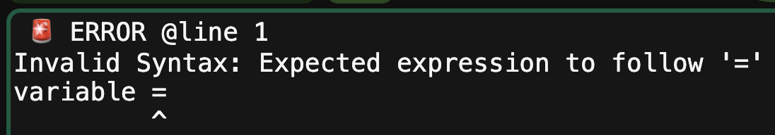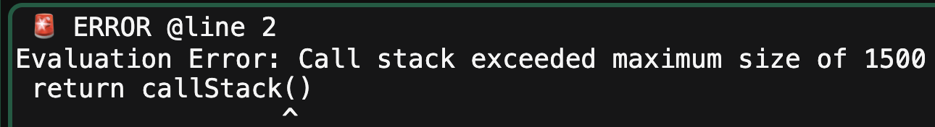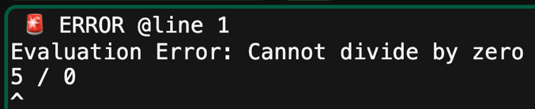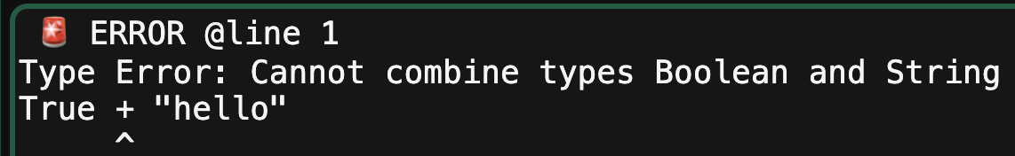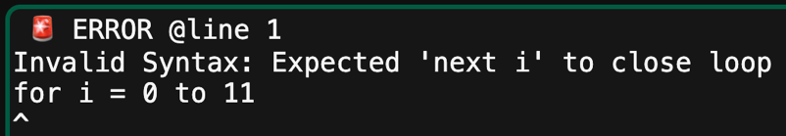I have largely demonstrated these throughout the program, so will not show a huge number of examples here but will display a few examples of the types of messages that are displayed.

Again, this is just a small sample of the many but it shows the range of different errors, and overall I am pretty sure that all of the different cases have been excluded.

### targeted errors

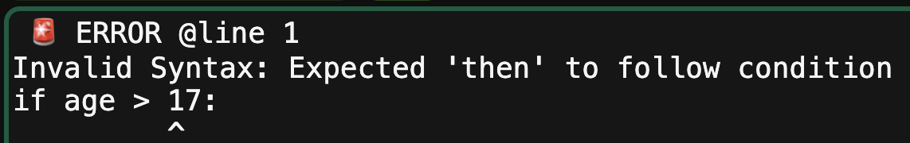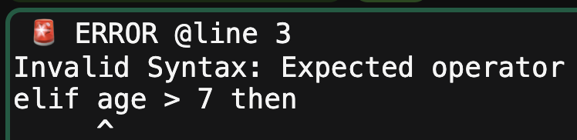Although I am vastly happy with the error handling there are a few cases I feel that could be improved.

Even though these errors are still caught, the messages themselves could be more descriptive. This is especially because they are likely to be very common errors that are made and they share the same generic error message for any of that type instead of being more specific.

However overall, the system is extremely robust, and I do not think that there are any cases that would cause the website to crash at any points because I have been very cautious to check every single case using a lot of white box testing throughout the entire program. These targeted errors are moreso something to think of moving forwards, but I am still happy with errors.

# usability: stakeholders

## A piece of paper with writing on it Description automatically generatedtanish arjaria

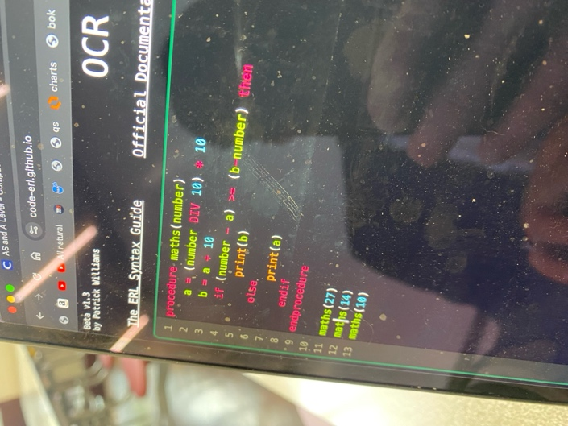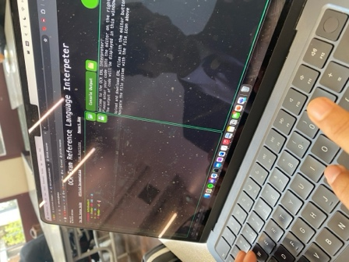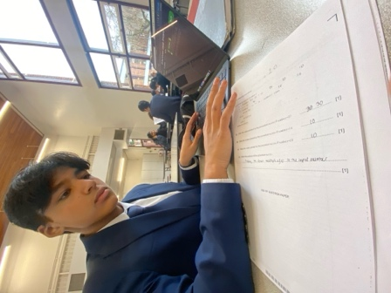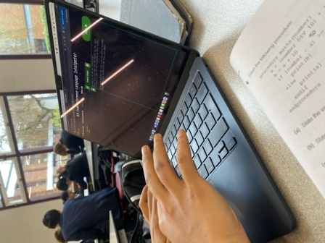Tanish had been set a computer science practice paper for his homework, so I let him use the interpreter to check one of his answers to an ERL question. This was an A-level paper; however, it uses the same syntax as the GCSE ERL so is a good example.

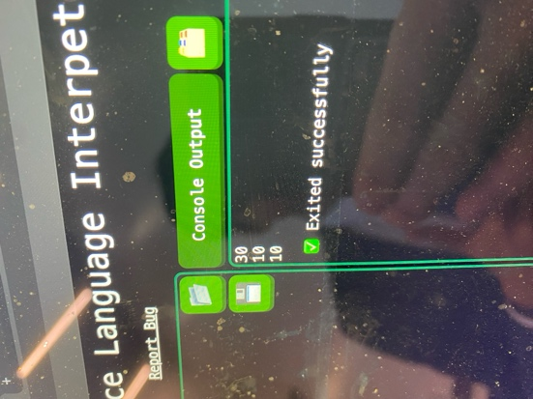  
When he had fully written out the procedure, including the test cases that were explained in the question, the outputs matched the answers he wrote, helping him to check the question.

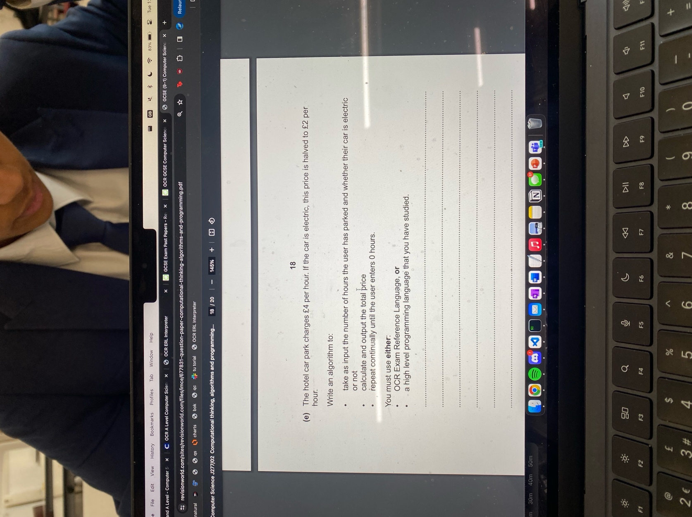This is just a small example of how helpful the interpreter can be when working. In this case, Tanish had already done the question and just used it to check his work, but if a potentially less-able student was confused on a question, they could use the interpreter to try different test cases, to help them figure out the purpose of the procedure, like question 4d) asks for.

To note, Tanish found the main controls of the program very instinctive: he instantly jumped to the input window to enter his code and was able to run it without being confused about where he should be pressing or entering different buttons.

### A person typing on a computer Description automatically generatedA person in a suit using a computer Description automatically generatedinputs with programming

Now, I gave Tanish a new problem, to see how he could solve a question from scratch, which will use inputs so that he can check if his program is correct.

This will test how intuitive the input system is, which will help evaluate the usability, but first Tanish coded the problem in the ERL, which was a GCSE past paper question, so he managed to do easily.

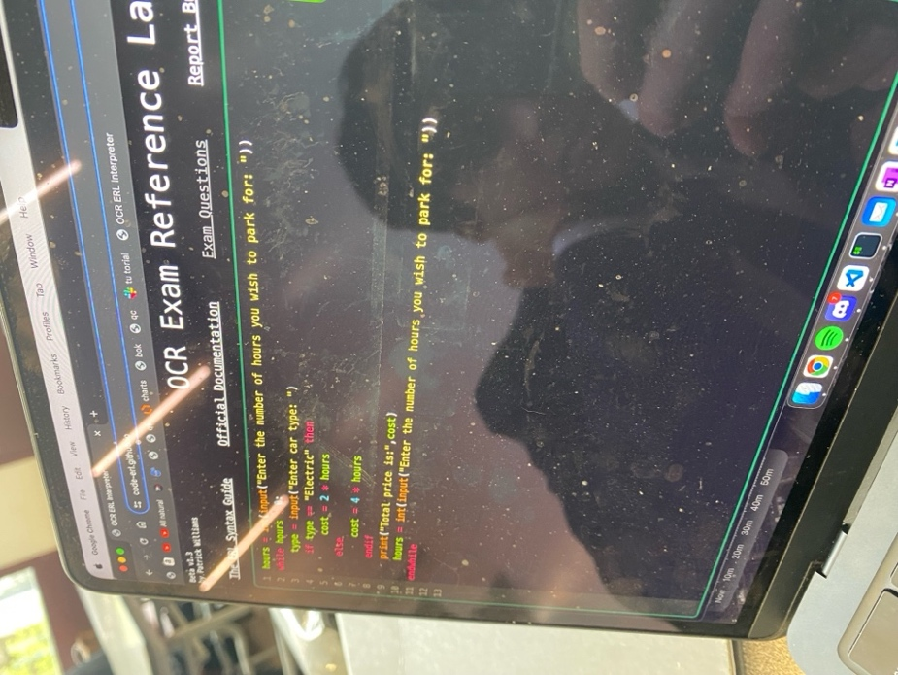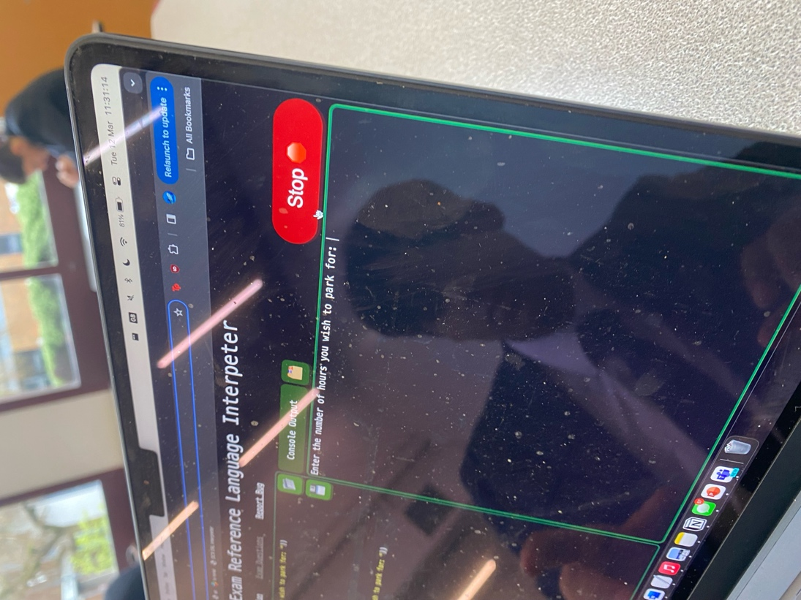Then he pressed run, which triggered the program to enter the input as shown:

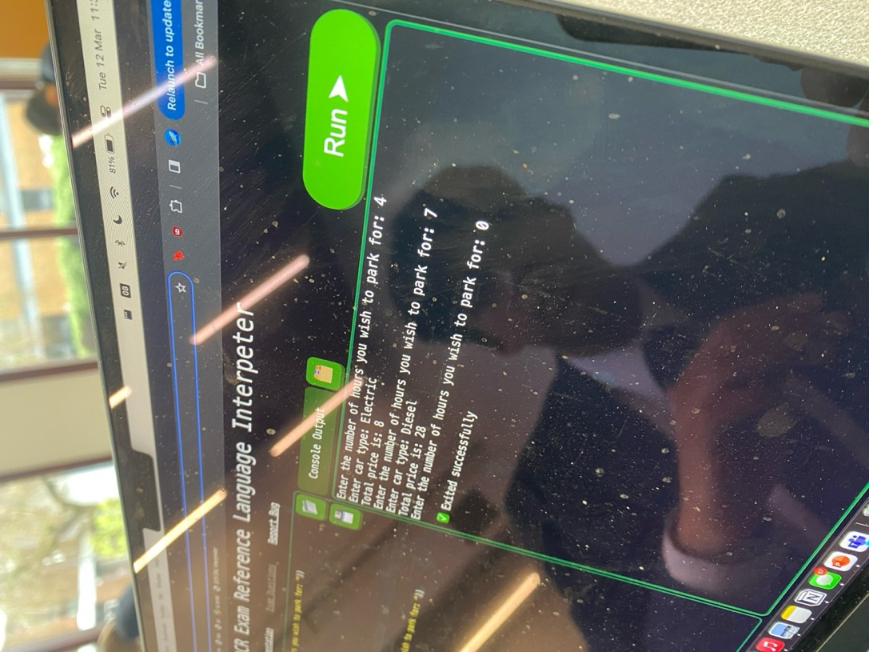

From here, Tanish immediately knew how to input his value, because I made it like how most programming languages take inputs, with the text being entered directly after the prompt.

This allowed him to check that his code worked, as it gave the corresponding prices and halted when 0 was entered.

Therefore, this proves that the Interpreter can be useful when answering exam-style questions, as the testing provided instant feedback to the issue, and that the input system is very intuitive, and should be instantly recognisable for most programmers with experience.

### A computer screen with white text and green letters Description automatically generatedfile handling

The last thing I’d like to test with Tanish is the file handling system, as that is a large part of the interface.

I told him to create a file with some test data, called “names.txt”, and to fill it with some test data.

His first instinct was to click the upload ERL file button, which opened the wrong menu, and instead he should have clicked the button above the output window. This is an issue and means that some of my icons are not very intuitive, so I could have potentially had better labelling to make it easier to understand.

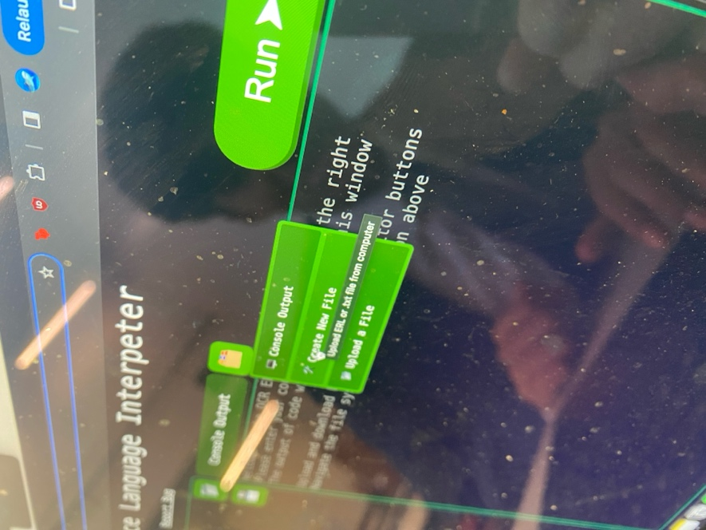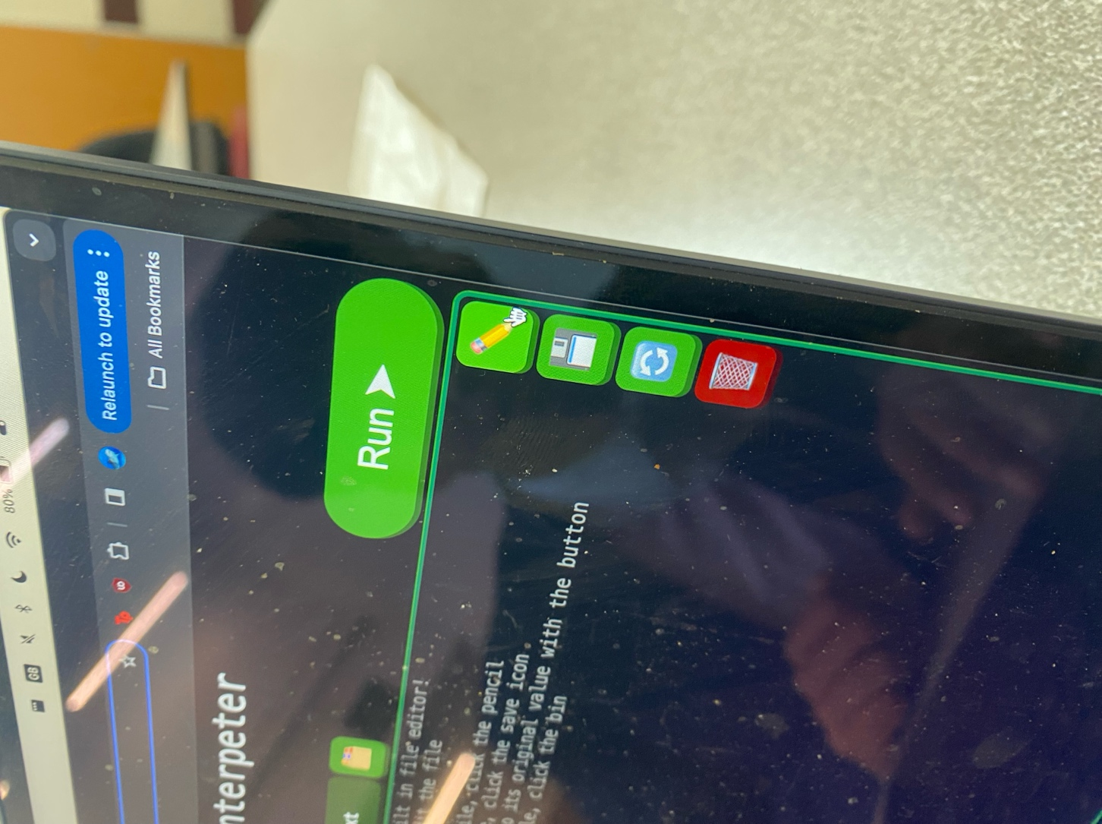After realising he was in the wrong menu, he read the information text in the output window, and immediately navigated to the correct place, making a new file easily.

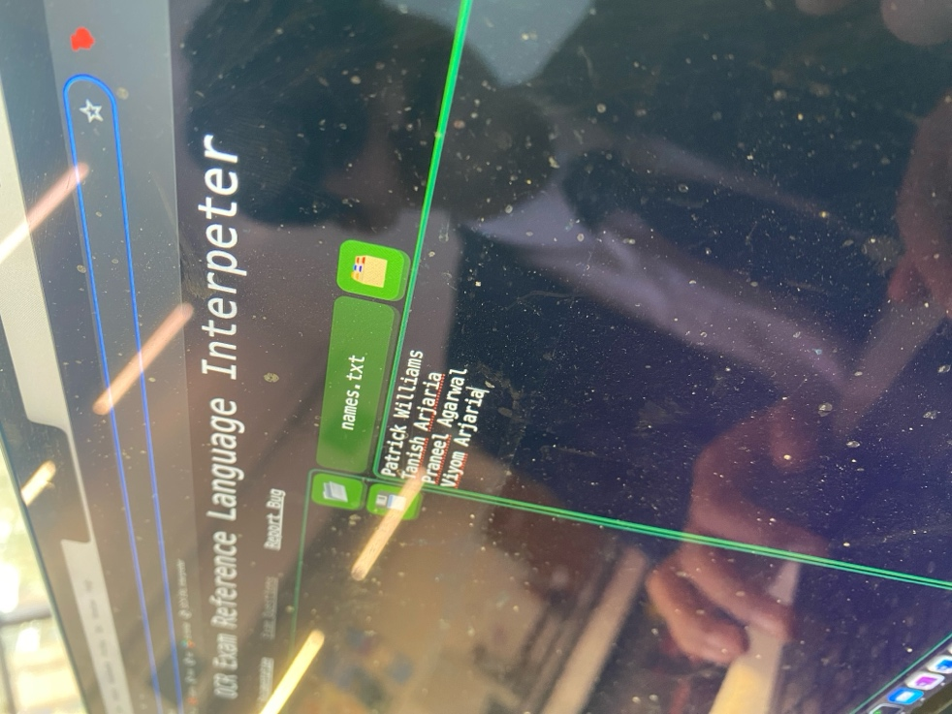He then immediately went to the correct rename button, so the pencil icon was very logical, where he then entered the name into the alert window, an input that was obvious but I don’t love because it is not as clean as the rest of the interface, such as inputs.

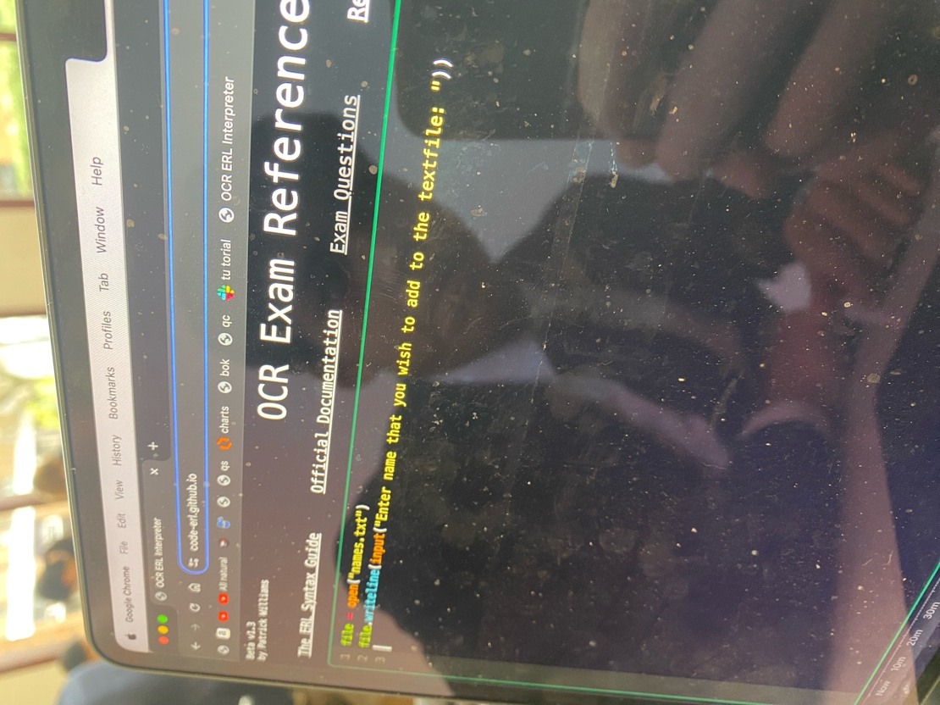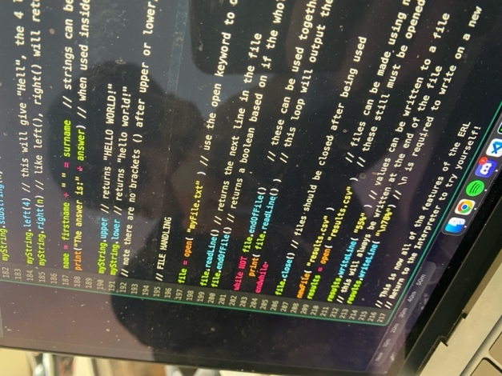After filling in his test data, I told him to write a test case, and he was not exactly sure of the syntax for how to write something to a file in the ERL. He thought it was file.write(), but he checked the syntax guide and realised that it was writeLine(), showing that the accessible ERL guide can be very useful.

After reading about this change, he modified his code to be the very simple example shown on the left.

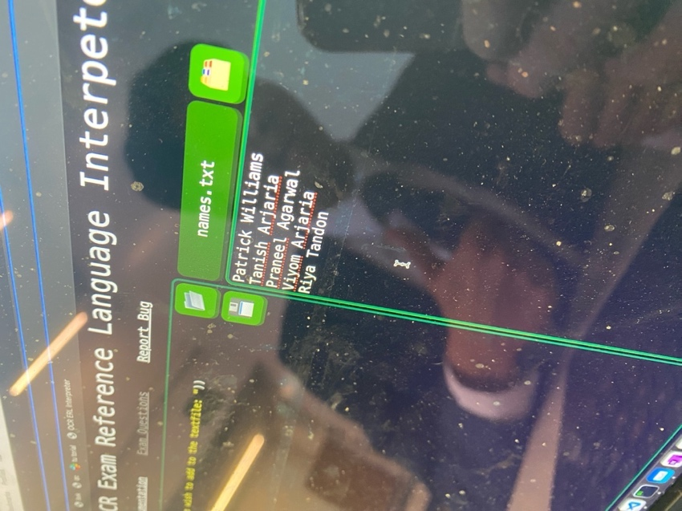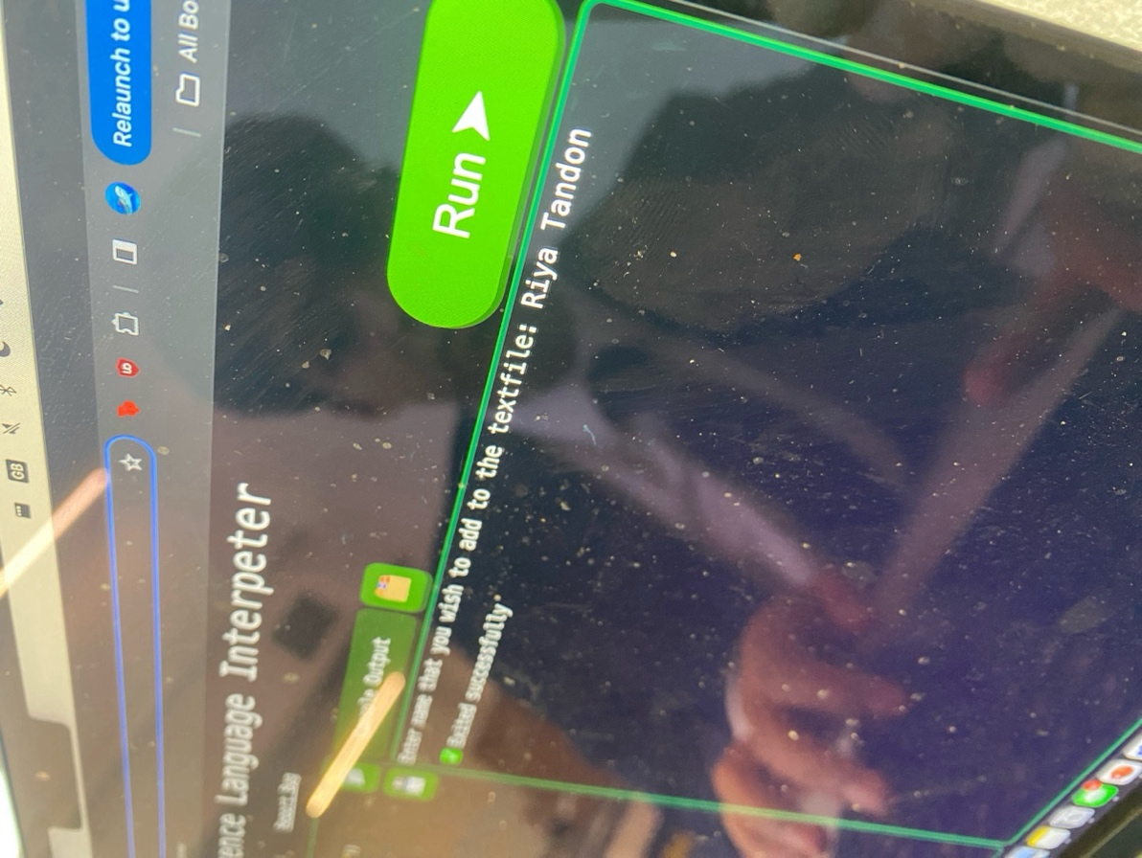After then writing the correct code and entering the input, Tanish correctly navigated back to the file, and the file was correctly updated, which shows how intuitive file handling is for the program.

These are all the cases I wanted Tanish to try for the program, and I think it shows how the interface.

### feedback

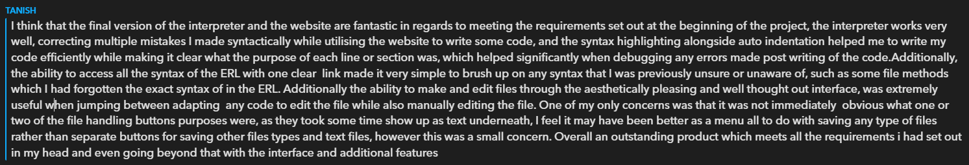When asking Tanish for some overall feedback, he replied with:

This aligns with my observations of how he interacted with the interface, with the issues being with some button labelling. I think what he means by “took some time to show up as text underneath” was the descriptive hovering text that appears under the buttons took a while to appear when hovering, which is more of an issue with the web browser than my code specifically because it was just a HTML addition.

But he does point out that there are some downsides of using icons, especially with ones that have very similar functions, so some additional text may be useful. However though, I feel like his feedback is very positive, so overall the user experience seems very positive.

## abigail williams

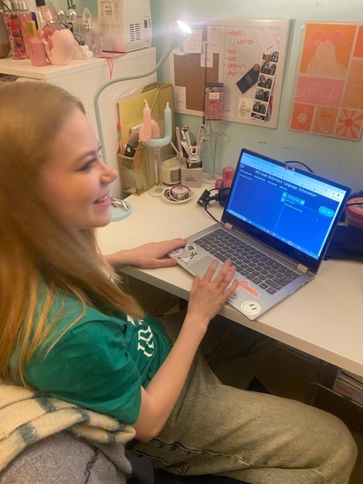Now, for the main test: the new learner. I have not had much interaction with Abigail Williams, who was my main end user in the program, because there was only code to provide feedback on.

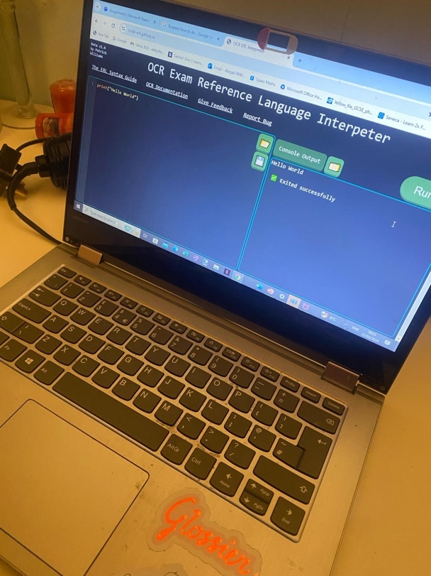She is my example of a completely new student, as she had only had little experience with programming as a whole – knowing just a bit of Python – let alone knowing anything about ERL.

Her first instinct was doing a hello world output, without any prompt from me.

This again immediately proves how intuitive the user interface is: immediately being recognisable as a code editor that can be run.

### square number task

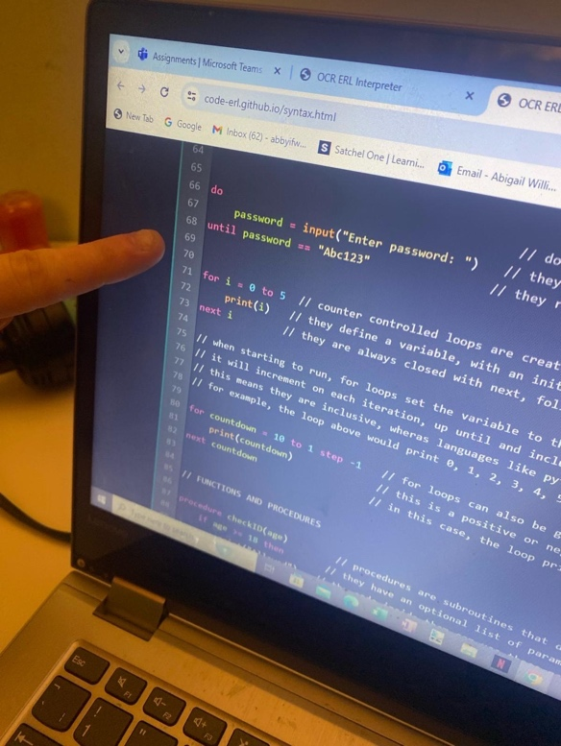Her first task was to print out the first 11 square numbers.

She knew that she needed to use a for loop, because that was what she had used before in python, so she used the guide button in the top left and found the keyword for.

This proved very useful as to an absolute beginner it provided some very useful information. However, it did take her a while to find this, so maybe some better organisation is needed.

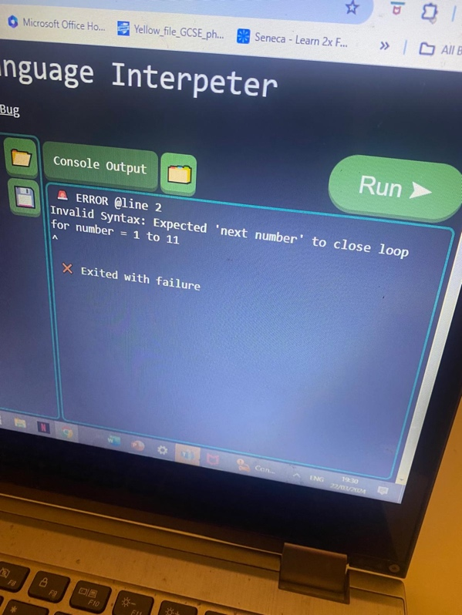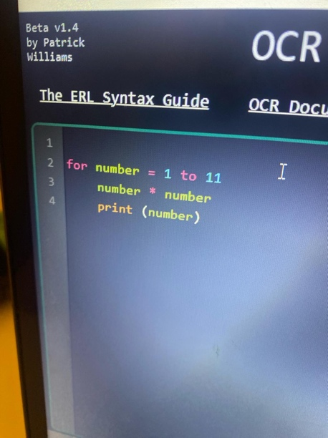Her initial program was as shown, and as you can see there was a main issue with the structure of the loops, which the error message perfectly outlined.

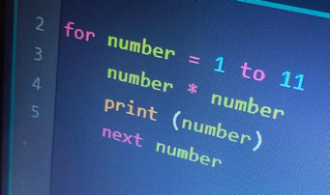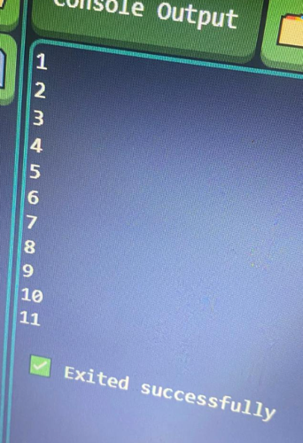She then fixed her code with the suggestion it made (even if the indentation was slightly broken) and then ran her code.

The far left shows the output, and she was immediately aware that she had made an error with her code.

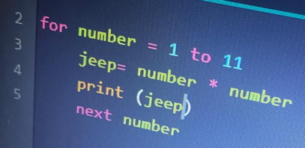This is why having the interpreter is so useful because it helps to identify any logical errors quickly, and she started changing her code because of this wrong output.

Her final code is now shown on the left, and she introduced an additional variable to store the square number before printing it. The program then outputted the correct output, so her program worked.

### inputs

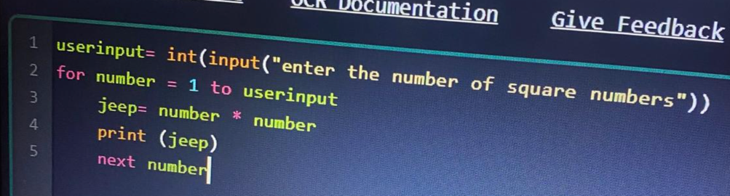I told her to modify her code so the user inputted the number of square numbers to output, and she immediately did so.

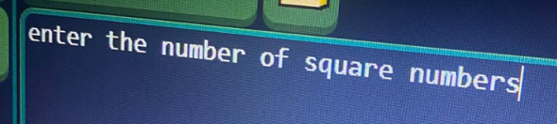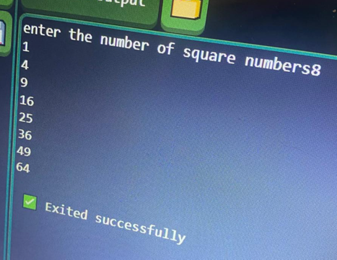This is because the syntax is identical to python, but she incorporated it perfectly.

When running the code, she again intuitively knew where her input had to go without hesitation.

This is because it was designed to be identical to other IDEs, such as the python shell, so It was very recognisable to her.

Therefore, the main parts of the interface: code entry, running and inputs are all very intuitive and easy to use features, which I am happy with.

### A hand pointing at a screen Description automatically generatedfile handling

Now for the last component of the interface: file handling.

This was something Abigail had not even done in Python before, but she read through the guide to get some information. Again, this took a while to find because it was right at the bottom, so some better organisation might be needed to make this easier.

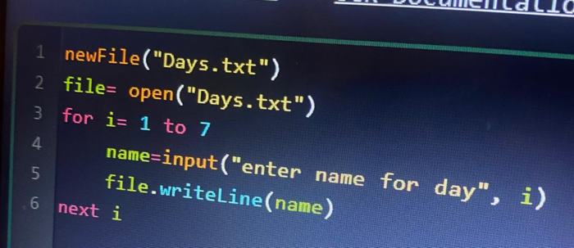I tasked her to make a file called Days.txt, and to make a program that would take in 7 user inputs and write these to the files.

The code she came up with on the left was very good.

She did require a little bit of assistance for the newFile creation; however the whole loop and input system was all her own work.

She then tried to execute the file.

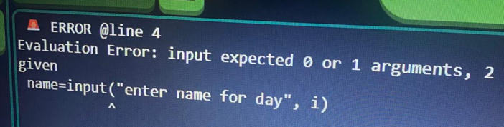Initially her program did crash, and it says it was because input() expected a single argument.

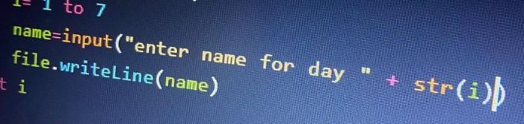I still feel that this is the correct response, however the error message was very confusing for Abigail, who had not yet learnt what an argument was in school.

Therefore, I had to help fix her code for her: not ideal as she had the correct idea but it was just a very small issue.

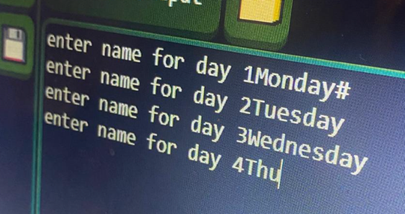In this instance, the error message probably isn’t very useful but I do not feel like this is an error message I could improve massively. Hopefully if this was a real scenario, Abigail could ask a teacher for help, who would be able to solve their solution.

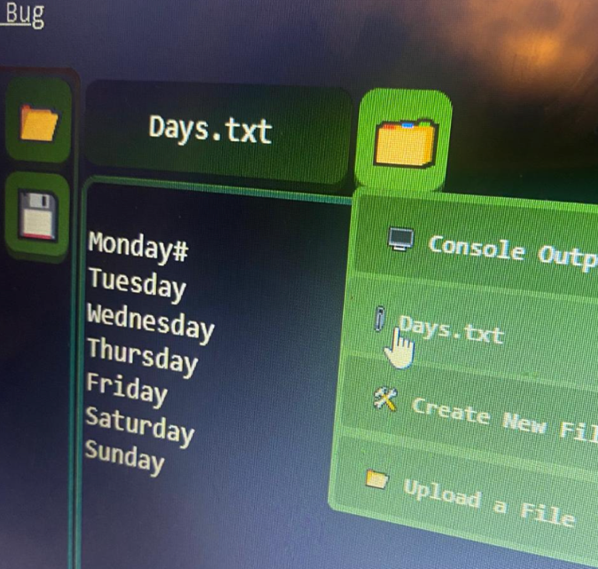After pressing run, she again could correctly input all the values.

After it had concluded and I told her to open the file, she did not know where she was meant to go to find it.

After telling her to hover on the folder icon, she then clicked on the correct file and could see that the changes had been correctly updated in her file.

Again though, the confusion over where to navigate was also a problem with Tanish, so is a flaw in my user interface as it is confusing for all types of students.

Overall though, I feel that this was very positive. File management is not a core part of the language, and the core features, as I have already discussed, are very intuitive.

When I asked her for feedback, she said that:  
*“I feel like I should use it more because I don’t know a lot of the different ways you should write things very well like the different ways to write the loops. So, I think it is important that I start getting used to it so the website would be useful for me revising in the future. I think for the file bits they need to be labelled more clearly and there’s a lot of buttons that I don’t know what they do.”*

## stakeholder conclusions

Overall, I think that the stakeholder opinions have been very positive. The core features of the Interpreter are extremely clear, so the vast majority of ERL code can be executed - taking inputs and correctly processing the code. Tanish especially appreciated the syntax highlighting and indentation, but I feel like this would make it easier for all students to use.

I also think the file system, excluding the button that needs to be hovered on is also very clear: both students could easily open and operate files once in the menu, but this presents the main issue.

A lot of the icons seem to be a bit ambiguous. At first, I did this to reduce the clutter on the interface, however both students have experienced confusion as to what the different icons do, so the system needs some sort of redesign as to what exactly they do.

I did still include some explanation in the program as to their purpose, so I still feel like it is usable, especially when the student learns what they do as it becomes easy to operate, however any first-time users experience confusion, as shown with these two. But overall, I am very happy with the usability, as they both managed to successfully execute some code and use the Interpreter to help them.

# A group of people sitting at a desk with computers Description automatically generatedusability: gcse class feedback

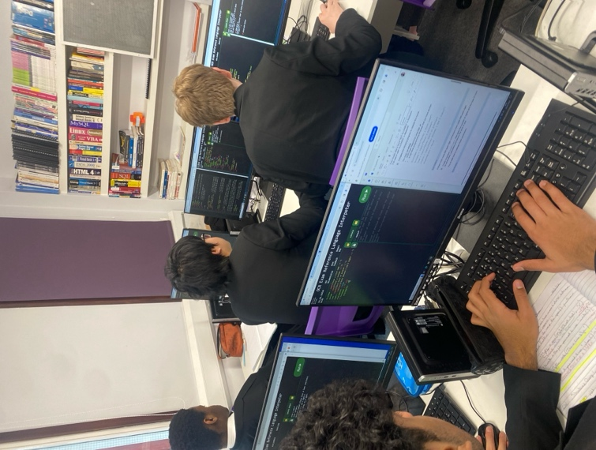For some final feedback, I got a year 10 class at my school to use the Interpreter in one of their lessons.

They will be sitting their computing GCSE next year, so are target users for the program.

For the lesson, I provided them with a set of coding questions taken from past papers and tasked them to try and code them all in ERL, using the program to help them learn it.

## A computer screen with text on it Description automatically generatedthe lesson

When I started the lesson, a lot of the students did not know what ERL was by name, but after explaining the premise of it they were somewhat familiar with the features but were not comfortable.

When starting up the tasks, there was definitely a lot of confusion with python, and lots of small details with the syntax were being missed out because of their differences, primarily:

🡺 Using colons after if statements and loops.  
🡺 Not using closing keywords like “endif” and “endwhile”.  
🡺 Incorrect keyword usage, like “elif” and “or”.  
🡺 Using python’s [] syntax to slice strings.  
🡺 Using non-existent methods, such as range() for loops.

However, when they discovered the syntax guide in the top left-hand corner it became very widely used, which surprised me because it was one of my less important features.

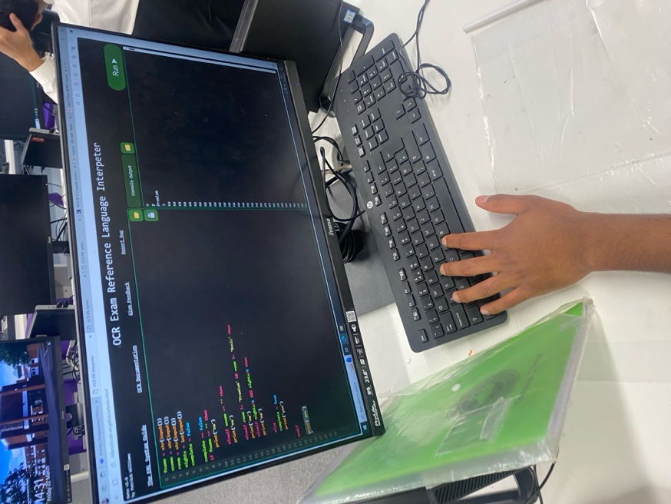However, I think it ended up becoming the most important aspect of the project, as it allowed students to look up the new syntax and then easily adapt their ideas into this new format. This easily allowed students to learn these changes, and as soon as they realised what was different, they became a lot more consistent with the language, and began passing through the questions a lot faster.

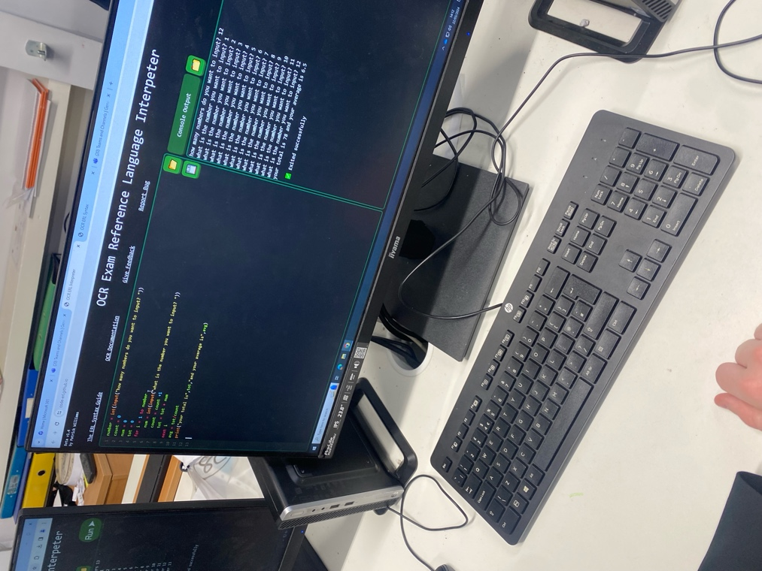The program was also very useful for helping solve any logical errors. The example on the left is not clear, but the student’s program ended up printing a huge number of inputs because it was stuck in an infinite loop, which they may not have realised until they used the program.

They were then able to fix this issue, and afterwards their code works, showing how useful the program can be.

The other main benefit is having inputs work with the system, so as shown on the left, students could easily test their programs with actual data, which lead to a lot of debugging code, which may have otherwise been left in the original, incorrect state.

I have got some more photos on the next page.

### A screen shot of a computer Description automatically generatedissues

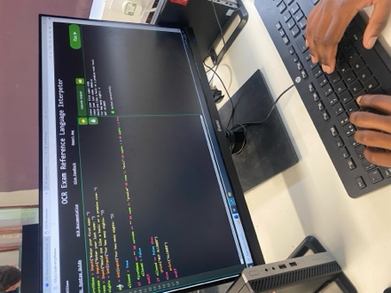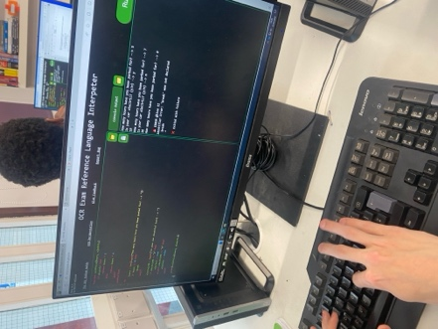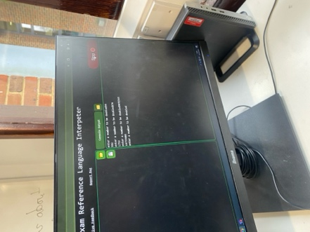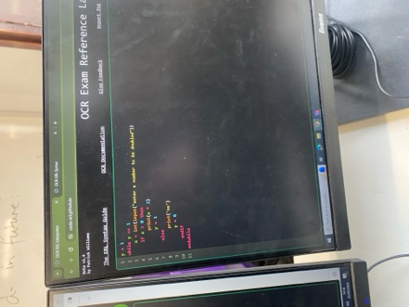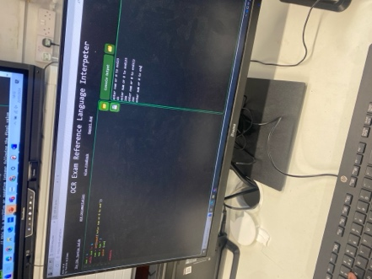

Because this was a beta test, I was expecting some issues, and some errors did arise.

Firstly, the program returned an error when an underscore was being used within a variable name. This was an oversight on my side, but would be an extremely easy change to make, just changing the letters array in the Lexer to include the underscore. Therefore, this could easily be rolled out in any patch change.

The second issue was with comparisons. I deliberately ensured that comparisons of different types would return errors, because I thought that having a greater than comparison between two different types would make no sense at all, and therefore returning an error in that case would be most logical.

However, one student was trying to use != on two different types and an error was still returned. In this case, I agree with the student, as I feel that == and != should be able to be used on different types, because it does not matter that they have no relative value, and it is just checking if they are equal or not.

This should also be a relatively easy change, just changing the types that are permitted in the ComparisonOperator class based on the tag property and could also be easily updated in the future.

### usability

I experienced no issues with the interface, as most issues were with confusion to do with the language. This shows how intuitive the system is, and immediately all students could recognise where they had to type their code, and could easily run it, recognise the outputs, and take many inputs.

I am very happy with this, as I made quite a complicated system to make these inputs extremely like all the other IDEs, and it has paid off because I had no issues regarding how to use the core features.

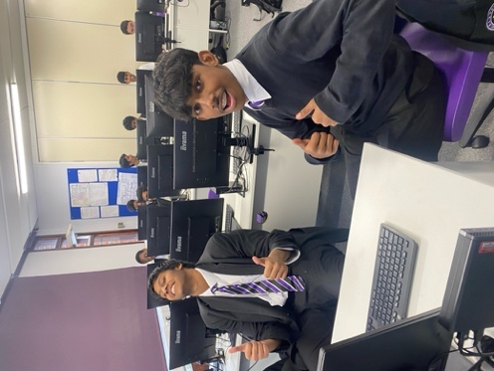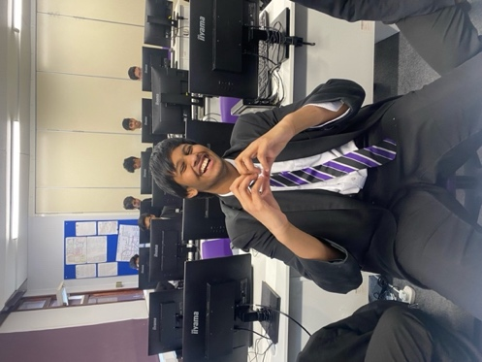This shows the overall usability is very high, although no students used any of the file handling features or more intricate features like uploading and downloading files.

The main thing that impressed me was the usage of the guide. I added this as just a small feature to hopefully help but it was significantly used by almost all of the students: often being split-screened with their actual code because of how unfamiliar they were.

Therefore, I feel like upgrading this syntax guide would probably be useful. They all managed to find the features and still utilised it a lot, but some additional clarification and categorisation with this guide would increase the usage in the future.

## feedback

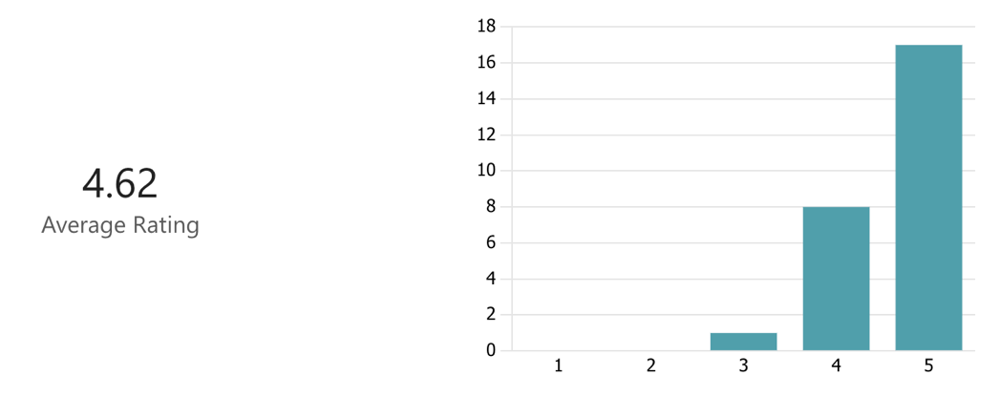At the end of the lesson, I got them to fill out a small form for some feedback.

The first question was just an overall rating, which turned out very positively as seen with the results.

Then I asked them how strongly they agreed with a set of statements surrounding the Interpreter.

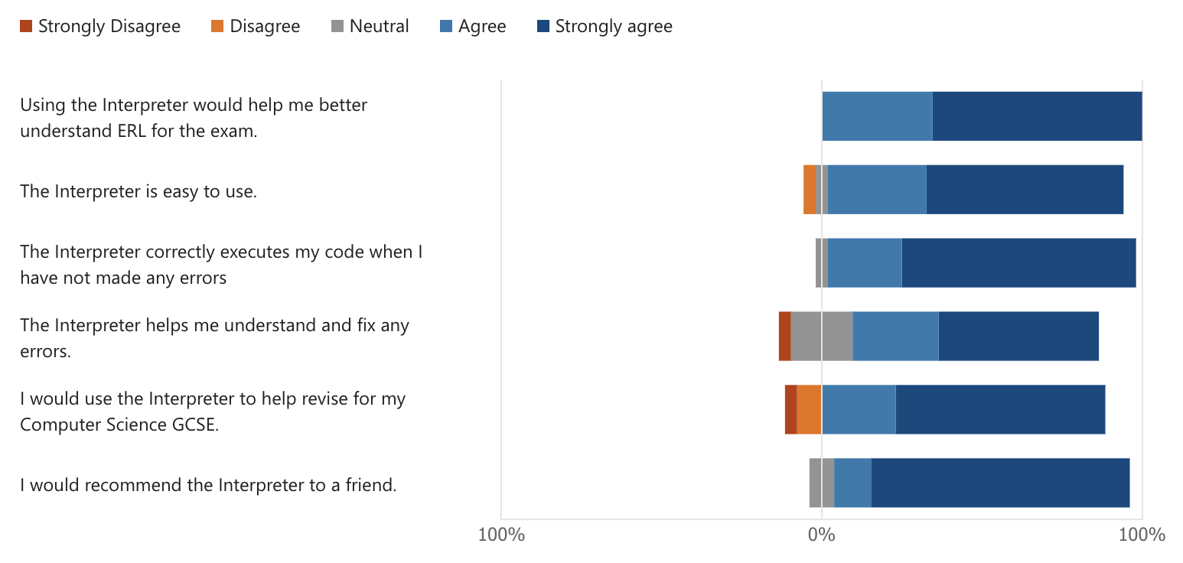These were just some statements I thought should hopefully cover the different aspects of the program to get their overall general opinion of the project.

Overall, I also am very happy with these results. The feedback for the quality of errors and if they’d use the Interpreter to revise had slightly worse results.

I feel this is reflective of the class, as some students had some weird and less useful error messages just because of the weird cases they’d inputted. For instance, using a lowercase or instead of OR just gave the error message “expected operator” because the program thought it was a variable, which confused one of the students, so work can still be done.

It is these more targeted error messages I feel could be added to the program. All the generic cases have been added but having more language-specific cases for different things could help with how useful the system is at helping students find their mistakes.

For the revision aspect, all students have different ways of revising so I feel it is realistic that some students would not incorporate it. Even though they may not all use it regularly, the small session today should still have hopefully conveyed the key differences: a lot of the students learnt how for loops are inclusive and how the new substring method differs, which the teacher pointed out was a key point of confusion and was hard to teach in general.

However, the feedback was still overwhelmingly positive so I am very happy with how this session went, and it does seem like the program could be used in a learning setting.

### additional feedback

I also had an option for students to provide some additional feedback with a text window, and all of the different comments that I received are shown below:

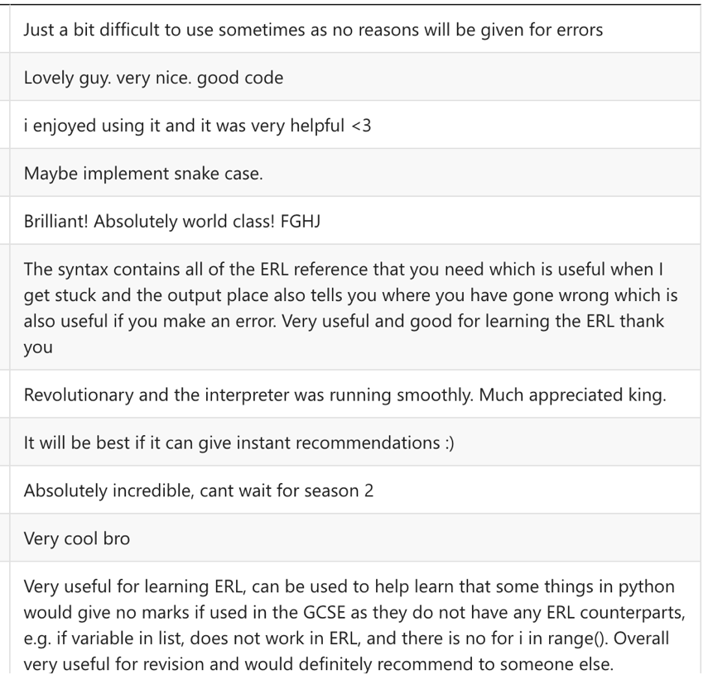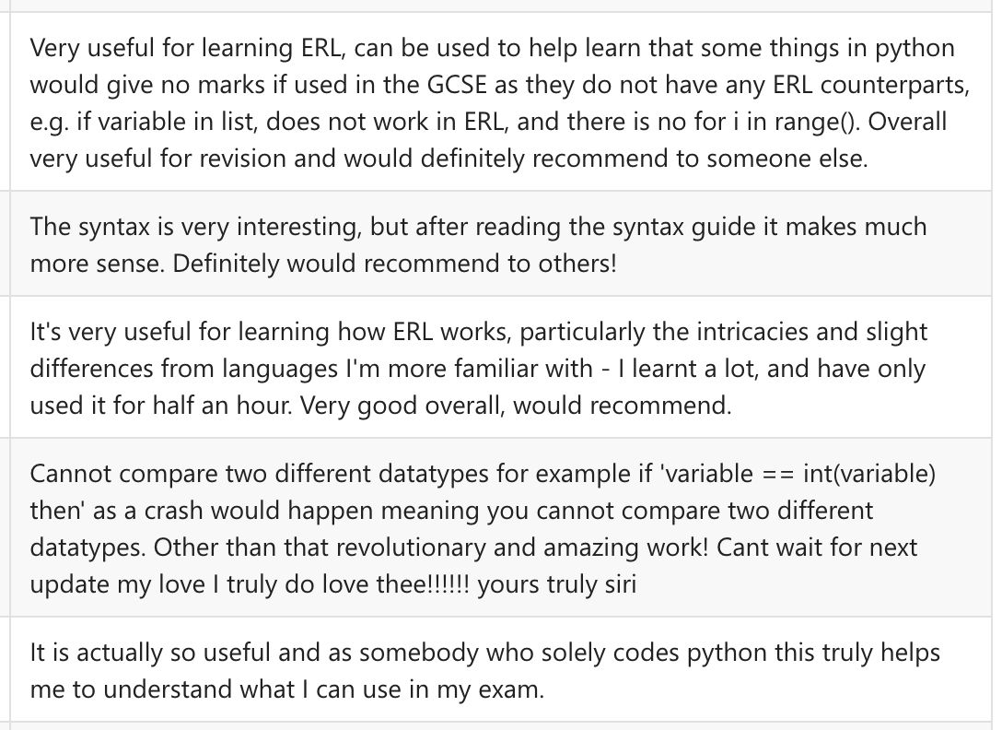Ignoring some of the more jokey responses, there is a lot of genuine feedback in there. This includes the two errors that I discussed earlier but also how some of them did learn a lot from using it and now should feel a lot more confident when seeing the code in their exams.

evALUATION

# success criteria

Overall, the test cases for all the ERL modules, 1 to 11, were complertely successful, which I proved when doing all the test cases in the testing section. Because my success criteria are just descriptions of how the ERL should be executed, these therefore all met the criteria, so the success criteria for the ERL have been completely met, with all my test cases working as expected.

Now, I am going to analyse the module 12 success criteria for the interface. These do not have subjective tests, like the previous, so I am going to try and prove that the criteria has been met, using the knowledge from my stakeholder’s testing to help with this.

|  |  |  |
| --- | --- | --- |
| No. | Criteria | Proof and Success? |
| 12.1 | Have an input and an output window, for which ERL can be entered, and then the result is displayed in the output window whenever a run button is pressed. | Two, clear distinct windows, with an obvious run button in the corner, making it easy and obvious to use the core features of the program, so therefore I feel that this segment is successful. |
| 12.2 | Allow for user inputs to be taken directly from the output window, like a console interface, and allowing the user to properly interact with the program | Allows text to be written into the text field but does not allow the cursor to move outside of the input area in the window, and none of the outputted text can be deleted, only the entered text.  This simulates how IDEs take inputs, so therefore this is successful. |
| 12.3 | Allowing for ERL files to be uploaded from the local computer, and put into the input window, and also downloaded, where the current contents of the input window will be saved into a file | Has the two buttons in the top right of the editor window, which will correctly function, with the folder opening the local file system, where a text or erlcode file can be opened, and the save button downloading an erlcode file with the input’s current contents.  This was shown in the video demo and works correctly so I count it as a success. There may be some issues with the icon, as it confused Tanish, my stakeholder, however when he learnt the interface it was fine so I think this criteria was successful. |
| 12.4 | Allow files to be uploaded from the local computer, as well as modified in the interface, so that the user can use the file handling in the ERL and see the results. | The interface for the files is very clear, with labelled buttons, with the only slight issue being the main icon.  This makes it very easy for the user to navigate between files, as well as to create and upload their own files, and write directly into them.  Additionally, the 4 tools that appear on the right-hand side add additional functionality to the original criteria, and renaming, downloading, resetting, and deleting files directly in the user interface makes it very easy to use files with the project.  Overall, I think that this criteria is a success. |
| 12.5 | Allow for basic highlighting of different keywords in the input window, as well as different colours for strings, numbers, Booleans, methods and each type of token that the language contains. | Above are some examples of this, and it makes it a lot clearer to distinguish the different keywords. Additionally, I also implemented auto-indentation based off the different keywords, which makes the code written a lot more readable.  Therefore, I feel that this section is definitely a success. |
| 12.6 | A resource containing a clear description of the ERL is available, with details on the syntax to be used by students, as a more friendly alternative to the badly organised and confusing specification. | I have a 216-line guide to the ERL, available from a link on the main page of the interpreter. This goes through every bit of syntax, explaining how to use it and is a much more logical order, and was used loads by my GCSE class and I ended up as more important than I first considered.  This is also a success, and a small extract is shown above. |
| 12.7 | A resource containing exam questions and solutions is available, so that a student can use it to help practice questions for an exam if they are using ERL in a revision setting rather than inside of lessons | I did not manage to implement this criteria, and that was partially due to time constraints. I could have easily implemented a very basic version, just a separate webpage with a bunch of questions and answers attached, however I feel like a more advanced version could be added.  Therefore, I am going to leave this feature for a potential future update of the interpreter and have excluded it from this phase of development. This means that I have failed this criteria, but it was a less important one so is not a major issue, and I feel like I can make a much better product out of it, but I will discuss this |

### my conclusions

In total, out of the 80 criteria, only one of them was a failure, which I am very happy with. Seeing as I was originally tentative that I might not get all the ERL features implemented, I think this is a great result, and therefore the whole project should be a success (79/80).

Likewise, all the feedback from my stakeholders was also generally good, and the session with the year 10 class was also very positive, so therefore I am confident in evaluating it as a success.

# code maintainability

Overall, I am very happy with how maintainable the code is. In a lot of my past projects, my code quality has been very poor, but I make a deliberate effort to improve it in this project, which made the process a lot easier, especially when returning to old code later in the process.

## A screenshot of a computer Description automatically generatedsmall scale maintenance

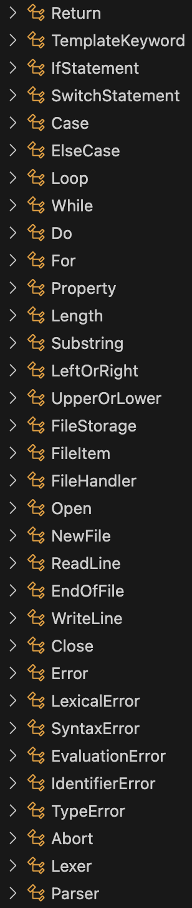The first main example of how the program has been maintained is with the structure and naming of the different classes. This consistent naming allowed me to easily identify and navigate the different classes in the program, as well as the inheritance orders being very logical.

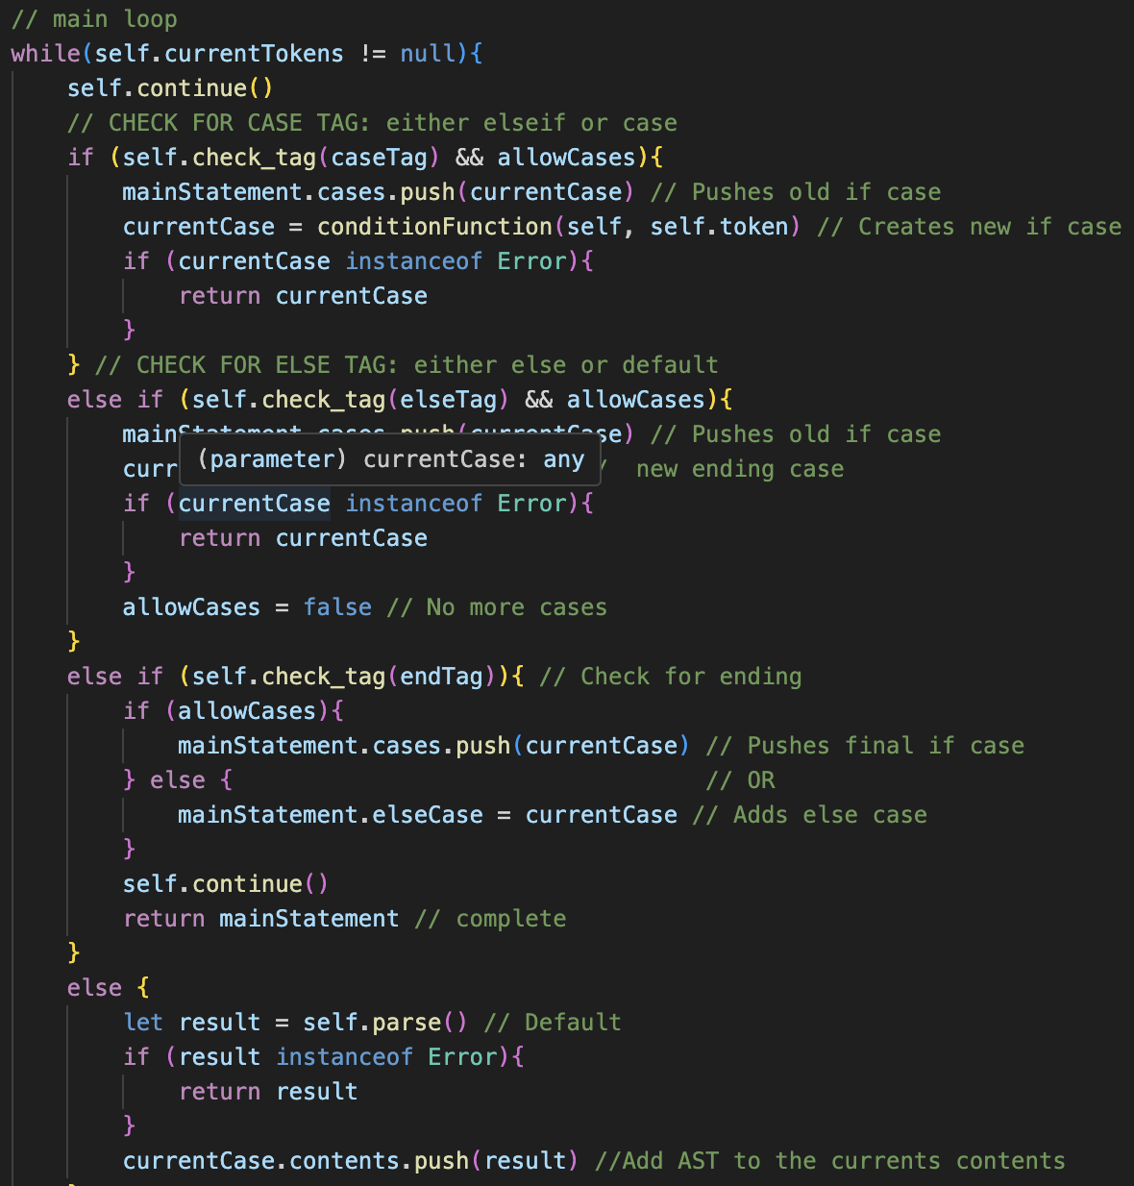 I also made heavy usage of commenting and good variable naming, especially for algorithms that were a lot less self-explanatory is nature, such as the method for parsing if and switch statements in the parser.

Because these methods look very complex, the comments easily allowed me to understand how they worked when re-reading the algorithm after a month.

The names of the properties and methods of classes were also made as generalised as possible, as it allowed for everything to be more easily identified.

If I had a main issue with my naming, it would be the use of the keyword “result” which I used 258 times throughout the entire program.

Even though it is a temporary keyword, used to store intermediate results and values, I still like I could sometimes specify slightly more the exact purpose of the variable. This mainly occurred at the start of the project, and later I named variables more descriptively as I often got confused in development as to the purpose of a “result” variable.

The use of result is that it can be used multiple times with different purposes, which I did use at many points to save memory, as a generic variable to hold different bits of data throughout a function, which meant less unique variables had to be created so the performance would increase.

One example of the reusability is in build_for_loop(), where I used result to store the assignment, final value, step value as well as each line of contents in the loop, to check for errors and so on, saving 3 different memory locations needing to be made.

However, in lots of cases, such as for arithmetic and logical parsing, using result is very redundant. Here, result stores the comparison operator that is in the middle of two different expressions, which is very poor naming because result is not used in any other context, and it provides absolutely no insight into what the variable does without having to look at comments, so I feel naming could have been improved.

## larger scale maintenance

Even though I am very happy with the smaller scale maintenance, it is how the program is structured on a larger scale that has made the process very easy to work on and will make it easy to make new additions in the future due to how flexible everything is.

This essentially means that, for any new feature that needs to be added for the syntax of the language, the corresponding code in the Lexer, Parser and the Token’s evaluation code needs to be added, and then it should seamlessly work with the rest of the pre-existing code. This is because the parser works in a top-down way, so as long as the new token or structure is added to the parser in its original place, it will be built into the ast correctly, where evaluate() will be called on it.

The best example of this is before the half-way evaluation, when I needed to add NOT because I didn’t do it in the logic section. However, when adding it, all I had to do was the following:

🡺 Add the corresponding class, extending Token with a single child  
🡺 Add a “NOT” case in make_identifier() to create one of these tokens  
🡺 Add a method in the parser to check for it, and set its child to the comparison parsing method’s result  
🡺 Change the AND and OR parsing methods to call this method instead of the comparison method  
🡺 Set the Not classes evaluate() method to return the opposite boolean of its child’s evaluate() value

Apart from these features, none of the original code had to be changed, as every module is very independent. This was a deliberate choice to avoid dependencies between the different modules, and as long as everything is made in the lexer, weaved correctly into the parser to produce the correct abstract syntax tree, and given a correct evaluate() method, the system should correctly function with the feature.

## negatives

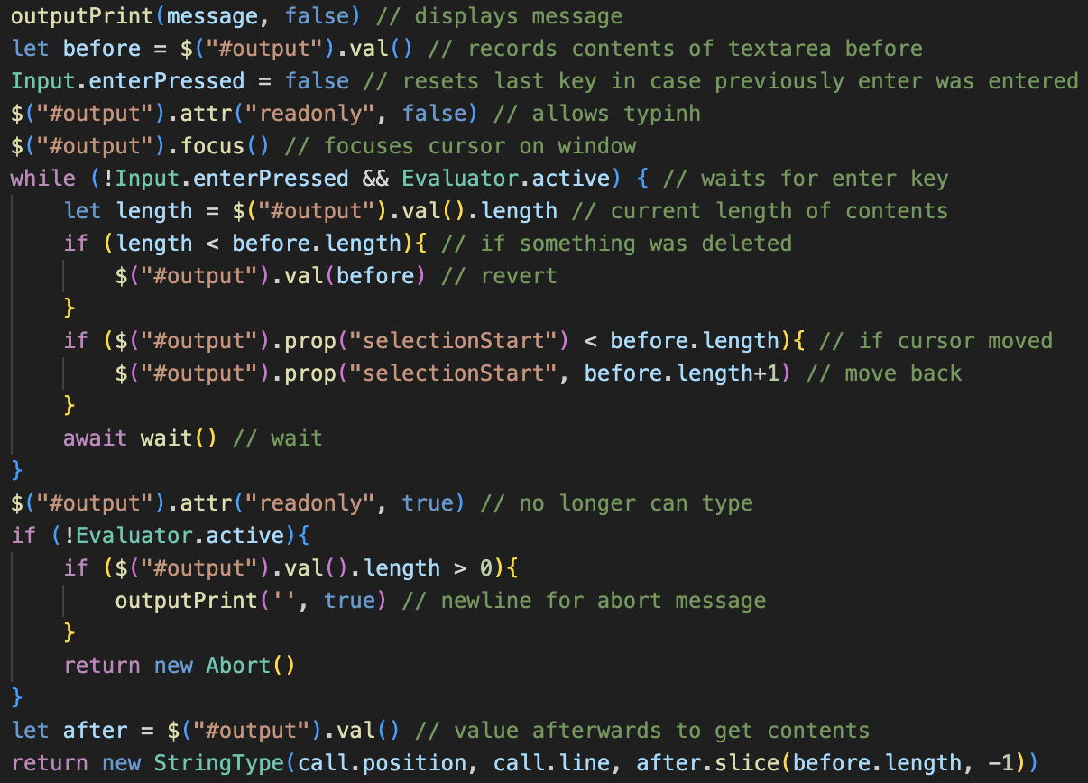At the end of module 11, I was very happy with how maintainable the project was, because everything was very centralised, such as with having a single place to output all errors and printing.

However, when implementing the user interface, I feel the code became slightly messier, with lots of the different interface code scattered across multiple different locations, without many central methods to control outputs, inputs and waiting.

For example, I do not find the code on the right very readable, and despite all the commenting describing the steps that it does, the approach to taking inputs is not a very logical process, and I find the approach to be slightly haphanded.

This is true with some other interface aspects, such as needing to wait for 4ms after each time something is outputted to ensure that it is still properly rendered and will not be delayed. That is mainly because of an issue with JavaScript not rending properly, however it still kind of messed up the program.

Additionally, linking it into the user interface completely meant that the Interpreter no longer works with the console anymore. This largely doesn’t matter; however, it is useful for testing if I were to add additional features in the future, so maybe implementing the interface in a way that could have been toggled between the website and a console would have been useful.

### maintainability conclusions

Overall, if I had to change certain aspects of the program, I would:

🡺 Implement better variable naming in the earlier modules of the program  
🡺 Put more of the interface’s input and output code into separate subroutines

Apart from these I am very happy with how maintainable it is, and I feel that the program will be very easy to expand and continue development with in the future!

# future of the project

For potential future development and expansion of the project, there are two different types of additions I can make: the first being changes to the actual language, but secondly being additional interface and quality of life features which would make the experience better for a user.

## language changes

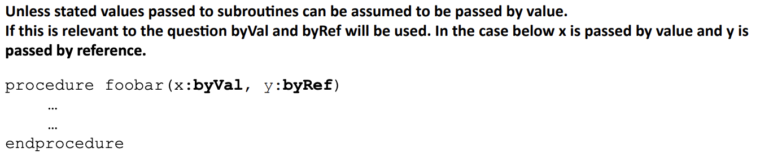The entirety of the GCSE exam reference language has been implemented, so there is no expansion I can make for GCSE students. However, the language used by OCR for the Computer Science A level is a superset of the GCSE Language, so follows the same base syntax but had some additional features which could be implemented.

This includes some small changes, such as allowing arguments to be passed to functions by reference or by value using the colon syntax as shown on the right-hand side.

I feel this would definitely be useful because students who have primarily used python in the past will have no concept of passing by value or by reference, and it frequently comes up in past papers so having used it before in programs should make it a lot easier to understand.

Additional changes to file handling are also made, with unique functions for opening a file depending on if it will be read from or written to.

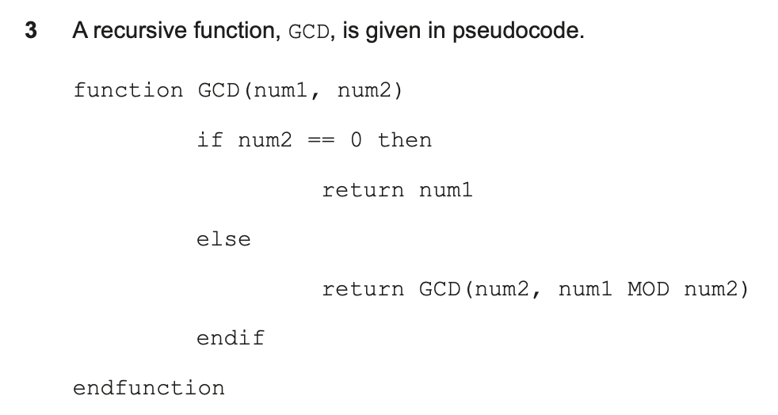Both changes are relatively minor, so should be small changes to implement and would work well with the existing system and allow significantly more students to use the program.

Some kind of toggle would likely be needed to switch between the GCSE mode and A level mode to avoid any confusion. It would still be very useful for A level students, with a past paper question on the right showing how the syntax is the same.

### object oriented programming

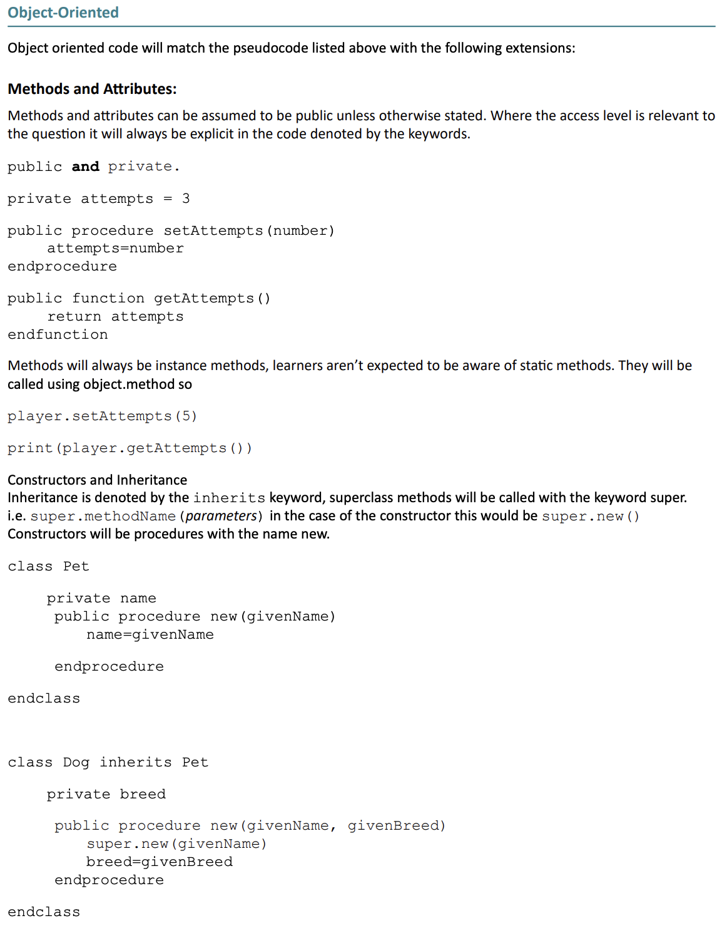The main addition the A-level Exam Reference Language makes is the addition of classes, which then includes public and private methods and attributes, constructor methods and inheritance.

The full list of additions can be seen on the right, as specified in the A-level specification, and it include a lot of features, which would be a massive upgrade to the system.

This large addition would probably more complex than any other module that I have currently incorporated into the language, as previously it was adding functions and this will be significantly more complicated to add.

However, adding these features should be very useful, as most of the work will have already been done for the bulk of the language, and it will vastly increase the number of students who can use and benefit from the language.

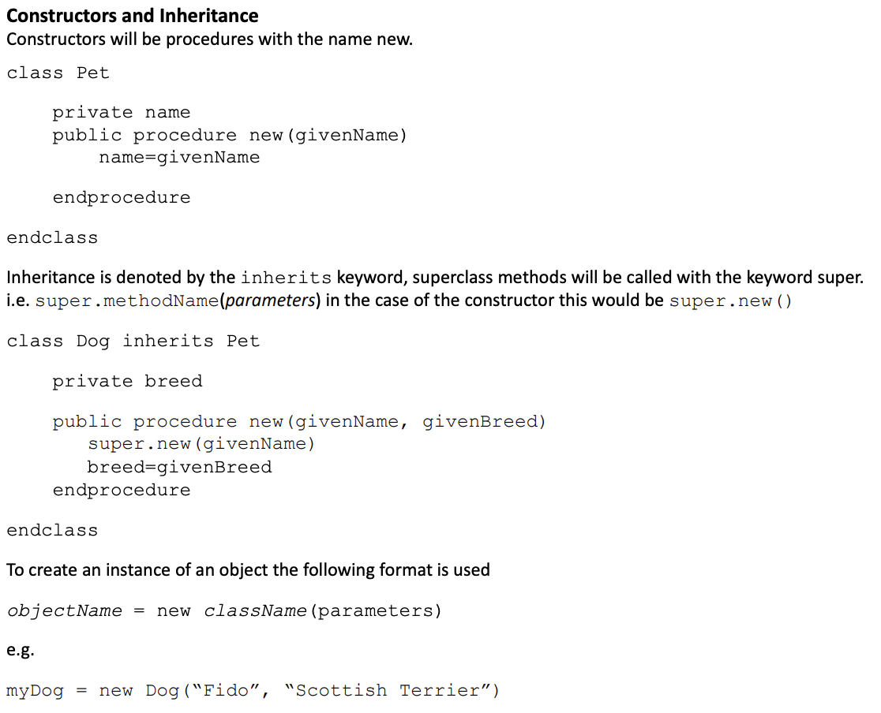Additionally, because the complexity of the algorithms presented for a level students will be significantly more than the GCSE counter parts, the interpreter should be a lot more useful because it can run these much more advanced algorithms which would take even longer to try and run by other means, such as by using a trace table.

More generally, this would also engage a-level students with the basic features as well, such as the formatting of loops and if statements, also making them more familiar with the basics which will still be useful to them when in examinations.

Also at this point, it would be technically possible to code the whole project inside of the language, because adding classes adds the layer of complexity needed to create the interpreter.

Overall, these additions would be very useful, so I could see myself doing this in the future, after my A level is complete.

### error handling

The error handling of the project can always be upgraded, by adding more descriptive messages to make it a lot easier for the user to fix. Currently there are some cases I still need to fix, such as the two small issues that incorrectly returned errors when the GCSE class tested my program.

These changes should be easy to implement and fix, and because I have a bug report form linked on the website, it should collect more issues over time which I could fix.

For the addition of new errors, the targeted errors that I discussed earlier are worth adding in the future, to make the transition from other programming languages (primarily Python) to ERL easier.

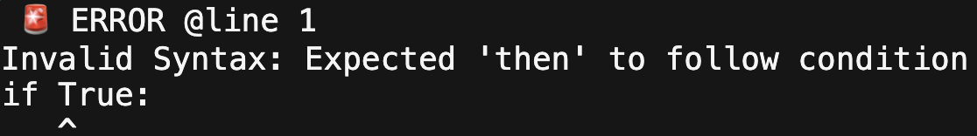For example, the program could specify that syntaxes in different languages are not continued into ERL, such as telling the user that colons are not used after conditions.

This can be expanded for other common misconceptions, mainly from syntaxes from other languages, to make the feedback more useful for any new students. Many students in the GCSE class had lots of issues with carrying across syntax from other languages into the ERL, so just targeting these and being very clear about the exact issues should make the experience better.

## usability features

There are also additional features which could be implemented that would not affect the core purpose of the program but would make it more convenient or easier for students to use.

Primarily, these ideas are the discarded ideas from the Analysis stage, and although they would have been beneficial, they were beyond the scope for this phase of development. However, I could easily see them being added in future updates, as some of them would be very useful.

### trace tables

My favourite potential feature from the analysis stage is adding trace tables to track how the variables’ values change when the program would be run.

Not only would this help with debugging any logical errors in their code, it would also tie in perfectly with the specification. This is because trace tables often come up in questions, usually tied with ERL code with questions asking the student to trace out the values of the variables throughout. This would allow the user to easily check if the trace table they made was correct and would extend the usability of the interpreter.

Therefore, this two-in-one feature would work perfectly, and is a lot more of a student-friendly approach to debugging programs, compared to more complex versions used in actual IDE’s, so I feel like it is a perfect fit for the program and the target audience.

This could just be a button that is kept in the top right-hand corner of the console output for consistency with the rest of the design in the language, which would open up a pop-up menu with the table correctly laid out like it would be in the exam.

### exam questions

This was the success criteria that I failed because I feel like I could implement a much better system in a future update, which I am going to outline now.

I feel I could add an additional button at the top titled exams questions which would open a tab in the console output window with the question laid out, specifying the criteria and the number of marks.

The student should still be able to test their code normally in the output window, but I would like a test feature which the student would press, and the program would automatically try their code, simulating different user inputs and seeing if their program would return the same output.

It can therefore pass or fail the student, like how some of the programming challenges like OUCC and the Perse coding challenge mark their questions. This will provide fast feedback and should make it a lot easier for students to practice their code and be sure they are right.

For this to work, a lot of different questions would have to be created to avoid repeats.

This system has a lot of scope, as they could all be stored on a server, allowing for users to upload questions and test data, and it could be expanded significantly. But with just the basic questions that I create, it should mean that students no longer must navigate different revision websites to find past paper questions, making it a lot easier to just practice.

### updating the guide

The guide was used by both my stakeholders and by lots of students in the GCSE class, which surprised me because I made it more of a smaller, basic additional feature.

Therefore, I could potentially redesign it: separating the different sections into different windows with bigger titles between them, as some students complained that the one big file was difficult to navigate and find the specific section they wanted.

This could also be aided by having a navigation bar down the side of the webpage, with labels so they can easily jump to the section they want. Overall, I think that would make it a lot more useful and would help students learn the syntax of ERL a lot faster, because the guide is actually a very important feature.

### user logins

My final idea links to one of Abigail’s ideas in Analysis, about having accounts for the system. Her idea was having leaderboards and streaks, which I still think are not relevant to the program, but the idea of having accounts could be very useful.

The main use of this would be to store files on the website, so that when you returned to the Interpreter between sessions, you could login and the code and any associated files would be saved.

This could also allow for an easy way to send files to different people: such as to teachers as proof of work. This could be done by different links, which would automatically load the relevant files by storing them on some form of data base which is accessed by the links.

This feature would be implemented long into the future from this point, and the other suggestions would all be of a higher priority, but this could be useful.

# final conclusions

In conclusion, this project has been a very large success, proven by most of the success critieria being implemented and the final product receiving very positive impact.

I also feel like my skills as a programmer have significantly improved over the course of development. If I were to start this process again, I think I would have a much better idea of how to implement the earlier modules. At a lot of points, I had to go back and re-write old sections of code to improve them, because I learn better ways of implementing certain features.

I am very proud of the final product though and think it has turned out very well.

Please visit the website at <https://code-erl.github.io/> if you can!

Source code

# main file (src.js)

// ╔════════════════════════════════════════════════════════╗

// ║ ___ ____ ____ _ ║

// ║ / _ \ / ___| _ \ ___ _ __| | ║

// ║ | | | | | | |_) | / _ \ '__| | ║

// ║ | |_| | |___| _ < | __/ | | | ║

// ║ \___/ \____|_| \_\ \___|_| |_| ║

// ║ ___ _ _ ║

// ║ |_ _|_ __ | |_ ___ _ __ _ __ _ __ ___| |_ ___ _ __ ║

// ║ | || '_ \| __/ _ \ '__| '_ \| '__/ _ \ __/ _ \ '__| ║

// ║ | || | | | || __/ | | |_) | | | __/ || __/ | ║

// ║ |___|_| |_|\__\___|_| | .__/|_| \___|\__\___|_| ║

// ║ |_| ║

// ║ made by Patrick Williams ║

// ║ for his OCR Computer Science NEA ║

// ╚════════════════════════════════════════════════════════╝

//

// main repository: https://github.com/patrickWilliams07/ocr-erl-interpreter

// nea repository: https://github.com/patrickWilliams07/ocr-erl-nea

// website URL: tbd.

////////////////

// SYMBOL TABLE

////////////////

class SymbolTable {

constructor(){

this.table = []

}

async get(token){

for (let item of this.table){ // Checks if in current table

if (item.name == token.name){

return await item.value

}

}

if (this != Evaluator.global){ // If current table isnt global, checks global

for (let item of Evaluator.global.table){

if (item.name == token.name){

return await item.value

}

}

}

return new IdentifierError(token, "was not declared") // Not defined

}

async set(token, newValue){

for (let item of this.table){ // Checks own table onlky

if (item.name == token.name){

return await item.set(token, newValue)

}

}

this.table.push(new Symbol(token)) // If doesn't exist, will create

return await this.table[this.table.length - 1].set(token, newValue)

}

push_native_subroutine(name, subroutine, tag=null){

let symbol = new Symbol(new Identifier(null, null, name, true))

if (tag == null){

symbol.value = new subroutine(null, null)

} else {

symbol.value = new subroutine(null, null, tag)

}

this.table.push(symbol)

}

}

class Symbol {

constructor(token){

this.name = token.name

this.value = null

this.constant = token.constant // Is a constant

this.declared = false // If it is a constant, has it been declared

}

set(token, newValue){

if (token.constant){ // Check if is now a constant

this.constant = true

this.declared = false

}

if (!this.constant){ // Normal variable

this.value = newValue

return null

}

if (this.declared){ // Constant and already defined

return new IdentifierError(token, "is a constant and has already been defined")

}

this.declared = true // Defining a constant

this.value = newValue

return null

}

}

////////////////

// TOKEN

////////////////

class Token {

constructor(position, line){

this.position = position

this.line = line

}

}

////////////////

// ARITHMETIC

////////////////

class BinaryOperator extends Token{

constructor(position, line){

super(position, line)

this.left = null

this.right = null

this.leftValue = null

this.rightValue = null

}

async evaluate(){

let leftValueHolder = await this.left.evaluate()

this.rightValue = await this.right.evaluate()

this.leftValue = leftValueHolder

if (this.contains_type(Error)){

return this.leftValue instanceof Error ? this.leftValue : this.rightValue

}

if (this.contains_type(Return)){

return new EvaluationError((this.leftValue instanceof Return ? this.leftValue : this.rightValue), "Cannot operate on subroutine with no return")

}

return this.calculate()

}

// Ensures the left data type is left argument, and right data type is right argument

strict_type_check(leftType, rightType){

if (this.leftValue instanceof leftType && this.rightValue instanceof rightType){

return true

}

return false

}

// Ensures both left and right are instances of one of the arguments each

loose_type_check(){

let leftDone = false

let rightDone = false

for (let type of arguments){

if (this.leftValue instanceof type){

leftDone = true

}

if (this.rightValue instanceof type){

rightDone = true

}

}

return leftDone && rightDone

}

// Ensures either left or right are instances of one of the arguments

contains_type(){

for (let type of arguments){

if (this.leftValue instanceof type || this.rightValue instanceof type){

return true

}

}

return false

}

}

class Add extends BinaryOperator{

calculate(){

if (this.contains_type(FloatType) && this.loose_type_check(FloatType, IntegerType)){ // Contains at least one float with potential integers

return new FloatType(this.position, this.line, this.get_result()) // Definitely a float return

}

if (this.strict_type_check(IntegerType, IntegerType)){ // Contains two integers

return new IntegerType(this.position, this.line, this.get_result()) // Definitely an integer return for addition

}

if (this.strict_type_check(StringType, StringType)){ // Contains two strings

return new StringType(this.position, this.line, this.get_result()) // Concatenation

} // ERRORS

if (this.leftValue instanceof StringType){ // String + ?

return new TypeError(this, `Cannot concatenate type ${this.rightValue.typeAsString} with String, expected String`)

}

if (this.leftValue instanceof IntegerType || this.leftValue instanceof FloatType){ // Number + ?

return new TypeError(this, `Cannot add type ${this.rightValue.typeAsString} to ${this.leftValue.typeAsString}, expected Integer or Float`)

} // ELSE

return new TypeError(this, `Cannot combine types ${this.leftValue.typeAsString} and ${this.rightValue.typeAsString}`)

}

get_result = () => this.leftValue.value + this.rightValue.value

}

class Minus extends BinaryOperator{

calculate(){

if (this.contains_type(FloatType) && this.loose_type_check(FloatType, IntegerType)){ // Contains at least one float with potential integers

return new FloatType(this.position, this.line, this.get_result()) // Definitely a float return

}

if (this.strict_type_check(IntegerType, IntegerType)){ // Contains two integers

return new IntegerType(this.position, this.line, this.get_result()) // Definitely an integer return for addition

} // ERRORS

return new TypeError(this, `Cannot subtract type ${this.rightValue.typeAsString} from ${this.leftValue.typeAsString}, expected Integers or Floats`)

}

get_result = () => this.leftValue.value - this.rightValue.value

}

class Multiply extends BinaryOperator{

constructor(position, line){

super(position, line)

}

calculate(){

if (this.contains_type(FloatType) && this.loose_type_check(FloatType, IntegerType)){ // Contains at least one float with potential integers

return new FloatType(this.position, this.line, this.get_result()) // Definitely a float return

}

if (this.strict_type_check(IntegerType, IntegerType)){ // Contains two integers

return new IntegerType(this.position, this.line, this.get_result()) // Definitely an integer return for addition

} // ERRORS

return new TypeError(this, `Cannot mutltiply type ${this.leftValue.typeAsString} with ${this.rightValue.typeAsString}, expected Integers or Floats`)

}

get_result = () => this.leftValue.value * this.rightValue.value

}

class Divide extends BinaryOperator{

calculate(){

if (this.rightValue.value === 0){

return new EvaluationError(this.leftValue, "Cannot divide by zero")

}

if (this.contains_type(FloatType) && this.loose_type_check(FloatType, IntegerType)){ // Contains at least one float with potential integers

return new FloatType(this.position, this.line, this.get_result()) // Definitely a float return

}

if (this.strict_type_check(IntegerType, IntegerType)){ // Contains two integers

let result = this.get_result() // Must check as can produce a float result

return String(result).includes('.') ? new FloatType(this.position, this.line, result) : new IntegerType(this.position, this.line, result)

} // ERRORS

return new TypeError(this, `Cannot divide type ${this.rightValue.typeAsString} by ${this.leftValue.typeAsString}, expected Integes or Floats`)

}

get_result = () => this.leftValue.value / this.rightValue.value

}

class Exponent extends BinaryOperator{

calculate(){

if (isNaN(this.get_result())){

return new EvaluationError(this.leftValue, "Cannot raise a negative number to this power")

}

if (this.contains_type(FloatType) && this.loose_type_check(FloatType, IntegerType)){ // Contains at least one float with potential integers

return new FloatType(this.position, this.line, this.get_result()) // Definitely a float return

}

if (this.strict_type_check(IntegerType, IntegerType)){ // Contains two integers

let result = this.get_result() // Must check as can produce a float result

return String(result).includes('.') ? new FloatType(this.position, this.line, result) : new IntegerType(this.position, this.line, result)

} // ERRORS

return new TypeError(this, `Cannot divide type ${this.rightValue.typeAsString} by ${this.leftValue.typeAsString}, expected Integers or Floats`)

}

get_result = () => this.leftValue.value ** this.rightValue.value

}

class Modulus extends BinaryOperator{

calculate(){

if (this.rightValue.value === 0){

return new EvaluationError(this.leftValue, "Cannot take moduluo by zero")

}

if (this.contains_type(FloatType) && this.loose_type_check(FloatType, IntegerType)){ // Contains at least one float with potential integers

return new FloatType(this.position, this.line, this.get_result()) // Definitely a float return

}

if (this.strict_type_check(IntegerType, IntegerType)){ // Contains two integers

return new IntegerType(this.position, this.line, this.get_result()) // Definitely an integer return

} // ERRORS

return new TypeError(this, `Cannot take modulus of type ${this.leftValue.typeAsString} modulo ${this.rightValue.typeAsString}, expected Integers or Floats`)

}

get_result = () => this.leftValue.value % this.rightValue.value

}

class Quotient extends BinaryOperator{

calculate(){

if (this.rightValue.value === 0){

return new EvaluationError(this.leftValue, "Cannot do quotient division by zero")

}

if (this.contains_type(FloatType) && this.loose_type_check(FloatType, IntegerType)){ // Contains at least one float with potential integers

return new FloatType(this.position, this.line, this.get_result()) // Definitely a float return

}

if (this.strict_type_check(IntegerType, IntegerType)){ // Contains two integers

return new IntegerType(this.position, this.line, this.get_result()) // Definitely an integer return

} // ERRORS

return new TypeError(this, `Cannot take the quotient of type ${this.leftValue.typeAsString} and ${this.rightValue.typeAsString}, expected Integers or Floats`)

}

get_result = () => Math.floor(this.leftValue.value / this.rightValue.value)

}

////////////////

// EQUALS

////////////////

class Equals extends BinaryOperator{

async evaluate(){

this.rightValue = await this.right.evaluate()

if (this.leftValue instanceof Error){

return this.leftValue

}

if (this.rightValue instanceof Error){

return this.rightValue

}

return await this.left.set(this.rightValue)

}

}

////////////////

// LOGICAL

////////////////

class And extends BinaryOperator{

calculate(){

if (this.strict_type_check(BooleanType, BooleanType)){ // Contains two Booleans

return new BooleanType(this.position, this.line, this.get_result()) // Expected result

} // ERRORS

return new TypeError(this, `Cannot use AND on type ${this.rightValue.typeAsString} with ${this.leftValue.typeAsString}, expected Booleans`)

}

get_result = () => this.leftValue.value && this.rightValue.value

}

class Or extends BinaryOperator{

calculate(){

if (this.strict_type_check(BooleanType, BooleanType)){ // Contains two Booleans

return new BooleanType(this.position, this.line, this.get_result()) // Expected result

} // ERRORS

return new TypeError(this, `Cannot use OR on type ${this.rightValue.typeAsString} with ${this.leftValue.typeAsString}, expected Booleans`)

}

get_result = () => this.leftValue.value || this.rightValue.value

}

class Not extends Token{

constructor(position, line){

super(position, line)

this.child = null

}

async evaluate(){

let childValue = await this.child.evaluate()

if (childValue instanceof Error){

return childValue

}

if (childValue instanceof BooleanType){

return new BooleanType(this.position, this.line, !childValue.value)

}

return new TypeError(this, `Cannot use NOT on type ${childValue.typeAsString}, expected Boolean`)

}

}

class ComparisonOperator extends BinaryOperator{

constructor(position, line, tag){

super(position, line)

this.tag = tag

}

calculate(){

if (this.loose_type_check(IntegerType, FloatType) || this.strict_type_check(StringType, StringType)){ // Contains two Booleans

return new BooleanType(this.position, this.line, this.get_result()) // Expected result

}

if (this.strict_type_check(BooleanType, BooleanType)){

if (this.tag == "==" || this.tag == "!="){

return new BooleanType(this.position, this.line, this.get_result())

}

return new TypeError(this, `Cannot compare two Booleans with comparator '${this.tag}', only '==' or '!='`)

}

// ERRORS

return new TypeError(this, `Cannot compare type ${this.rightValue.typeAsString} against ${this.leftValue.typeAsString}`)

}

get_result(){

switch (this.tag){

case "==":

return this.leftValue.value == this.rightValue.value

case ">":

return this.leftValue.value > this.rightValue.value

case ">=":

return this.leftValue.value >= this.rightValue.value

case "<":

return this.leftValue.value < this.rightValue.value

case "<=":

return this.leftValue.value <= this.rightValue.value

case "!=":

return this.leftValue.value != this.rightValue.value

}

}

}

////////////////

// DATA TYPES

////////////////

class DataType extends Token{

constructor(position, line, value){

super(position, line)

this.value = value

}

evaluate() {

return this

}

}

class IntegerType extends DataType{

get typeAsString(){

return "Integer"

}

display(){

return String(this.value)

}

cast_to_type(type){ // FROM INTEGERS

switch (type){

case IntegerType:

return this

case FloatType:

return new FloatType(this.position, this.line, this.value)

case BooleanType: // true when not 0, false when 0

return new BooleanType(this.position, this.line, this.value != 0)

case StringType:

return new StringType(this.position, this.line, this.display())

}

}

}

class FloatType extends DataType{

get typeAsString(){

return "Float"

}

display(){

if (String(this.value).includes('.')){

return String(this.value)

}

return String(this.value) + ".0"

}

cast_to_type(type){ // FROM FLOAT

switch (type){

case IntegerType:

return new IntegerType(this.position, this.line, Math.floor(this.value))

case FloatType:

return this

case BooleanType: // true when not 0, false when 0

return new BooleanType(this.position, this.line, this.value != 0)

case StringType:

return new StringType(this.position, this.line, this.display())

}

}

}

class BooleanType extends DataType{

get typeAsString(){

return "Boolean"

}

display(){

return this.value ? "True" : "False"

}

cast_to_type(type){ // FROM BOOLEAN

switch (type){

case IntegerType:

case FloatType: // 1 when true, 0 when false

return new type(this.position, this.line, this.value ? 1 : 0)

case BooleanType:

return this

case StringType:

return new StringType(this.position, this.line, this.display())

}

}

}

class StringType extends DataType{

get typeAsString(){

return "String"

}

display(){

return this.value

}

cast_to_type(type){ // FROM STRING

switch (type){

case IntegerType: // Can be converted to a number, no full stops

if (isNaN(Number(this.value)) || this.value.includes('.')){

return new TypeError(this, `Cannot cast ${this.value} to type Integer`)

}

return new IntegerType(this.position, this.line, Number(this.value))

case FloatType: // Can be converted to a number

if (isNaN(Number(this.value))){

return new TypeError(this, `Cannot cast ${this.value} to type Float`)

}

return new FloatType(this.position, this.line, Number(this.value))

case BooleanType: // "True" or "False" are accepted, rest are errors

switch (this.value){

case "True":

return new BooleanType(this.position, this.line, true)

case "False":

return new BooleanType(this.position, this.line, false)

default:

return new TypeError(this, `Cannot cast ${this.value} to type Float, expected "True" or "False"`)

}

case StringType:

return this

}

}

}

////////////////

// ARRAYS

////////////////

class ArrayCall extends Token{

constructor(position, line){

super(position, line)

this.callee = null

this.indexes = []

}

async evaluate(ignoreLastIndex=false){

let callee = await this.callee.evaluate() // Ensures callee is valid datatpye

if (callee instanceof Error){

return callee

}

if (!(callee instanceof ArrayType)){

return new TypeError(this, `Can only access value from type Array, not ${callee.typeAsString}`)

}

let evaluatedIndexes = []

for (let i = 0; i < this.indexes.length - (ignoreLastIndex ? 1 : 0); i++){ // converts ASTS to values

let result = await this.indexes[i].evaluate()

if (result instanceof Error){

return result

}

evaluatedIndexes.push(result)

} // returns array of data types

return await callee.get_index(evaluatedIndexes)

}

async set(newValue){

let outerArray = await this.evaluate(true)

if (outerArray instanceof Error){

return outerArray

}

if (!(outerArray instanceof ArrayType)){

return new EvaluationError(outerArray, "Array does not have this many dimensions")

}

let finalIndex = await this.indexes[this.indexes.length-1].evaluate()

if (finalIndex instanceof Error){

return finalIndex

}

if (!(finalIndex instanceof IntegerType)){ // index must be integer

return new SyntaxError(finalIndex, "Integer value required as index")

}

if (finalIndex.value < 0 || finalIndex.value >= outerArray.arrayLength) { // ensure in range

return new EvaluationError(finalIndex, `Array index not in range from 0 to ${outerArray.arrayLength - 1}`)

}

if (outerArray.type == null){

outerArray.type = newValue.typeAsString

}

else if (newValue.typeAsString != outerArray.type){

return new TypeError(newValue, `Cannot add item of type ${newValue.typeAsString} to array of ${outerArray.type}`)

}

outerArray.contents[finalIndex.value] = newValue

return null

}

}

class ArrayType extends Token {

static nullValue = {typeAsString : "EmptyArrayValue"}

constructor(position, line){

super(position, line)

this.creationAsts = [] // the initial asts to define the array in the line of code

this.isEmptyCreation = true // determines wether the array is predefined or not

this.contents = [] // the actual values of the array which is dynamically updated

this.type = null // the data type of the array

this.arrayLength = null

this.identifier = null

}

get typeAsString(){

return "Array"

}

display(){

console.log("printed")

let displayed = []

for (let item of this.contents){

if (item == ArrayType.nullValue){

displayed.push("<Empty>")

} else if (item instanceof StringType){

displayed.push(`"${item.display()}"`)

} else {

displayed.push(item.display())

}

}

if (this.type == "Array"){

return `[ ${displayed.join(",\n ")} ]`

}

return `[ ${displayed.join(", ")} ]`

}

async get_index(indexes){

if (indexes.length == 0){

return this

}

let index = indexes[0]

if (!(index instanceof IntegerType)){ // index must be integer

return new SyntaxError(index, "Integer value required as index")

}

indexes.shift() // remove current index from index dimensions

if (index.value < 0 || index.value >= this.arrayLength) { // ensure in range

return new EvaluationError(index, `Array index not in range from 0 to ${this.arrayLength - 1}`)

}

if (indexes.length == 0){ // If this is current dimensions

return this.contents[index.value]

}

if (this.type != "Array"){ // Only do further dimensions if array

return new EvaluationError(indexes[0], "Array does not have this many dimensions")

}

return await this.contents[index.value].get_index(indexes)

}

async evaluate(){

let result = this.isEmptyCreation ? await this.evaluate_empty_array() : await this.evaluate_defined_array()

if (result instanceof Error){

return result

}

if (this.identifier != null) {

await this.identifier.set(this)

}

return this

}

async evaluate_defined_array(){ // ensuring identifier is assigned with values

let arrayLengths = null // for 2d arrays only

this.contents = []

for (let item of this.creationAsts){

let result = await item.evaluate()

if (result instanceof Error){

return result

}

if (this.type == null){

this.type = item.typeAsString

} else if (this.type != item.typeAsString){ // not aligning types

return new TypeError(item, "Array can only be defined with a single data type")

}

if (item instanceof ArrayType){ // only if 2d array

if (arrayLengths == null){

arrayLengths = item.arrayLength

} else if (arrayLengths != item.arrayLength) { // lengths dont match up

return new EvaluationError(item, "All sub-arrays must be the same length")

}

}

this.contents.push(result)

}

}

async evaluate_empty_array(){

let currentLength = await this.creationAsts[0].evaluate() // this index

if (currentLength instanceof Error){

return currentLength

}

if (!(currentLength instanceof IntegerType)){ // ensure is integer

return new TypeError(currentLength, `Array length must be of type Integer, not ${currentLength.typeAsString}`)

}

this.arrayLength = currentLength.value

if (this.creationAsts.length == 1){ // if last dimension, fill with null

this.contents = Array(currentLength.value).fill(ArrayType.nullValue) // empty item

return

}

this.type = this.typeAsString // set type to array

for (let i = 0; i < currentLength.value; i++){ // next dimension

let newArray = new ArrayType(currentLength.position, currentLength.line)

newArray.creationAsts = this.creationAsts.slice(1) // ignores first index

let result = await newArray.evaluate_empty_array()

if (result instanceof Error){

return result

}

this.contents.push(newArray) // creates own contents

}

console.log("built")

}

}

////////////////

// VARIABLES AND FUNCITONS

////////////////

class Identifier extends Token{

constructor(position, line, name, constant=false){

super(position, line)

this.name = name

this.constant = constant

this.global = false

}

async evaluate(){

return await Evaluator.currentScope.get(this)

}

async set(newValue){

if (this.global){

return await Evaluator.global.set(this, newValue)

}

return await Evaluator.currentScope.set(this, newValue)

}

}

class Call extends Token{

constructor(position, line){

super(position, line)

this.callee = null

this.argumentsAsts = []

}

async evaluate(){

if (this.callee instanceof Property){ // if a property

return this.callee.call(this) // calls without evaluation

}

let callee = await this.callee.evaluate() // Ensures callee is valid datatpye

if (callee instanceof Subroutine){

return await callee.call(this)

}

if (callee instanceof Error){

return callee

}

if (callee instanceof DataType){

return new TypeError(this.callee, `Type ${callee.typeAsString} cannot be called`)

}

return new TypeError(this.callee, "Cannot call this")

}

}

class Subroutine extends Token {

static nullReturn = {typeAsString : "an empty Subroutine Return value"}

get typeAsString(){

return "Subroutine"

}

}

class UserDefinedSubroutine extends Subroutine {

static callStackSize = 0

constructor(position, line, tag){

super(position, line)

this.tag = tag

this.parameters = []

this.contents = []

this.identifier = null

}

display(){

return `<subroutine: ${this.identifier.name}>`

}

async call(call){

if (UserDefinedSubroutine.callStackSize >= 1500){

return new EvaluationError(call, "Call stack exceeded maximum size of 1500")

}

UserDefinedSubroutine.callStackSize++

if (this.parameters.length != call.argumentsAsts.length){

return new EvaluationError(call, `Subroutine expected ${this.parameters.length} arguments, ${call.argumentsAsts.length} given`)

}

let argumentsValues = []

for (let i = 0; i < call.argumentsAsts.length; i++){ // First get argument values in old scope

let result = await call.argumentsAsts[i].evaluate()

if (result instanceof Error){

return result

}

argumentsValues.push(result)

}

let previousScope = Evaluator.currentScope // Then change

Evaluator.currentScope = new SymbolTable()

for (let i = 0; i < argumentsValues.length; i++){ // Then sets parmaters in new scope

await this.parameters[i].set(argumentsValues[i])

}

let result = await new Evaluator().evaluate_many_asts(this.contents)

if (result instanceof Error){

return result

}

let returnValue = Subroutine.nullReturn

if (result instanceof Return){

if (result.child != null){

returnValue = await result.child.evaluate()

}

}

Evaluator.currentScope = previousScope

UserDefinedSubroutine.callStackSize--

return returnValue

}

async evaluate(){

await this.identifier.set(this)

}

}

////////////////

// NATIVE FUNCTIONS

////////////////

class Print extends Subroutine {

display(){

return "<native subroutine: print>"

}

async call(call){

let output = [] // output

if (call.argumentsAsts.length == 0){ // Ensure 1 or more parameters

return new EvaluationError(call, "print expected 1 or more arguments, 0 given")

}

for (let item of call.argumentsAsts){

let result = await item.evaluate()

if (result instanceof Error){

return result

}

if (!(result instanceof DataType || result instanceof ArrayType ||

result instanceof Subroutine)){

return new EvaluationError(item, `Can only print type String, not ${result.typeAsString}`)

}

output.push(result.display())

}

outputPrint(output.join(' '))

await wait()

return Subroutine.nullReturn

}

}

class Input extends Subroutine {

static enterPressed = false

display(){

return "<native subroutine: input>"

}

async call(call){

if (call.argumentsAsts.length > 1){ // Ensure 1 parameter

return new EvaluationError(call, `input expected 0 or 1 arguments, ${call.argumentsAsts.length} given`)

}

let message = ""

if (call.argumentsAsts.length == 1){

let result = await call.argumentsAsts[0].evaluate()

if (result instanceof Error){

return result

}

if (!(result instanceof StringType)){

return new EvaluationError(result, `Can only output type String, not ${result.typeAsString}`)

}

message = result.display() // Outputs input message

}

outputPrint(message, false) // displays message

let before = $("#output").val() // records contents of textarea before

Input.enterPressed = false // resets last key in case previously enter was entered

$("#output").attr("readonly", false) // allows typinh

$("#output").focus() // focuses cursor on window

while (!Input.enterPressed && Evaluator.active) { // waits for enter key

let length = $("#output").val().length // current length of contents

if (length < before.length){ // if something was deleted

$("#output").val(before) // revert

}

if ($("#output").prop("selectionStart") < before.length){ // if cursor moved

$("#output").prop("selectionStart", before.length+1) // move back

}

await wait() // wait

}

$("#output").attr("readonly", true) // no longer can type

if (!Evaluator.active){

if ($("#output").val().length > 0){

outputPrint('', true) // newline for abort message

}

return new Abort()

}

let after = $("#output").val() // value afterwards to get contents

return new StringType(call.position, call.line, after.slice(before.length, -1))

}

}

class Random extends Subroutine {

display(){

return "<native subroutine: random>"

}

async call(call){

if (call.argumentsAsts.length != 2){

return new EvaluationError(call, `random expected 2 arguments, ${call.argumentsAsts.length} given`)

}

let min = await call.argumentsAsts[0].evaluate()

if (min instanceof Error){

return min

}

let max = await call.argumentsAsts[1].evaluate()

if (max instanceof Error){

return max

}

if (min instanceof IntegerType && max instanceof IntegerType){

return new IntegerType(call.postition, call.line, Math.floor(Math.random() * (max.value - min.value + 1) + min.value))

}

if (min instanceof FloatType && max instanceof FloatType){

return new FloatType(call.position, call.line, Math.random() * (max.value - min.value) + min.value)

}

return new TypeError(call, `Cannot use random on type ${min.typeAsString} with ${max.typeAsString}, expected two Integers or two Float`)

}

}

class TypeCast extends Subroutine {

constructor(position, line, tag){

super(position,line)

this.tag = tag

}

display(){

switch (this.tag){

case IntegerType:

return "<native subroutine: int>"

case FloatType:

return "<native subroutine: float>"

case BooleanType:

return "<native subroutine: bool>"

case StringType:

return "<native subroutine: str>"

}

}

async call(call){

if (call.argumentsAsts.length != 1){

return new EvaluationError(call, `${this.tag} expected 1 argument, ${call.argumentsAsts.length} given`)

}

let old = await call.argumentsAsts[0].evaluate()

if (old instanceof Error){

return old

}

return await old.cast_to_type(this.tag)

}

}

class Asc extends Subroutine {

display(){

return "<native subroutine: ASC>"

}

async call(call){

if (call.argumentsAsts.length != 1){

return new EvaluationError(call, `asc expected 1 argument, ${call.argumentsAsts.length} given`)

}

let character = await call.argumentsAsts[0].evaluate()

if (character instanceof Error){

return character

}

if (!(character instanceof StringType)){

return new TypeError(character, `Expected type String, not type ${character.typeAsString}`)

}

if (character.value.length != 1){

return new TypeError(character, "Expexted single character, as string of length 1")

}

return new IntegerType(call.position, call.line, character.value.charCodeAt(0))

}

}

class Chr extends Subroutine {

display(){

return "<native subroutine: CHR>"

}

async call(call){

if (call.argumentsAsts.length != 1){

return new EvaluationError(call, `chr expected 1 argument, ${call.argumentsAsts.length} given`)

}

let code = await call.argumentsAsts[0].evaluate()

if (!(code instanceof IntegerType)){

return new TypeError(code, `Expected type Integer, not type ${code.typeAsString}`)

}

return new StringType(call.position, call.line, String.fromCharCode(code.value))

}

}

////////////////

// RETURN AND TEMPLATE

////////////////

class Return extends Token {

constructor(position, line){

super(position, line)

this.child = null

}

async evaluate(){

if (this.child == null){

return null

}

return await this.child.evaluate()

}

}

// For generic keywords like const, global which don't need a unique object

class TemplateKeyword extends Token{

constructor(position, line, tag){

super(position, line)

this.tag = tag

}

}

////////////////

// IF AND SWITCH

////////////////

class IfStatement extends Token{

constructor(position, line){

super(position, line)

this.cases = []

this.elseCase = null

}

async evaluate(){

for (let ifCase of this.cases){

let result = await ifCase.condition.evaluate()

if (result instanceof Error){

return result

}

if (!(result instanceof BooleanType)){

return new TypeError(result, `Condition must be type Boolean, not ${result.typeAsString}`)

}

if (result.value === true){

return ifCase.contents

}

}

if (this.elseCase != null){

return this.elseCase.contents

}

return null

}

}

class SwitchStatement extends Token{

constructor(position, line){

super(position, line)

this.comparison = null

this.cases = []

this.elseCase = null

}

async evaluate(){

let comparison = await this.comparison.evaluate()

let comparisonTypeAsString = comparison.typeAsString

if (comparison instanceof Error){

return comparison

}

for (let switchCase of this.cases){

let result = await switchCase.condition.evaluate()

if (result instanceof Error){

return result

}

if (comparisonTypeAsString == result.typeAsString && comparison.value == result.value){

return switchCase.contents

}

}

if (this.elseCase != null){

return this.elseCase.contents

}

return null

}

}

class Case extends Token{

constructor(position, line){

super(position, line)

this.condition = null

this.contents = []

}

}

class ElseCase extends Token{

constructor(position, line){

super(position, line)

this.contents = []

}

}

////////////////

// LOOPS

////////////////

class Loop extends Token{

constructor(position, line){

super(position, line)

this.contents = []

}

evaluate(){

return this.contents

}

}

class While extends Loop{

constructor(position, line){

super(position, line)

this.condition = null

}

async evaluate_condition(){

let condition = await this.condition.evaluate()

if (condition instanceof Error){

return condition

}

if (!(condition instanceof BooleanType)){

return new TypeError(condition, `Condition must be type Boolean, not ${condition.typeAsString}`)

}

return condition.value

}

reset = () => null

}

class Do extends Loop{

constructor(position, line){

super(position, line)

this.condition = null

this.firstPassComplete = false

}

async evaluate_condition(){

if (!this.firstPassComplete){

this.firstPassComplete = true

return true

}

let condition = await this.condition.evaluate()

if (condition instanceof Error){

return condition

}

if (!(condition instanceof BooleanType)){

return new TypeError(condition, `Condition must be type Boolean, not ${condition.typeAsString}`)

}

return !condition.value

}

reset(){

this.firstPassComplete = false

}

}

class For extends Loop{

constructor(position, line){

super(position, line)

this.firstPassComplete = false

this.variable = null

this.variableValue = null

this.assignment = null

this.finish = null

this.finishValue = null

this.step = null

this.stepValue = null

this.increasing = null

}

async first_pass(){

let assignment = await this.assignment.evaluate()

if (assignment instanceof Error){

return assignment

}

let result = await this.variable.evaluate()

if (!(result instanceof IntegerType)){

return new TypeError(result, "Starting value is not an Integer")

}

this.variableValue = new IntegerType(this.variable.position, this.variable.line, result.value)

this.finishValue = await this.finish.evaluate()

if (this.finishValue instanceof Error){

return this.finishValue

}

if (!(this.finishValue instanceof IntegerType)){

return new TypeError(this.finishValue, "Final value is not an Integer")

}

this.stepValue = await this.step.evaluate()

if (this.stepValue instanceof Error){

return this.stepValue

}

if (!(this.stepValue instanceof IntegerType)){

return new TypeError(this.stepValue, "Step value is not an Integer")

}

if (this.variableValue.value <= this.finishValue.value && this.stepValue.value > 0){

this.increasing = true

} else if (this.variableValue.value >= this.finishValue.value && this.stepValue.value < 0){

this.increasing = false

} else if (this.stepValue.value == 0){

return new EvaluationError(this.step, "Step must have non-zero value")

} else {

return new EvaluationError(this.step, "Step value must align with bounds of for loop")

}

this.firstPassComplete = true

}

async evaluate_condition(){

let newValue

if (this.firstPassComplete){ //increasing value

newValue = this.variableValue.value + this.stepValue.value

} else {

let result = await this.first_pass()

if (result instanceof Error){

return result

}

newValue = this.variableValue.value

}

let condition = this.increasing ? newValue <= this.finishValue.value : newValue >= this.finishValue.value

if (condition){ // only change identifier if another loop will occur

this.variableValue.value = newValue

await this.variable.set(this.variableValue)

}

return condition

}

reset(){

this.firstPassComplete = false

}

}

////////////////

// PROPERTIES

////////////////

class Property extends Token {

constructor(position, line){

super(position, line)

this.callee = null

}

evaluate(){

return new EvaluationError(this, "This method should be called using '()'")

}

call(call){

return new EvaluationError(call, "This property should not be called and does not require '()'")

}

}

class Length extends Property {

async evaluate(){

let callee = await this.callee.evaluate()

if (callee instanceof Error){

return callee

}

if (callee instanceof StringType){

return new IntegerType(callee.position, callee.line, callee.value.length)

}

if (callee instanceof ArrayType){

return new IntegerType(callee.position, callee.line, callee.arrayLength)

}

return new TypeError(callee, `Type ${callee.typeAsString} has no property length`)

}

}

class Substring extends Property {

async call(call){

let string = await this.callee.evaluate() // evaluates what it is a property of

if (string instanceof Error){

return string

}

if (!(string instanceof StringType)){ // ensures it is a string

return new TypeError(string, `Type ${string.typeAsString} has no substring method`)

}

if (string.value.length == 0){

return new EvaluationError(string, "Cannot take substring of an empty string")

}

if (call.argumentsAsts.length != 2){ // Ensure 1 or more parameters

return new EvaluationError(call, `Substring expected 2 arguments, ${call.argumentsAsts.length} given`)

}

let index = await call.argumentsAsts[0].evaluate() // first argument

if (index instanceof Error){

return index

}

if (!(index instanceof IntegerType)){

return new TypeError(index, `Index argument must be type Integer, not ${index.typeAsString}`)

}

let length = await call.argumentsAsts[1].evaluate() // second argument

if (length instanceof Error){

return length

}

if (!(length instanceof IntegerType)){

return new TypeError(length, `length argument must be type Integer, not ${length.typeAsString}`)

}

if (index.value < 0 || index.value >= string.value.length){ // index must be in range of string

return new EvaluationError(index, `Value of index must be in range of string, from 0 to ${string.value.length-1}`)

}

if (length.value <= 0){ // length must be more than 1

return new EvaluationError(length, "Length must be 1 or greater")

}

if (index.value + length.value > string.value.length){ // length must be compatible with the index

return new EvaluationError(length, `Substring must be in range of string.\nFor position ${index.value}, substring length must be between 1 and ${string.value.length - index.value}`)

}

return new StringType(this.position, this.line, string.value.substring(index.value, index.value + length.value))

}

}

class LeftOrRight extends Property {

constructor(position, line, tag){

super(position, line)

this.tag = tag

}

async call(call){

let string = await this.callee.evaluate() // evaluates what it is a property of

if (string instanceof Error){

return string

}

if (!(string instanceof StringType)){ // ensures it is a string

return new TypeError(string, `Cannot use ${this.tag} on type ${string.typeAsString}`)

}

if (call.argumentsAsts.length != 1){ // Ensure 1 or more parameters

return new EvaluationError(call, `${this.tag} expected 1 argument, ${call.argumentsAsts.length} given`)

}

let length = await call.argumentsAsts[0].evaluate() // first argument

if (length instanceof Error){

return length

}

if (!(length instanceof IntegerType)){

return new TypeError(length, `Argument must be type Integer, not ${length.typeAsString}`)

}

if (length.value > string.value.length){ // cannot be longer than list length

return new EvaluationError(length, "Length of new string must be less than or equal to the old string's length ")

}

if (length.value <= 0){

return new EvaluationError(length, "Length of new string must be 1 or greater")

}

if (this.tag == "left"){ // LEFT

return new StringType(this.position, this.line, string.value.substring(0, length.value))

} // RIGHT

return new StringType(this.position, this.line, string.value.substring(string.value.length - length.value))

}

}

class UpperOrLower extends Property {

constructor(position, line, tag){

super(position, line)

this.tag = tag

}

async evaluate(){

let string = await this.callee.evaluate()

if (string instanceof Error){ // check for error

return string

}

if (!(string instanceof StringType)){ // must be a string

return new TypeError(callee, `Type ${callee.typeAsString} has no property ${this.tag}`)

} // returning new value

return new StringType(this.position, this.line, this.tag == "upper" ? string.value.toUpperCase() : string.value.toLowerCase())

}

}

////////////////

// FILES

////////////////

class FileStorage {

constructor(){

this.files = []

}

get length(){

return this.w

}

get(fileName) { // returns file based on name

for (let file of this.files){

if (file.name == fileName) {

return file

}

} // null if doesnt exist

return null

}

addNew(fileName) {

let file = this.get(fileName)

if (file == null){ // if it doesnt exist, creates

$(`<div id="${(fileName)}">📎 ${fileName}</div>`).insertBefore( "#add" )

this.files.push(new FileItem(fileName))

}

else { // otherwise it will reset the current file

file.reset()

}

}

getNewName(fileName){

if (this.get(fileName) == null){ // name is not taken

return fileName

}

let i = 1 // iterates until avaliable name is free

let parts = fileName.split('.')

while (this.get(`${parts[0]} (${i}).${parts[1]}`) != null){

i++

}

return `${parts[0]} (${i}).${parts[1]}`

}

forceAddNew(fileName, contents="") {

let name = this.getNewName(fileName)

this.files.push(new FileItem(name, contents))

return name

}

rename(oldName, newName){

let file = this.get(oldName) // get file to rename

let avaliable = this.getNewName(newName)

file.name = avaliable // updates name

return avaliable

}

storeAll() { // updates all the stores

for (let file of this.files){

file.storedContents = file.contents

}

}

delete(fileName){

this.files = this.files.filter( (file) => {

file.name != fileName

})

}

import(fileName) { // only used manually

this.files.push(new FileItem(fileName, fs.readFileSync(fileName, 'utf8')))

}

export(fileName) { // only used manually

fs.writeFileSync(fileName, this.get(fileName).contents)

}

}

class FileItem {

constructor(name, contents=""){

this.name = name

this.contents = contents

this.storedContents = ""

}

reset(){ // resets the contents

this.contents = ""

}

write(toWrite){

this.contents += toWrite

}

rewrite(toWrite){

this.contents = toWrite

}

writeStored(){

this.contents = this.storedContents

}

}

class FileHandler extends Token {

constructor(position, line, file){

super(position, line)

this.file = file

this.contents = file.contents.split('\n')

this.position = -1

this.closed = false

}

get typeAsString(){

return "File"

}

endOfFile(){

return this.position >= this.contents.length -1

}

readLine(){

this.position += 1

if (this.position >= this.contents.length) {

return null

}

return this.contents[this.position]

}

write(toWrite){

this.file.write('\n' + toWrite.replaceAll("\\n", "\n")) // replaces any \ns properly

this.contents = this.file.contents.split('\n')

}

}

class Open extends Subroutine {

async call(call){

if (call.argumentsAsts.length != 1){ // one argument only

return new EvaluationError(call, `open expected 1 argument, ${call.argumentsAsts.length} given`)

}

let fileName = await call.argumentsAsts[0].evaluate()

if (fileName instanceof Error){

return fileName

}

if (!(fileName instanceof StringType)){ // must be string

return new EvaluationError(call, `Expected file name to be type String, not ${fileName.typeAsString}`)

}

let file = Evaluator.files.get(fileName.value) // returns the file

if (file == null) { // does not exist

return new EvaluationError(call, `A file named ${fileName.value} does not exist`)

} // creates new filehandler

return new FileHandler(this.position, this.line, file)

}

}

class NewFile extends Subroutine {

async call(call){

if (call.argumentsAsts.length != 1){

return new EvaluationError(call, `newFile expected 1 argument, ${call.argumentsAsts.length} given`)

}

let fileName = await call.argumentsAsts[0].evaluate() // filename is string value

if (fileName instanceof Error){

return fileName

}

if (!(fileName instanceof StringType)){

return new EvaluationError(call, `Expected file name to be type String, not ${fileName.typeAsString}`)

} // creates new file, addNew manages if it resets the file

if (!validateFileName(fileName.value)){

return new EvaluationError(fileName, "Can only create files with '.txt' or '.csv' extentions, containing a single '.'")

}

Evaluator.files.addNew(fileName.value)

}

}

class ReadLine extends Property {

async call(call){

let file = await this.callee.evaluate() // gets file

if (file instanceof Error){

return file

}

if (!(file instanceof FileHandler)){ // ensures it is a file

return new TypeError(file, `Type ${file.typeAsString} has no readLine method, expected File`)

}

if (file.closed){

return new EvaluationError(this, "File has been closed and can no longer be read")

}

if (call.argumentsAsts.length != 0){ // Ensure no argyments

return new EvaluationError(call, `readLine expected 0 arguments, ${call.argumentsAsts.length} given`)

}

let nextLine = file.readLine()

if (nextLine == null){

return new EvaluationError(this, "Cannot read new line, end of file reached")

}

return new StringType(this.position, this.line, nextLine)

}

}

class EndOfFile extends Property {

async call(call){

let file = await this.callee.evaluate() // gets file

if (file instanceof Error){

return file

}

if (!(file instanceof FileHandler)){ // ensures it is a file

return new TypeError(file, `Type ${file.typeAsString} has no endOfFile method, expected File`)

}

if (file.closed){

return new EvaluationError(this, "File has been closed")

}

if (call.argumentsAsts.length != 0){ // Ensure no arguments

return new EvaluationError(call, `endOfFile expected 0 arguments, ${call.argumentsAsts.length} given`)

}

return new BooleanType(this.position, this.line, file.endOfFile())

}

}

class WriteLine extends Property {

async call(call){

let file = await this.callee.evaluate() // gets file

if (file instanceof Error){

return file

}

if (!(file instanceof FileHandler)){ // ensures it is a file

return new TypeError(file, `Type ${file.typeAsString} has no readLine method, expected File`)

}

if (file.closed){

return new EvaluationError(this, "File has been closed and can no longer be written to")

}

if (call.argumentsAsts.length != 1){ // needs argument of what to write

return new EvaluationError(call, `writeLine expected 1 argument, ${call.argumentsAsts.length} given`)

}

let toWrite = await call.argumentsAsts[0].evaluate()

if (toWrite instanceof Error){

return toWrite

}

if (!(toWrite instanceof StringType)){

return new TypeError(toWrite, `Can only write type String to file, not ${toWrite.typeAsString}`)

}

file.write(toWrite.value)

return Subroutine.nullReturn

}

}

class Close extends Property {

async call(call){

let file = await this.callee.evaluate() // gets file

if (file instanceof Error){

return file

}

if (!(file instanceof FileHandler)){ // ensures it is a file

return new TypeError(file, `Type ${file.typeAsString} has no endOfFile method, expected File`)

}

if (file.closed){ // already closed

return new EvaluationError(this, "File is already closed")

}

if (call.argumentsAsts.length != 0){ // Ensure no arguments

return new EvaluationError(call, `close expected 0 arguments, ${call.argumentsAsts.length} given`)

}

file.closed = true

file.contents = []

return Subroutine.nullReturn

}

}

////////////////

// ERRORS

////////////////

class Error {

constructor(position, line){

this.position = position

this.line = line + 1

this.text = Interpreter.currentText[line]

}

location(){

return `${this.text}\n${' '.repeat(this.position)}^`

}

}

class LexicalError extends Error {

constructor(position, line, description='') {

super(position, line)

this.description = description

}

display(){

return ` 🚨 ERROR @line ${this.line}\nLexical Error: ${this.description}\n${this.location()}`

}

}

class SyntaxError extends Error {

constructor(token, description='') {

super(token.position, token.line)

this.token = token

this.description = description

}

display(){

return ` 🚨 ERROR @line ${this.line}\nInvalid Syntax: ${this.description}\n${this.location()}`

}

}

class EvaluationError extends Error {

constructor(token, description='') {

super(token.position, token.line)

this.token = token

this.description = description

}

display(){

return ` 🚨 ERROR @line ${this.line}\nEvaluation Error: ${this.description}\n${this.location()}`

}

}

class IdentifierError extends Error{

constructor(token, description='') {

super(token.position, token.line)

this.token = token

this.description = description

}

display(){

return ` 🚨 ERROR @line ${this.line}\nIdentifier Error: '${this.token.name}' ${this.description}\n${this.location()}`

}

}

class TypeError extends Error{

constructor(token, description='') {

super(token.position, token.line)

this.token = token

this.description = description

}

display(){

return ` 🚨 ERROR @line ${this.line}\nType Error: ${this.description}\n${this.location()}`

}

}

class Abort extends Error{

constructor(){

super(null, null)

}

display(){

return " 🚨 Program aborted by user"

}

}

////////////////

// LEXER

////////////////

class Lexer {

static DIGITS = [..."0123456789"]

static LETTERS = [..."qwertyuiopasdfghjklzxcvbnmQWERTYUIOPASDFGHJKLZXCVBNM"]

constructor(program){

this.allPlaintext = program

this.line = -1

this.currentPlaintext = null

this.position = -1

this.character = null

this.advance_line()

}

advance_line(){

this.line += 1

this.currentPlaintext = this.line == this.allPlaintext.length ? null : this.allPlaintext[this.line]

this.position = -1

}

continue(){

this.position += 1

this.character = this.position == this.currentPlaintext.length ? null : this.currentPlaintext[this.position]

}

reverse(){

this.position -= 1

this.character = this.currentPlaintext[this.position]

}

make_tokens(){

let file = []

while (this.currentPlaintext != null){

this.continue()

let result = this.make_tokens_line()

if (result instanceof Error){

return result

}

if (result.length >= 1){

file.push(result)

}

this.advance_line()

}

return file

}

make_tokens_line(){

let tokens = []

while (this.character != null){

// Checking for anb empty space or tab to ignore

if (this.character == ' ' || this.character == "\t"){

// checking for number to create

} else if (Lexer.DIGITS.includes(this.character)) {

let number = this.make_number()

if (number instanceof Error) {

return number

}

tokens.push(number)

continue

// checking to create identifier

} else if (Lexer.LETTERS.includes(this.character)){

tokens.push(this.make_identifier())

continue

// checking for quotations for a string

} else if (this.character == '"' || this.character == "'"){

let string = this.make_string()

if (string instanceof Error){

return string

}

tokens.push(string)

// checks for full stops for a property

} else if (this.character == '.') {

let property = this.make_property()

if (property instanceof Error){

return property

}

tokens.push(property)

continue

// all arithmetic symbols

} else if (this.character == '+') {

tokens.push(new Add(this.position, this.line))

} else if (this.character == '-') {

tokens.push(new Minus(this.position, this.line))

} else if (this.character == '*') {

tokens.push(new Multiply(this.position, this.line))

} else if (this.character == '/') {

this.continue()

if (this.character == '/'){ // Comment

return tokens

}

tokens.push(new Divide(this.position-1, this.line))

continue

} else if (this.character == '^') {

tokens.push(new Exponent(this.position, this.line))

// logical operators

} else if (['=','<','>','!'].includes(this.character)){

tokens.push(this.make_logical_operator())

continue

// punctuation

} else if (['(', ')',',',':','[',']'].includes(this.character)){

tokens.push(new TemplateKeyword(this.position, this.line, this.character))

// Not recognised gives an error

} else {

return new LexicalError(this.position, this.line, `Unexpected character '${this.character}'`)

}

this.continue()

}

return tokens

}

make_number(){

let number = []

let fullStops = 0

let position = this.position

while (Lexer.DIGITS.includes(this.character) || this.character == '.'){

number.push(this.character)

if (this.character == '.'){ // for full stops

fullStops += 1 // increment

if (fullStops == 2){ // float followed by .

this.continue()

if (!Lexer.DIGITS.includes(this.character)){ // property check

this.reverse()

return new FloatType(position, this.line, Number(number.join('')))

} // error

return new LexicalError(this.position, this.line, "Only expected one '.' to create Float")

}

this.continue()

if (Lexer.DIGITS.includes(this.character)){ // float case

number.push(this.character)

} else if (this.character == null) { // end case

return new LexicalError(this.position, this.line, "Expected rest of Float to follow '.'")

} else { // property case

this.reverse()

return new IntegerType(position, this.line, Number(number.join('')))

}

}

this.continue()

}

return fullStops == 0 ? new IntegerType(position, this.line, Number(number.join(''))) : new FloatType(position, this.line, Number(number.join('')))

}

get_name(){

let name = []

while (Lexer.LETTERS.includes(this.character) || Lexer.DIGITS.includes(this.character)){

name.push(this.character)

this.continue()

}

return name.join('')

}

make_identifier(){

let position = this.position

let name = this.get_name()

switch (name) {

case "MOD":

return new Modulus(position, this.line)

case "DIV":

return new Quotient(position, this.line)

case "True":

return new BooleanType(position, this.line, true)

case "False":

return new BooleanType(position, this.line, false)

case "AND":

return new And(position, this.line)

case "OR":

return new Or(position, this.line)

case "NOT":

return new Not(position, this.line)

case "if":

return new IfStatement(position, this.line)

case "switch":

return new SwitchStatement(position, this.line)

case "while":

return new While(position, this.line)

case "do":

return new Do(position, this.line)

case "for":

return new For(position, this.line)

case "procedure":

case "function":

return new UserDefinedSubroutine(position, this.line, name)

case "return":

return new Return(position, this.line)

case "const": case "global": case "array":

case "elseif": case "else": case "then":

case "case": case "default":

case "endif": case "endswitch":

case "endwhile": case "until":

case "to": case "step": case "next":

case "endprocedure": case "endfunction":

return new TemplateKeyword(position, this.line, name)

default:

return new Identifier(position, this.line, name)

}

}

make_logical_operator(){

let initialCharacter = this.character

this.continue()

if (this.character == '='){

this.continue()

return new ComparisonOperator(this.position-2, this.line, initialCharacter+'=')

}

switch (initialCharacter){

case '=':

return new Equals(this.position-1, this.line)

case '!':

return new LexicalError(this.position-1, this.line, "Unexpected character '!'")

default:

return new ComparisonOperator(this.position-1, this.line, initialCharacter)

}

}

make_string(){

let string = []

let position = this.position

let quotationMark = this.character

this.continue()

while (this.character != quotationMark && this.character != null){

string.push(this.character)

this.continue()

}

return this.character == null ? new LexicalError(position, this.line, "Unclosed string") : new StringType(position, this.line, string.join(''))

}

make_property(){

let position = this.position

this.continue()

let name = this.get_name()

switch (name) {

case "length":

return new Length(position, this.line)

case "substring":

return new Substring(position, this.line)

case "left": case "right":

return new LeftOrRight(position, this.line, name)

case "upper": case "lower":

return new UpperOrLower(position, this.line, name)

case "readLine":

return new ReadLine(position, this.line)

case "endOfFile":

return new EndOfFile(position, this.line)

case "writeLine":

return new WriteLine(position, this.line)

case "close":

return new Close(position, this.line)

default:

return new LexicalError(position, this.line, `No property called '.${name}' exists`)

}

}

}

////////////////

// PARSER

////////////////

class Parser {

constructor(tokens){

this.allTokens = tokens // All of the tokens in the program in an 2D array

this.line = -1 // The current index of tokens in the array

this.currentTokens = null // The corresponding line of tokens in an array

this.position = -1 // The current position in the line

this.token = null // The corresponding token for the position

this.previous = null // The previous token

this.allowReturn = false // True if a function is currently being parsed

this.allowSubroutines = true // False if a subroutine is being parsed

}

advance_line(){

this.line += 1

this.currentTokens = this.line == this.allTokens.length ? null : this.allTokens[this.line]

this.position = -1

}

continue(){

this.position += 1

this.previous = this.token

this.token = this.position == this.currentTokens.length ? null : this.currentTokens[this.position]

}

reset(){

this.position = -1

this.continue()

}

// Takes in an the classes as arguments and checks if current token is instance of the items

check_instance() {

for (let item of arguments){

if (this.token instanceof item){

return true

}

}

return false

}

check_tag(){

if (!(this.token instanceof TemplateKeyword)){

return false

}

for (let item of arguments){

if (this.token.tag == item){

return true

}

}

return false

}

check_binary_operator(){

if (this.token instanceof BinaryOperator){

if (this.token instanceof Add || this.token instanceof Minus){

return false

}

return true

}

return false

}

parse_next(){

this.advance_line()

if (this.currentTokens == null){

return null

}

this.continue()

return this.parse()

}

parse(){

// Check if there are no tokens

if (this.token == null){

return null

}

// Checks if it a while loop

if (this.token instanceof While){

let result = this.build_while_loop(this)

return this.check_result(result) ? result : new SyntaxError(this.token, "Expeceted nothing to follow 'endwhile'")

}

// Checks if a do until loop

if (this.token instanceof Do){

return this.build_do_loop(this)

}

// Check if a for loop

if (this.token instanceof For){

return this.build_for_loop(this)

}

// Checks for a subroutine definition

if (this.token instanceof UserDefinedSubroutine){

if (this.allowSubroutines){

return this.build_subroutine(this)

}

return new SyntaxError(this.token, "Cannot define a subroutine inside another subroutine")

}

// Check if it is a return statement

if (this.token instanceof Return) {

if (this.allowReturn){

return this.return(this)

}

return new SyntaxError(this.token, "Can only use 'return' within functions")

}

// Checks if an if statement is being built

if (this.token instanceof IfStatement){

let result = this.build_if_statement(this)

return this.check_result(result) ? result : new SyntaxError(this.token, "Expeceted nothing to follow endif")

}

// Check for switch statements

if (this.token instanceof SwitchStatement){

let result = this.build_switch_statement(this)

return this.check_result(result) ? result : new SyntaxError(this.token, "Expeceted nothing to follow endif")

}

// Check if the first token is a binary operator

if (this.check_binary_operator()){

return new SyntaxError(this.token, "Expected value")

}

// Check if there is a tagged variable assignment

if (this.check_tag("const", "global")){

let result = this.assignment(this)

return this.check_result(result) ? result : new SyntaxError(this.token, "Expected operator")

}

if (this.check_tag("array")){

return this.create_array(this)

}

// Check if elseif or endif is used not at end of line

if (this.check_tag("endif", "elseif", "else")){

return new SyntaxError(this.token, "Needs to follow 'if' statement")

}

// Check for switch keywords used outside of switch

if (this.check_tag("endswitch", "case", "default")){

return new SyntaxError(this.token, "Needs to follow 'switch' statement")

}

// Check if it is a normal assignment

if (this.token instanceof Identifier){

this.continue()

if (this.token instanceof Equals){

this.reset()

let result = this.assignment(this)

return this.check_result(result) ? result : new SyntaxError(this.token, "Expected operator")

}

if (this.check_tag('[')){

do {

this.continue()

} while (!this.check_tag(']'))

this.continue()

if (this.token instanceof Equals){

this.reset()

let result = this.assignment(this)

return this.check_result(result) ? result : new SyntaxError(this.token, "Expected operator")

}

}

this.reset()

}

// Left over case is just an expression or a statement

let result = this.statement_chain(this)

return this.check_result(result) ? result : new SyntaxError(this.token, "Expected operator")

}

check_result(result){

if (result instanceof Error || this.token == null){

return true

}

return false

}

////////////////

// ARITHMETIC

////////////////

parse_arguments_or_parameters(self, bracket){

self.continue()

if (self.token == null){ // ensures does not end at [

return new SyntaxError(self.previous, `Expected first value or '${bracket}'`)

}

if (self.check_tag(bracket)){

self.continue()

return []

}

let argumentsOrParameters = []

let argument = self.statement_chain(self)

if (argument instanceof Error){

return argument

}

argumentsOrParameters.push(argument)

if (self.token == null){

return new SyntaxError(self.previous, `Expected '${bracket}' or ',' to follow first value`)

}

while (self.check_tag(',')){

self.continue()

if (self.token == null || self.check_tag(bracket)){

return new SyntaxError(self.previous, "Expected next value to follow ','")

}

argument = self.statement_chain(self)

if (argument instanceof Error){

return argument

}

argumentsOrParameters.push(argument)

}

if (self.check_tag(bracket)){

self.continue()

return argumentsOrParameters

}

if (self.token == null){

return new SyntaxError(self.previous, `Expected '${bracket}' or ',' to follow value`)

}

return new SyntaxError(self.token, `Expected '${bracket}' or ',' followed by additional argument`)

}

calls_or_property(self, factor){ // accepts old factor

if (self.token instanceof Property){

let property = self.token

property.callee = factor // makes old factor the callee of the property

self.continue()

return property

} // otherwise it is a function call or an array call

let functionCall = self.token.tag == '(' // true if an array call

let call = new (functionCall ? Call : ArrayCall)(self.token.position, self.token.line) // creates new call

let argumentsAsts = self.parse_arguments_or_parameters(self, functionCall ? ')' : ']') // parses args

if (argumentsAsts instanceof Error){

return argumentsAsts

}

if (functionCall) { // different names as very different purpioses

call.argumentsAsts = argumentsAsts

} else {

call.indexes = argumentsAsts

}

call.callee = factor // makes old factor callee

return call

}

factor(self){

let result

if (self.check_instance(DataType, Identifier)){

result = self.token

self.continue()

} else if (self.check_tag('(')){

result = self.parse_brackets(self, ')', self.statement_chain)

} else if (self.check_instance(Add)){ // Add unary operator

self.continue()

if (self.token == null){

return new SyntaxError(self.previous, "Incomplete input")

}

result = self.factor(self)

} else if (self.check_instance(Minus)){ // Minus unary operator

self.continue()

if (self.token == null){

return new SyntaxError(self.previous, "Incomplete input")

}

result = self.factor(self)

if (result instanceof Error){

return result

}

result.value = -result.value

} else { // Two operators in a row

return new SyntaxError(self.token, "Expected value")

}

while (self.check_tag('(', '[') || self.token instanceof Property){ // adding calls or properties

result = self.calls_or_property(self, result) // updating

if (result instanceof Error){

return result

}

}

return result

}

exponent(self){

return self.parse_binary_operator(self, self.factor, [Exponent])

}

term(self){

return self.parse_binary_operator(self, self.exponent, [Multiply, Divide, Modulus, Quotient])

}

expression(self){

let result = self.parse_binary_operator(self, self.term, [Add, Minus])

if (self.check_instance(IntegerType, FloatType, Identifier)){

return new SyntaxError(self.token, "Expected operator")

}

return result

}

statement(self){

if (this.check_binary_operator()){ // starts with binary operator

return new SyntaxError(self.token, "Expected value")

}

let left = self.expression(self) //left hand side

if (left instanceof Error || !(self.token instanceof ComparisonOperator)){

return left // returns if error or next is not comparison

}

let result = self.token // middle

self.continue()

if (self.token == null){ // nothing after comparison

return new SyntaxError(result, "Incomplete input")

}

if (this.check_binary_operator()){ // starts with binary operator

return new SyntaxError(self.token, "Expected value")

}

let right = self.expression(self) //right hand side

if (right instanceof Error){

return right

}

result.left = left

result.right = right

return result // returns comparison

}

not_statement(self){

if (self.token instanceof Not){

let notToken = self.token

self.continue()

if (self.token == null){

return new SyntaxError(self.previous, "Incomplete input")

}

let result = self.not_statement(self)

if (result instanceof Error){

return result

}

notToken.child = result

return notToken

}

return self.statement(self)

}

statement_chain(self){

return self.parse_binary_operator(self, self.not_statement, [And, Or])

}

assignment(self){

let tag = null

if (self.check_tag("const", "global")){

tag = self.token.tag

self.continue()

}

if (!(self.token instanceof Identifier)){

return new SyntaxError(self.token, "Expected identifier")

}

self.token.constant = tag == "const"

self.token.global = tag == "global"

let variable = self.factor(self)

let equals = self.token

if (equals == null){

return new SyntaxError(variable, "Expected '=' to follow identifier")

}

if (!(equals instanceof Equals)){

return new SyntaxError(equals, "Expected equals")

}

self.continue()

if (self.token == null){

return new SyntaxError(equals, "Expected expression to follow '='")

}

equals.right = self.statement_chain(self)

if (equals.right instanceof Error){

return equals.right

}

equals.left = variable

return equals

}

////////////////

// ARRAYS

////////////////

create_array(self){

let array = new ArrayType(self.token.position, self.token.line)

self.continue()

if (self.token == null){

return new SyntaxError(self.previous, "Expected identifier to follow 'array'")

}

if (!(self.token instanceof Identifier)){

return new SyntaxError(self.token, "Expected identifier after 'array'")

}

array.identifier = self.token

self.continue()

if (self.token == null){

return new SyntaxError(self.previous, "Expected = or [] to follow identifier")

}

if (self.check_tag('[')){

let errorToken = self.token

array.creationAsts = self.parse_arguments_or_parameters(self, ']')

if (array.creationAsts instanceof Error){

return array.creationAsts

}

if (array.creationAsts.length == 0){

return new SyntaxError(errorToken, "Array declaration must contain at least 1 dimension")

}

if (self.token != null){

return new SyntaxError(self.token, "Expected no tokens after array declaration")

}

return array

}

if (self.token instanceof Equals){

self.continue()

if (!self.check_tag('[')){

return new SyntaxError(self.token == null ? self.previous : self.token , "Expected array to follow '='")

}

return self.create_defined_array(self, array)

}

}

create_defined_array(self, array){

array.isEmptyCreation = false

self.continue()

if (self.token == null){

return new SyntaxError(self.previous, "Expected first value to follow '['")

}

if (self.check_tag(']')){

return new SyntaxError(self.token, "Cannot create arrays with length 0")

}

let result

let arrayLength = 0

if (self.check_tag('[')){

result = self.create_defined_array(self, new ArrayType(self.token.position, self.token.line))

} else {

result = self.statement_chain(self)

}

if (result instanceof Error){

return result

}

arrayLength += 1

array.creationAsts.push(result)

if (self.token == null){

return new SyntaxError(self.previous, "Expected ']' or ',' to follow first value")

}

while (self.check_tag(',')){

self.continue()

if (self.token == null || self.check_tag(']')){

return new SyntaxError(self.previous, "Expected next item in array to follow ','")

}

if (self.check_tag('[')){

result = self.create_defined_array(self, new ArrayType(self.token.position, self.token.line))

} else {

result = self.statement_chain(self)

}

if (result instanceof Error){

return result

}

arrayLength += 1

array.creationAsts.push(result)

}

if (self.check_tag(']')){

array.arrayLength = arrayLength

self.continue()

return array

}

if (self.token == null){

return new SyntaxError(self.previous, `Expected ']' or ',' to follow value`)

}

return new SyntaxError(self.token, `Expected ']' or ',' followed by additional argument`)

}

////////////////

// IF AND SWITCH

////////////////

// elseif

if_condition(self){

let ifToken = new Case(self.token.position, self.token.line)

self.continue() // Continues past initial token

if (self.token == null){

return new SyntaxError(ifToken, "Expected condition after 'if")

}

let result = self.statement_chain(self) // Gets statement to check

if (result instanceof Error){

return result

}

if (self.check_tag("then")){ // Checks if line finishes with then

ifToken.condition = result

self.continue()

if (self.token == null){

return ifToken

}

return new SyntaxError(self.token, "Unexpected token after 'then'") // Tokens after then

}

return new SyntaxError(self.previous, "Expected 'then' to follow condition")

}

// else

else_condition(self){

let elseToken = self.token

self.continue()

if (self.token != null){

return new SyntaxError(self.token, "Expected newline after 'else'")

}

return new ElseCase(elseToken.position, elseToken.line)

}

// case

switch_condition(self){

let caseToken = new Case(self.token.position, self.token.line)

self.continue() // Continues past initial token

if (self.token == null){

return new SyntaxError(caseToken, "Expected value after 'case'")

}

let result = self.statement_chain(self) // Gets statement to check

if (result instanceof Error){

return result

}

if (self.check_tag(':')){ // Checks if line finishes with then

caseToken.condition = result

self.continue()

if (self.token == null){

return caseToken

}

return new SyntaxError(self.token, "Expected newline after ':'") // Tokens after then

}

return new SyntaxError(self.previous, "Expected ':' to follow expression")

}

// default

default_condition(self){

let defaultToken = self.token

self.continue()

if (!self.check_tag(':')){

return new SyntaxError(defaultToken, "Expected ':' after 'default'")

}

self.continue()

if (self.token != null){

return new SyntaxError(self.previous, "Expected newline after 'else")

}

return new ElseCase(defaultToken.position, defaultToken.line)

}

// if

build_if_statement(self){

let mainStatement = self.token // Stores the entire chain

let currentCase = self.if_condition(self) // Creating first if case

if (currentCase instanceof Error){

return currentCase

}

self.advance_line() // Advances line

return this.generic_if_or_switch(self, mainStatement, currentCase)

}

// switch

build_switch_statement(self){

let mainStatement = self.token // Holds switch statement

self.continue()

if (self.token == null){

return new SyntaxError(self.previous, "Expected expression after 'switch'")

}

let result = self.statement_chain(self) // For switch statement comparison

if (result instanceof Error){

return result

}

mainStatement.comparison = result

if (self.token == null){

return new SyntaxError(self.previous, "Expected ':' to follow expression")

}

if (!self.check_tag(':')){

return new SyntaxError(self.token, "Expected ':' after expression")

}

self.continue()

if (self.token != null){

return new SyntaxError(self.token, "Expected newline following ':'")

}

self.advance_line()

if (self.currentTokens == null){

return new SyntaxError(self.previous, "Expected case after switch declaration")

}

self.continue()

if (!self.check_tag("case")){

return new SyntaxError(self.token, "Expected 'case' keyword to define case")

}

let currentCase = self.switch_condition(self) // Creating first switch case

if (currentCase instanceof Error){

return currentCase

}

self.advance_line() // Advances line

return this.generic_if_or_switch(self, mainStatement, currentCase)

}

// called after first case's expression has been parsed

// first expression is statement token

// current case is the first case already parsed, ready to add contents

generic_if_or_switch(self, mainStatement, currentCase){

let isIf = mainStatement instanceof IfStatement

let conditionFunction = isIf ? self.if_condition : self.switch_condition

let elseFunction = isIf ? self.else_condition: self.default_condition

let statementName = isIf ? "if" : "switch"

let caseTag = isIf ? "elseif" : "case"

let elseTag = isIf ? "else" : "default"

let endTag = "end" + statementName

let allowCases = true

// main loop

while(self.currentTokens != null){

self.continue()

// CHECK FOR CASE TAG: either elseif or case

if (self.check_tag(caseTag) && allowCases){

mainStatement.cases.push(currentCase) // Pushes old if case

currentCase = conditionFunction(self, self.token) // Creates new if case

if (currentCase instanceof Error){

return currentCase

}

} // CHECK FOR ELSE TAG: either else or default

else if (self.check_tag(elseTag) && allowCases){

mainStatement.cases.push(currentCase) // Pushes old if case

currentCase = elseFunction(self) // new ending case

if (currentCase instanceof Error){

return currentCase

}

allowCases = false // No more cases

}

else if (self.check_tag(endTag)){ // Check for ending

if (allowCases){

mainStatement.cases.push(currentCase) // Pushes final if case

} else { // OR

mainStatement.elseCase = currentCase // Adds else case

}

self.continue()

return mainStatement // complete

}

else {

let result = self.parse() // Default

if (result instanceof Error){

return result

}

currentCase.contents.push(result) //Add AST to the currents contents

}

self.advance_line()

}

return new SyntaxError(mainStatement, `Expected ${endTag} at end of ${statementName} statement`) // Not complete

}

////////////////%

// LOOPS

////////////////

build_while_loop(self){

let whileToken = self.token

self.continue()

if (self.token == null){

return new SyntaxError(whileToken, "Expected condition after 'while'")

}

let condition = self.statement_chain(self)

if (condition instanceof Error){

return condition

}

whileToken.condition = condition

self.continue()

if (self.token != null){

return new SyntaxError(self.token, "Expected no tokens after condition")

}

self.advance_line()

while (self.currentTokens != null){

self.continue()

if (self.check_tag("endwhile")){

this.continue()

return whileToken

}

let result = self.parse()

if (result instanceof Error){

return result

}

whileToken.contents.push(result)

self.advance_line()

}

return new SyntaxError(whileToken, "Expected 'endwhile' to close loop")

}

build_do_loop(self){

let doToken = self.token //do

self.continue()

if (self.token != null){

return new SyntaxError(this.token, "Expeceted nothing to follow 'do'")

}

self.advance_line()

while (self.currentTokens != null){ // adding contents

self.continue()

if (self.check_tag("until")){ // finishing loop

self.continue()

if (self.token == null){

return new SyntaxError(self.previous, "Expected condition after 'until'")

}

let condition = self.statement_chain(self) // get condition

if (condition instanceof Error){

return condition

}

doToken.condition = condition

if (self.token != null){

return new SyntaxError(self.token, "Expected no tokens after condition")

}

return doToken // returned

}

let result = self.parse() // default case

if (result instanceof Error){

return result

}

doToken.contents.push(result)

self.advance_line()

}

return new SyntaxError(doToken, "Expected 'until' to close loop")

}

build_for_loop(self){

let forToken = self.token // for

self.continue()

if (self.token == null){ // ensures tokena fter for

return new SyntaxError(forToken, "Expected assignment after 'for'")

}

if (self.token instanceof TemplateKeyword){

return new SyntaxError(self.token, "Expected identifier")

}

let result = self.assignment(self) //assignment

if (result instanceof Error){

return result

}

forToken.assignment = result

forToken.variable = result.left

if (self.token == null){

return new SyntaxError(self.previous, "Expected 'to' to follow assignment")

}

if (!self.check_tag("to")){ // ensures next token is to

return new SyntaxError(self.token, "Expected 'to'")

}

self.continue()

if (self.token == null){

return new SyntaxError(self.previous, "Expected expression after 'to'")

}

result = self.expression(self) // final value

if (result instanceof Error){

return result

}

forToken.finish = result

if (self.token == null){ // no step keyword

forToken.step = new IntegerType(self.previous.position, self.previous.line, 1)

} else {

if (!self.check_tag("step")){ // ensures next token is step

return new SyntaxError(self.token, "Expected 'step' or end of line")

}

self.continue()

if (self.token == null){

return new SyntaxError(self.previous, "Expected expression after 'step'")

}

result = self.expression(self) // step value

if (result instanceof Error){

return result

}

forToken.step = result

if (self.token != null){

return new SyntaxError(self.token, "Expected end of line")

}

}

self.advance_line()

while (self.currentTokens != null){ // loop over contents

self.continue()

if (self.check_tag("next")){

self.continue()

if (self.token == null){

return new SyntaxError(self.previous, `Expected '${forToken.variable.name}' after 'next'`)

}

if (!(self.token instanceof Identifier)){

return new SyntaxError(self.token, `Expected identifier named '${forToken.variable.name}'`)

}

if (self.token.name != forToken.variable.name){

return new SyntaxError(self.token, `Expected identifier to be named '${forToken.variable.name}'`)

}

self.continue()

if (self.token != null){

return new SyntaxError(self.token, `Expected no tokens after '${forToken.variable.name}'`)

}

return forToken

}

let result = self.parse() // default contents

if (result instanceof Error){

return result

}

forToken.contents.push(result)

self.advance_line()

}

return new SyntaxError(forToken, `Expected 'next ${forToken.variable.name}' to close loop`)

}

////////////////

// OTHER

////////////////

build_subroutine(self){

self.allowReturn = self.token.tag == "function"

self.allowSubroutines = false

let subroutineToken = self.token // defining token

self.continue()

if (self.token == null ){ // function name

return new SyntaxError(subroutineToken, `Expected identifier to follow ${subroutineToken.tag} decleration`)

}

if (!(self.token instanceof Identifier)){

return new SyntaxError(self.token, `Expected identifier`)

}

subroutineToken.identifier = self.token

self.continue()

if (self.token == null){

return new SyntaxError(self.previous, "Expected '(' to follow identifier")

}

if (!self.check_tag("(")){

return new SyntaxError(self.token, "Expected '(' followed by arguments")

}

let parameters = self.parse_arguments_or_parameters(self, ')') // checking parameters

if (parameters instanceof Error){

return parameters

}

for (let parameter of parameters){

if (!(parameter instanceof Identifier)){

return new SyntaxError(parameter, "Expected identifier as parameter")

}

}

subroutineToken.parameters = parameters

if (self.token != null){

return new SyntaxError(self.token, "Expected no tokens following subroutine definition")

}

self.advance_line()

while (self.currentTokens != null){ // adding contents

self.continue()

if (self.check_tag("end" + subroutineToken.tag)){ // closing clause

this.continue()

self.allowReturn = false

self.allowSubroutines = true

return subroutineToken

}

let result = self.parse()

if (result instanceof Error){

return result

}

subroutineToken.contents.push(result)

self.advance_line()

}

return new SyntaxError(subroutineToken, `Expected 'end${subroutineToken.tag}' to close ${subroutineToken.tag}`)

}

return(self){

let returnToken = self.token

self.continue()

if (self.token == null){

return returnToken

}

let result = self.statement_chain(self)

if (result instanceof Error){

return result

}

returnToken.child = result

return returnToken

}

// First parameter = References the instance of the parser

// Second parameter = Method to call that is beneath the current one

// Thid parameter = Array of tokens which are to be checked for

parse_binary_operator(self, nextFunction, tokens){

let result = nextFunction(self)

if (result instanceof Error){

return result

}

while (self.token != null && self.check_instance(...tokens)){

self.token.left = result

result = self.token

self.continue()

if (self.token == null){

return new SyntaxError(result, "Incomplete Input")

}

result.right = nextFunction(self)

if (result.right instanceof Error){

return result.right

}

}

return result

}

parse_brackets(self, end, nextFunction){

let bracket = self.token

self.continue()

if (self.check_tag(end)){

return new SyntaxError(bracket, "'()' was empty")

}

let result = nextFunction(self)

if (result instanceof Error){

return result

}

if (self.check_tag(end)){

self.continue()

return result

}

return new SyntaxError(bracket, "'(' was never closed")

}

}

////////////////

// EXECUTION

////////////////

class Evaluator {

static global

static currentScope

static files = new FileStorage()

async evaluate_loop(loop){

let iterationsSinceWait = 0

let condition = await loop.evaluate_condition()

if (condition instanceof Error){

return condition

}

while (condition){

let contents = await loop.evaluate()

let result = await this.evaluate_many_asts(contents)

if (result != null){

return result

}

if (!Evaluator.active){

return new Abort()

}

iterationsSinceWait++

if (iterationsSinceWait >= 128){

await wait()

iterationsSinceWait = 0

}

condition = await loop.evaluate_condition()

if (condition instanceof Error){

condition

}

}

loop.reset()

return null

}

async evaluate_single_ast(ast){

if (!Evaluator.active){

return new Abort()

}

if (ast instanceof Return){

return ast

}

if (ast instanceof IfStatement || ast instanceof SwitchStatement){

let result = await ast.evaluate()

if (result instanceof Error){

return result

}

return await this.evaluate_many_asts(result)

}

if (ast instanceof Loop){

return await this.evaluate_loop(ast)

}

if (ast instanceof Error){

return ast

}

if (ast == null){

return

}

let evaluated = await ast.evaluate()

if (evaluated instanceof Error){

return evaluated

}

// if (evaluated instanceof DataType){ // Old code to print everything

// console.log(evaluated.display())

// }

return null

}

async evaluate_many_asts(asts){

if (asts == null){

return

}

for (let ast of asts){

let result = await this.evaluate_single_ast(ast)

if (result != null){

return result

}

}

return null

}

}

class Interpreter extends Evaluator{

static currentText = []

static active = false

constructor(){

super()

this.plaintext = null

this.tokens = []

this.have_tokens = false

}

build_global(){

Evaluator.global = new SymbolTable()

Evaluator.currentScope = Evaluator.global

Evaluator.global.push_native_subroutine("print", Print)

Evaluator.global.push_native_subroutine("input", Input)

Evaluator.global.push_native_subroutine("random", Random)

Evaluator.global.push_native_subroutine("str", TypeCast, StringType)

Evaluator.global.push_native_subroutine("int", TypeCast, IntegerType)

Evaluator.global.push_native_subroutine("float", TypeCast, FloatType)

Evaluator.global.push_native_subroutine("real", TypeCast, FloatType)

Evaluator.global.push_native_subroutine("bool", TypeCast, BooleanType)

Evaluator.global.push_native_subroutine("ASC", Asc)

Evaluator.global.push_native_subroutine("CHR", Chr)

Evaluator.global.push_native_subroutine("open", Open)

Evaluator.global.push_native_subroutine("newFile", NewFile)

}

get_plaintext_from_file(fileName){

try {

this.plaintext = fs.readFileSync(fileName, 'utf8').split("\n")

Interpreter.currentText = this.plaintext

} catch (err) {

console.error(err)

}

this.have_tokens = false

}

set_plaintext_manually(string){

this.plaintext = string.split("\n")

Interpreter.currentText = this.plaintext

this.have_tokens = false

}

make_tokens(){

let result = new Lexer(this.plaintext).make_tokens()

if (result instanceof Error){

return result

}

this.tokens = result

this.have_tokens = true

}

async run(){

this.build_global()

Evaluator.files.storeAll()

Input.lastKey = null

if (!this.have_tokens){

let result = this.make_tokens()

if (result instanceof Error){

outputPrint(`${result.display()}\n\n ❌ Exited with failure`)

return 1

}

}

let parser = new Parser(this.tokens)

let ast = parser.parse_next()

while (ast != null){

let result = await this.evaluate_single_ast(ast)

if (result instanceof Error){

outputPrint(($("#output").val().length == 0 ? '' : '\n') + `${result.display()}\n\n ❌ Exited with failure`)

return 1

}

ast = parser.parse_next()

}

outputPrint($("#output").val().length == 0 ? " ✅ Exited successfully" : "\n ✅ Exited successfully")

return 0

}

shell(){

this.set_plaintext_manually(prompt(" ERL ==> "))

while (this.plaintext != "QUIT()"){

this.run()

this.set_plaintext_manually(prompt(" ERL ==> "))

}

}

run_file(fileName){

this.get_plaintext_from_file(fileName)

let code = this.run()

console.log(`\nExited with code ${code}`)

}

}

////////////////

// USER INTERFACE

////////////////

var savedOutput = "" // the contents of the output for switching

var currentFile = "output" // name of current file that is opened

$( () => {

////////////////

// HIGHLIGHTING

////////////////

CodeMirror.defineSimpleMode("erlcode", {

start: [

{regex: /"(?:[^\\]|\\.)*?(?:"|$)/, token: "string"},

{regex: /'(?:[^\\]|\\.)*?(?:'|$)/, token: "string"},

{regex: /endswitc/, token:"keyword", dedent: true, next: "endswitch"},

{regex: /(?:for|while|do|if|switch|case|procedure|function)\b/, token: "keyword", indent: true},

{regex: /(?:next|endwhile|until|endif|endswitch|endprocedure|endfunction)\b/, token: "keyword", dedent: true},

{regex: /(?:const|global|to|next|step|then|elseif|else|default|array|return)\b/ ,token: "keyword"},

{regex: /(?:input|print|str|int|float|real|bool|ASC|CHR|open|newFile|random)\b/, token: "native"},

{regex: /True|False/, token: "boolean"},

{regex: /0x[a-f\d]+|[-+]?(?:\.\d+|\d+\.?\d*)(?:e[-+]?\d+)?/i, token: "number"},

{regex: /\/\/.*/, token: "comment"},

{regex: /[-+\/\^*=<>]|!=|MOD|DIV|AND|OR|NOT/, token: "operator"},

{regex: /([a-zA-Z_]\w*)(\.)((?:length|substring|left|right|upper|lower|close|readLine|writeLine|endOfFile))\b/, token: ["variable", null, "property"]},

{regex: /[a-zA-Z_]\w*/, token: "variable"},

],

endswitch: [ // for double dedent

{regex: /h/, token:"keyword", dedent: true, next: "start"},

{regex: /(.|\n)*?/, next:"start"}

],

meta: {

lineComment: "//",

}

});

var inputArea = CodeMirror.fromTextArea($("#input")[0], {

lineNumbers : true,

theme: "monokai",

mode: "erlcode",

autofocus: true,

indentUnit: 4,

indentWithTabs: true

})

////////////////

// RUNNING

////////////////

let interpreter = new Interpreter

$("#run").click( async () => {

if (Evaluator.active) { // checks if already running

Evaluator.active = false

$("#output").focus()

} else {

loadOutput("output")

$("#output").val('') // reset output

$("#run").html("Stop 🛑") // change button text

$("#run ,#fileDropdown ,#manageFiles").addClass("active") // keep button pushed down

$("#abort").show()

Evaluator.active = true // make active

interpreter.set_plaintext_manually(inputArea.getValue())

await interpreter.run() // wait for completion

}

$("#run ,#fileDropdown ,#manageFiles").removeClass("active") // reset

$("#run").html("Run ➤") // to

Evaluator.active = false // original

$("#abort").hide()

})

$("#output").on( "keydown", (event) => {

if (event.keyCode == 13 || event.which == 13){

Input.enterPressed = true

}

})

////////////////

// UPLOAD / DOWNLOAD

////////////////

$("#upload").click( () => {

$("#uploadFile").click()

})

$("#uploadFile").change(() => {

let reader = new FileReader()

let files = $("#uploadFile")[0].files

reader.onload = () => {

inputArea.setValue(reader.result)

$("#uploadFile").val('')

}

reader.readAsText(files[0])

})

$("#download").click( () => {

$("#downloadFile").attr("href","data:text/text;utf8," + inputArea.getValue()) // set file contents to input

if (inputArea.getValue().startsWith('//')){ // if starts with comment, custom name

$("#downloadFile").attr("download", inputArea.getValue().split('\n')[0].substring(3) + ".erlcode")

} else { // otherwise default name

$("#downloadFile").attr("download", "myCode.erlcode")

} // click the anchor to trigger the download

$("#downloadFile")[0].click()

})

////////////////

// FILE MODES

////////////////

$("#add").click( () => {

let name = Evaluator.files.forceAddNew("newFile.txt")

$(`<div id="${(name)}">📎 ${name}</div>`).insertBefore( "#add" )

loadOutput(name)

})

$("#console").click( () => {

loadOutput("output")

})

$("#customUpload").click( () => {

$("#customUploadFile").click()

})

$('#fileDropdown div').click( (event) => {

let clicked = event.target.id

if (clicked == "add" || clicked == "console" || clicked == "customUpload"){

return

}

loadOutput((clicked))

});

function loadOutput(fileName) {

if (fileName == currentFile){

return

} // saving old

if (currentFile == "output"){

savedOutput = $("#output").val()

} else {

Evaluator.files.get(currentFile).rewrite($("#output").val())

} // if switching to output

if (fileName == "output"){

$("#output").val(savedOutput)

$("#output").attr("readonly", true)

$("#output").attr("placeholder",

`Welcome to the OCR ERL Interpreter!

Please enter your code into the editor on the right,

The output of code will be displayed in this window.

Upload and download ERL files with the editor buttons

Navigate the file system with the file icon above`)

$("#fileName").html("Console Output")

$('.fileOption').hide()

} else { // switching to file

$("#output").val(Evaluator.files.get(fileName).contents)

$("#output").attr("readonly", false)

$("#output").attr("placeholder",

`This is the built in file editor!

Type here to edit the file

To rename the file, click the pencil

To save the file, click the save icon

Reset the file to its original value with the button

To delete the file, click the bin`)

$("#fileName").html(fileName)

$('.fileOption').show()

} // final updates

currentFile = fileName

$("#output").focus()

}

$("#customUploadFile").change( () => {

let reader = new FileReader()

let files = $("#customUploadFile")[0].files

reader.onload = () => {

let name = Evaluator.files.forceAddNew(files[0].name, reader.result)

$(`<div id="${name}">📎 ${name}</div>`).insertBefore( "#add" )

$("#customUploadFile").val('')

loadOutput(name)

}

reader.readAsText(files[0])

})

////////////////

// FILE OPTIONS

////////////////

$("#renameFile").click( () => {

let inputName = prompt(`Enter the new name of '${currentFile}', with the file extention:`)

while (!validateFileName(inputName)){

inputName = prompt("Enter the new name in a valid format:\nIt must contain a single '.', and be a '.txt' or '.csv' file")

}

let name = Evaluator.files.rename(currentFile, inputName)

$($('#' + currentFile.replace('.', "\\."))[0]).text(`📎 ${name}`)

$($('#' + currentFile.replace('.', "\\."))[0]).attr("id", name)

currentFile = name

$("#fileName").html(name)

})

$("#customDownload").click( () => {

$("#downloadFile").attr("href","data:text/text;utf8," + $("#output").val())

$("#downloadFile").attr("download", currentFile)

$("#downloadFile")[0].click()

})

$("#resetFile").click( () => {

Evaluator.files.get(currentFile).writeStored() // reset the file

$("#output").val(Evaluator.files.get(currentFile).contents) // display

})

$("#deleteFile").click( () => {

let fileToDelete = currentFile

loadOutput("output")

Evaluator.files.delete(fileToDelete)

$($('#' + fileToDelete.replace('.', "\\."))[0]).remove()

})

})

////////////////

// GLOBAL FUNCTIONS

////////////////

function outputPrint(message, newLine=true){

$("#output").val($("#output").val() + message + (newLine ? '\n' : ''))

$("#output").scrollTop($("#output")[0].scrollHeight)

}

function wait(){

return new Promise((resolve) => {

setTimeout(() => {

resolve()

}, 4 // modify to change rate of input checking

)}) // in milliseconds

}

function validateFileName(name){

name = name.split('.')

if (name.length != 2){

return false

}

return ["txt", "csv"].includes(name[name.length - 1])

}

# webpage html (index.html)

<!DOCTYPE html>

<html lang="en">

<head>

<meta charset="UTF-8">

<meta name="viewport" content="width=device-width, initial-scale=1.0">

<title>OCR ERL Interpreter</title>

<link rel="stylesheet" href="main.css">

<link rel="stylesheet" href="./syntax-highlighting/codemirror.css">

<link rel="stylesheet" href="./syntax-highlighting/monokai.css">

<script src="./syntax-highlighting/codemirror.js"></script>

<script src="./syntax-highlighting/simpleMode.js"></script>

<script src="https://code.jquery.com/jquery-3.7.1.js" integrity="sha256-eKhayi8LEQwp4NKxN+CfCh+3qOVUtJn3QNZ0TciWLP4=" crossorigin="anonymous"></script>

</head>

<body>

<div id = "frame">

<div id="title">OCR Exam Reference Language Interpeter</div>

<div id="version">Beta v1.4<br>by Patrick Williams</div>

<!-- Links -->

<div id="pages">

<a class="page" href="./syntax.html" target="_blank">The ERL Syntax Guide</a>

<a class="page" href="https://www.ocr.org.uk/Images/558027-specification-gcse-computer-science-j277.pdf#page=27" target="_blank">OCR Documentation</a>

<a class="page" id="report" style href="https://forms.office.com/e/LQ54CkNLJE" target="_blank">Give Feedback</a>

<a class="page" id="report" href="https://forms.office.com/e/HSrVJjfCHR" target="_blank">Report Bug</a>

</div>

<!-- Execution -->

<textarea id="input"></textarea>

<textarea id="output" placeholder=

"Welcome to the OCR ERL Interpreter!

Please enter your code into the editor on the right

The output of code will be displayed in this window

Upload and download ERL files with the editor buttons

Navigate the file system with the file icon above"

readonly></textarea>

<button id="run" title="Execute ERL code">Run ➤</button>

<!-- Uploading ERL -->

<button class="rect" id="upload" title="Upload ERL or .txt file from computer">📂</button>

<input type="file" id="uploadFile" style="display:none" accept=".txt,.erlcode">

<!-- Downloading ERL -->

<button class="rect" id="download" title="Download current code as ERL file to save">💾</button>

<a download="myCode.erlcode" href="data:text/text;utf8," id="downloadFile" style="display:none"></a>

<!-- File Navigation -->

<div class="fileNavigation" id="fileName">Console Output</div>

<div id="fileDropdown">

<button class="rect fileNavigation" id="manageFiles" title="Save the current contents of this file">🗂️</button>

<div id="dropdownContents">

<div id="console">🖥️ Console Output</div>

<div id="add">🛠️ Create New File</div>

<div id="customUpload">📂 Upload a File</div>

</div>

</div>

<!-- Uploading File -->

<input type="file" id="customUploadFile" style="display:none" accept="text/plain">

<!-- File Options -->

<button class="rect fileOption" id="customDownload" title="Save the current contents of this file">💾</button>

<button class="rect fileOption" id="renameFile" title="Rename the file">✏️</button>

<button class="rect fileOption" id="resetFile" title="Reset this file to its original value">🔄</button>

<button class="rect fileOption" id="deleteFile" title="Remove this file from the Interpreter">🗑️</button>

<div id="files"></div>

<script src="./src.js"></script>

</div>

</body>

</html>

# styling (main.css)

body {

background-color: #0F0F0F;

font-family: monospace;

}

#frame {

display: grid;

grid-template-columns: repeat(30, 1fr);

grid-template-rows: repeat(20, 1fr);

height: 98vh;

grid-gap: 0.3vw;

}

#title {

grid-area: 1 / 1 / 1 / 31;

color: whitesmoke;

font-size: 40px;

text-align: center;

}

#pages {

grid-area: 2 / 1 / 3 / 18;

display: flex;

}

.page {

padding-left: 1vw;

font-size: 18px;

color: whitesmoke;

cursor: pointer;

text-decoration: underline;

flex-grow: 1;

align-self: center;

text-decoration-thickness: 1px;

}

#output {

background-color: #161617;

border-radius: 10px;

color: whitesmoke;

outline: 0;

font-size: 18px;

resize: none;

border: 3px solid #005B41;

grid-area: 4 / 18 / 21 / 31;

tab-size: 1;

}

#output:focus {

outline: 1px solid #3a772e;

font-size: 18px;

}

button {

background-color: #3a772e;

border: none;

box-shadow: 0 5px #23481c;

cursor: pointer;

text-align: center;

text-decoration: none;

outline: none;

color: #fff;

}

.rect {

border-radius: 10px;

width: 50px;

height: 50px;

justify-self: right;

font-size: 30px;

}

#upload {

grid-area: 3 / 17 / 4 / 18;

z-index: 2;

margin: 6px 6px 3px;

}

#download {

grid-area: 4 / 17 / 5 / 18;

z-index: 3;

margin: 0px 6px;

}

#run {

grid-area: 2 / 27 / 4 / 31;

height: 70px;

font-size: 30px;

border-radius: 35px;

margin-top: 45px;

}

#run.active, #deleteFile {

background-color: rgb(108, 10, 10);

box-shadow: 0 5px rgb(54, 5, 5);

}

#run.active:hover, #deleteFile:hover {

background-color: rgb(142, 0, 0);

}

button:active {

transform: translateY(2px);

}

button:hover:not(.active) {

background-color: #4e9f3d

}

.fileOption {

display: none;

}

#version {

grid-area: 1 / 1 / 2 / 4;

color: whitesmoke;

}

#renameFile {

grid-area: 4 / 29 / 5 / 31;

z-index: 2;

margin: 6px 6px 3px;

}

#customDownload {

grid-area: 5 / 29 / 6 / 31;

z-index: 3;

margin: 0px 6px 3px;

}

#resetFile {

grid-area: 6 / 29 / 7 / 31;

z-index: 3;

margin: 0px 6px 3px;

}

#deleteFile {

grid-area: 7 / 29 / 8 / 31;

z-index: 3;

margin: 0px 6px;

}

#fileName {

grid-area: 3 / 18 / 4 / 22;

color: white;

background-color: #23481c;

border: none;

box-shadow: 0 5px #152a11;

height: 50px;

border-radius: 10px;

text-align: center;

vertical-align: middle;

line-height: 50px;

font-size: 18px;

}

.fileNavigation {

margin-top: 6px;

}

#manageFiles {

cursor: default;

pointer-events: none;

}

#manageFiles.active {

background-color: #23481c;

box-shadow: 0 5px #152a11;

}

#fileDropdown {

position: relative;

display: inline-block;

grid-area: 3 / 22 / 4 / 23;

}

#dropdownContents {

border-radius: 6px;

display: none;

position: absolute;

background-color: #418633;

min-width: 230px;

box-shadow: 0px 8px 16px 0px rgba(0,0,0,0.2);

z-index: 3;

border: 1px solid #418633;

}

#dropdownContents div {

border-radius: 6px;

color: whitesmoke;

padding: 12px 16px;

text-decoration: none;

display: block;

cursor: pointer;

}

#dropdownContents div:hover {background-color: #356e2a;}

#fileDropdown:hover:not(.active) #dropdownContents {display: block;}

#fileDropdown:hover:not(.active) #manageFiles {background-color: #4e9f3d;}

#console, #add, #customUpload {

background-color: #295d1f;

border: 3px solid #418633;

}

# guide page (syntax.html)

<!DOCTYPE html>

<html lang="en">

<head>

<meta charset="UTF-8">

<meta name="viewport" content="width=device-width, initial-scale=1.0">

<title>OCR ERL Syntax</title>

<link rel="stylesheet" href="./syntax-highlighting/codemirror.css">

<link rel="stylesheet" href="./syntax-highlighting/monokai.css">

<script src="./syntax-highlighting/codemirror.js"></script>

<script src="./syntax-highlighting/simpleMode.js"></script>

<script src="https://code.jquery.com/jquery-3.7.1.js" integrity="sha256-eKhayi8LEQwp4NKxN+CfCh+3qOVUtJn3QNZ0TciWLP4=" crossorigin="anonymous"></script>

<style>

body {

color: whitesmoke;

background-color: #0F0F0F;

font-family: monospace;

}

h1 {

font-size: 40px;

text-align: center;

font-weight: 100;

}

a {

font-size: 18px;

color: whitesmoke;

cursor: pointer;

text-decoration: underline;

align-self: center;

}

</style>

</head>

<body>

<a class="page" href="./index.html">Return To Interpreter</a>

<h1>Exam Reference Language Syntax</h1>

<div style="width: 80vw; margin: auto;">

<textarea class="syntax">

// This is a layout of the syntax for the OCR Exam Reference Language

// ERL has a lot of differences to other languages, such as Python

// This document explains all of these differences so you can write ERL

// This document can also be edited, so write your own algorithms to practice

// ARITHMETIC

(2 + 3) * 7 / 4 // Normal arithmetic works as expected

3 ^ 7 // ERL uses ^ for powers, instead of **

27 MOD 5 // ERL uses MOD and DIV for modulus and remainder divison

16 DIV 7 // This is instead of % and // in python

// VARIABLES

x = 5 // variables do not need a keyword to be defined

myVariable = "OCR" // they can be of any type

const pi = 3.1415 // use the const keyword to create constants that cannot be modified

// BASIC FUNCTIONS

print("hello world") // printing is the same as python

name = input("Enter your name: ") // inputs also work similarly

// comments can always be made with two slashes

// prints with values seperated by commas will be printed with spaces between them

// BOOLEANS AND COMPARISONS

boolean = True // booleans require capitalisation

result = NOT ( True AND False ) OR True // the boolean operators are in full capitals

check = value >= 7 AND name != "Pramukhi" // the boolean operators are as expected

// the full list is >, >=, <, <=, == and !=

// IF STATEMENTS

if answer == "Yes" then // then is required after each condition

print("Correct") // this is instead of a colon, such as in python

endif // if statements must be closed with endif

if percentage >= 90 then // multiple branches can be added

print("A*")

elseif percentage >= 75 then // elseif is the keyword for adding additional cases

print("A")

elseif percentage >= 60 then // then is also needed after each elseif condition

print("B")

else // else is used for a default case

print("C") // it does not require then

endif // endif is always used

// LOOPS

answer = input("What is 3 * 7?")

while answer != "21" // while loops can be created with the while keyword

print("Incorrect, try again") // they are followed by a condition, with no colon afterwards

answer = input("What is 3 * 7?") // they repeat while the condition is true

endwhile // they must end with the endwhile keyword

do // do until loops are created with the do keyword

password = input("Enter password: ") // they close with until followed by a condition

until password == "Abc123" // they repeat when the condition is false, and stop when it is true

for i = 0 to 5 // counter controlled loops are created with for

print(i) // they define a variable, with an initial value and final value

next i // they are always closed with next, followed by the variable fileName

// when starting to run, for loops set the variable to the starting value

// it will increment on each iteration, up until and including the final value

// this means they are inclusive, wheras languages like python do not include the last value

// for example, the loop above would print 0, 1, 2, 3, 4, 5

for countdown = 10 to 1 step -1 // for loops can also be given a step

print(countdown) // this is a positive or negative integer following the final value

next countdown // in this case, the loop prints the numbers from 10 to 1 backwards

// FUNCTIONS AND PROCEDURES

procedure checkID(age) // procedures are subroutines that do not return a value

if age >= 18 then // they have an optional list of parameters that is defined on the first line

print("Allowed") // the code inside them can use these parameters

else // any variables created will be removed after the procedure is over

print("Denied")

endif

endprocedure // procedures are closed with endprocedure

checkID(21) // they can be called with their name, followed by brackets with the parameters

function square(number) // functions return values

return number^2 // they stop running when a return statement is run

endfunction // they are closed with endfunction

result = square(7) // the results of a function can be used by being stored in variables

global complete = False // global variables can be changed by using the global keyword

// this only works inside a function

// if not used, a local variable with the same name will be made, and the original will be unchanged

// global variables can still be acessed without the keyword, so long as a local with the same name does not exist

// TYPE CASTING

str(7.3) // to a string from any type

int("27") // to an integer(

int(4.3) // when used on a float, it will be truncated

int(True) // when used on a boolean, 1 or 0 will be returned

float("7.3") // to a float

real(4) // the real keyword can also be used

bool("True") // "True" or "False" will return their values

bool(7) // returns False if 0, otherwise returns True

// ARRAYS

array emptyArray[5] // creates an empty array with 5 items

// arrays are always 0 indexed, so this will have indexes 0 to 4

array colours = [ "red", "blue", "yellow", "green"] // they can also be made with items

// the type of every item in array must be the same

// this means that the array must be just strings, or just integers and so on

colours[2] = "pink" // values can be changed as expected

print( colours[0] ) // as well as being acessed

// there is no way to append or remove items from arrays

// this is because they are a constant size, so always stay the same length

// arrays can also have multiple dimensions

array chessBoard[8, 8] // this makes an empty 8 by 8 array

array names = [ ["Patrick", "Williams"], ["Pramukhi", "Vadrevu"] ] // this also makes a 2D array

names[0, 1] = "Frawley" // the items are acessed with commas seperating each index

// this can continue for any number of dimensions

// the length of all arrays inside an array must always be the same length

// SWITCH STATEMENTS

username = input("=> ") // switch statements are created with a value to compare from

switch username: // the switch statement value is followed by a colon

case "admin": // each case keyword is followed by a value and a colon

print("Administrator") // the code inside will only be run if they match

case "user1": // multiple cases can be created

print("User 1")

default: // default cases can be added at the end, the equivalent of else

print("Unauthorised") // these also need a colon

endswitch // a switch is closed by endswitch

// BUILT-IN FUNCTIONS

ASC("A") // returns the ascii value of a letter, in this case 65

CHR(97) // returns the character associated with an ascii value, in this case 'a'

diceRoll = random(1, 6) // will return a random integer from 1 to 6 inclusibe

value = random(-3.0, 2.0) // floats as arguments will return floats

// STRING METHODS

myString = "Hello World!" // this will be the example string

myString.length // returns the length, in this case 12

// length can also be used on arrays in this Interpreter, however it is not explicitly stated in OCR's ERL

myString.substring(3, 6) // this will return "lo Wor"

// the first argument for substring is the index of the first character in the substring

// the second argument will be the length of the substring

// this is different from many languages, which often accept the start and end index, not length

myString.substring(n, 1) // this will return the character at position n

myString.left(4) // this will give "Hell", the 4 left characters

myString.right(n) // like left(), right() will return the n last characters in a string

name = firstname + " " = surname // strings can be concatenated with +

print("The answer is:" + answer) // when used inside prints, they will not be seperated by spaces, unlike commas

myString.upper // returns "HELLO WORLD!"

myString.lower // returns "hello world!"

// note there are no brackets () after upper or lower, unlike in python

// FILE HANDLING

file = open( "myFile.txt" ) // use the open keyword to open a file

file.readLine() // returns the next line in the file

file.endOfFile() // returns a boolean based on if the whole file has been read

while NOT file.endOfFile() // these can be used together, as shown

print( file.readLine() ) // this loop will output the entire contents of a file

endwhile

file.close() // files should be closed after being used

newFile( "results.csv" ) // files can be made using newFile()

results = open( "results.csv" ) // these still must be opened after creation

results.writeLine( "55%" ) // values can be written to a file

// this will always be written at the end of the file

results.writeLine( "\n78%") // \n is required to write on a new line

// This is now all of the features of the ERL

// Return to the Interpreter to try yourself!</textarea>

</div>

<script>

$( () => {

CodeMirror.defineSimpleMode("erlcode", {

start: [

{regex: /"(?:[^\\]|\\.)*?(?:"|$)/, token: "string"},

{regex: /'(?:[^\\]|\\.)*?(?:'|$)/, token: "string"},

{regex: /endswitc/, token:"keyword", dedent: true, next: "endswitch"},

{regex: /(?:for|while|do|if|switch|case|procedure|function)\b/, token: "keyword", indent: true},

{regex: /(?:next|endwhile|until|endif|endswitch|endprocedure|endfunction)\b/, token: "keyword", dedent: true},

{regex: /(?:const|global|to|next|step|then|elseif|else|default|array|return)\b/ ,token: "keyword"},

{regex: /(?:input|print|str|int|float|real|bool|ASC|CHR|open|newFile|random)\b/, token: "native"},

{regex: /True|False/, token: "boolean"},

{regex: /0x[a-f\d]+|[-+]?(?:\.\d+|\d+\.?\d*)(?:e[-+]?\d+)?/i, token: "number"},

{regex: /\/\/.*/, token: "visible-comment"},

{regex: /[-+\/\^*=<>]|!=|MOD|DIV|AND|OR|NOT/, token: "operator"},

{regex: /([a-zA-Z_]\w*)(\.)([a-zA-Z_]\w*)/, token: ["variable", null, "property"]},

{regex: /[a-zA-Z_]\w*/, token: "variable"},

],

endswitch: [ // for double dedent

{regex: /h/, token:"keyword", dedent: true, next: "start"},

{regex: /(.|\n)*?/, next:"start"}

],

meta: {

lineComment: "//",

}

});

CodeMirror.fromTextArea($(".syntax")[0], {

lineNumbers : true,

theme: "monokai",

mode: "erlcode",

indentUnit: 4,

indentWithTabs: true

})

})

</script>

</body>

</html>

# modules (for the interface)

JQuery: <https://code.jquery.com/jquery-3.7.1.js>

CodeMirror: <https://codemirror.net/5/>

Theme for CodeMirror (I modified slightly): <https://github.com/FarhadG/code-mirror-themes>

Custom Highlighting (CodeMirror addon): <https://codemirror.net/5/addon/mode/simple.js>

### small snippets

I referenced links to the relevant sources that I used in the program throughout. This was mainly in the User Interface section, where I needed to find several solutions to the quirks of JavaScript and how it was not working fully as intended.

I also used the documentation for the various resources that I have linked above throughout development for a lot help with learning the different features. Overall though, all the files that have been pasted above have been almost completely written by me excluding these tiny fixes.